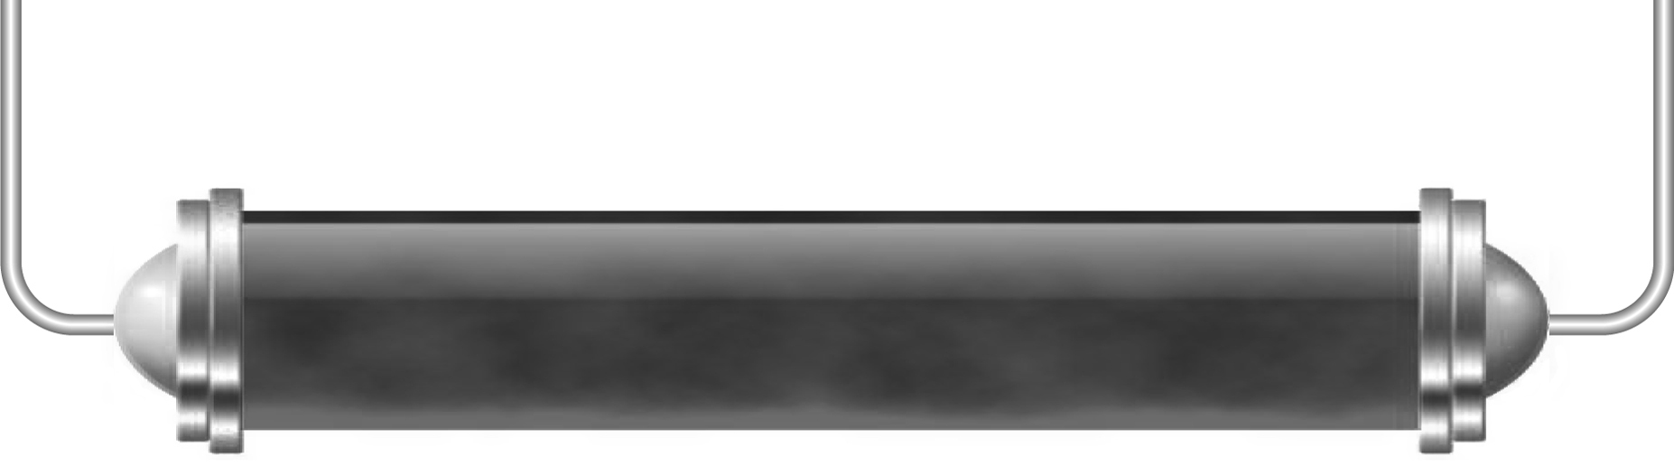
The Moon

Task 1: Phases of the Moon (Levels 4–5)

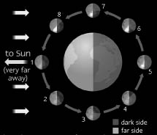
Look at this diagram of the Earth and the Moon.
For each of the positions 1 to 8 draw how you think the Moon would look from Earth in the table below. When you have finished compare your answer with the diagram on page 190 of your Pupil Book.
How many times in a year does the Moon complete this cycle?

Position on diagram | How the Moon would look from Earth | Position on diagram | How the Moon would look from Earth
1 |  | 5
2 |  | 6
3 |  | 7
4 |  | 8

Task 2: Modelling an eclipse (Levels 5–6)

When you have made your model of a solar or lunar eclipse use it to describe to some friends what is happening. They will then explain the other sort of eclipse to you.

While you are making your model record the key features of that sort of eclipse in this table and when you are listening to the other explanation record those key features as well.

Solar eclipses | Lunar eclipses

- Can you say one good thing about your model?

- And can you think of one limitation of your model?

- Can you find out when there was last a total solar eclipse visible from Britain?

Task 3: What was it like? (Levels 4–6)

During a total solar eclipse it gets dark during the day. Can you describe what you think it would feel like? Think about how birds and animals might behave, what you would see and hear and what would happen to the temperature.
The day after a solar eclipse, you are asked to write a newspaper article describing what it was like. Don’t forget to include a scientific explanation of what happened for your readers.

