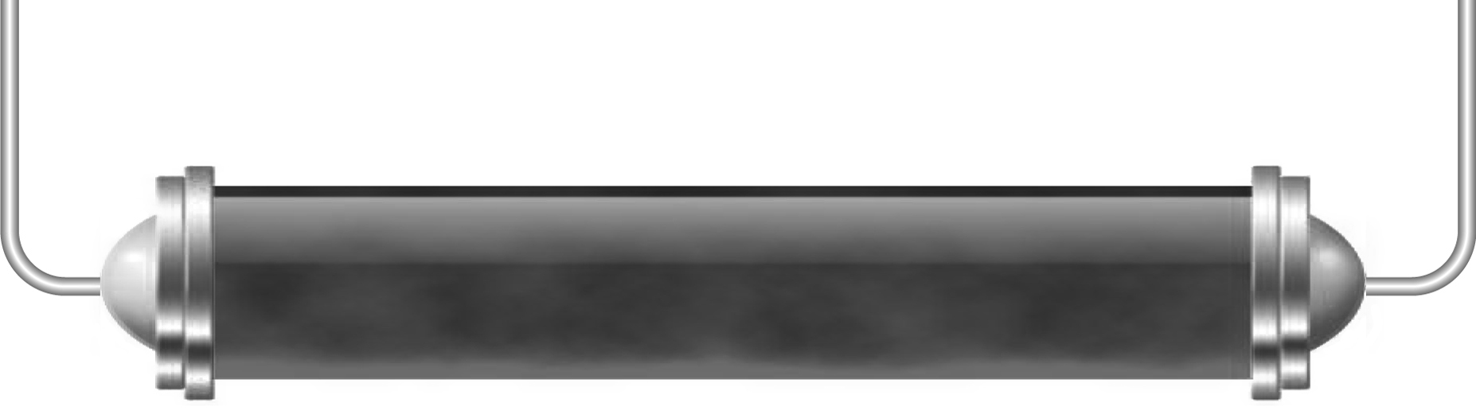
Eclipses
You are going to make a model of either a solar or a lunar eclipse.
Solar eclipse
An eclipse of the Sun happens in the daytime and is called a solar eclipse. The Moon passes between the Earth and the Sun, blocking the light coming from the Sun.

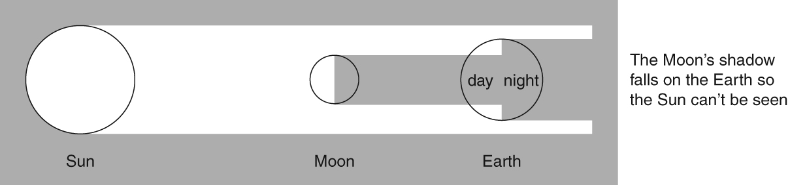
- Use the torch and card to show how a solar eclipse takes place.
- Place the Earth about 50 cm away from the Sun.
- The light from the Sun lights up the Earth.
- Move the Moon across, between the Sun and Earth so it blocks the Sun’s light.
- The Moon’s shadow darkens the Earth even though it is daytime.
- This is a solar eclipse.

Lunar eclipse
An eclipse of the Moon happens at night. It is called a lunar eclipse.
We normally see the Moon because it reflects the Sun’s light.
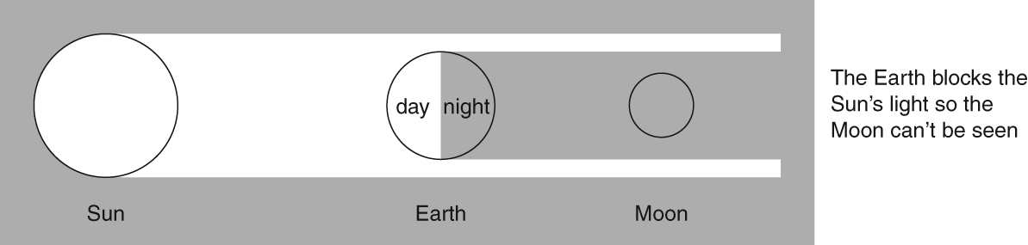
If the Earth gets between the Sun and the Moon, the light is blocked and the Earth’s shadow falls on the Moon.

- Use the torch and card to show how a lunar eclipse takes place.
- Place the Moon about 50 cm away from the Sun.
- The light from the Sun lights up the Moon when there is a full Moon.
- Move the Earth across, between the Sun and Moon so it blocks the Sun’s light.
- The Earth’s shadow darkens the Moon even though it is a full Moon.
- This is a lunar eclipse.
Eclipses aren’t seen every day or every month because the Earth, Sun and Moon have to be lined up in a particular way. More often, there is a partial eclipse (when part of the Sun or Moon is blocked).

