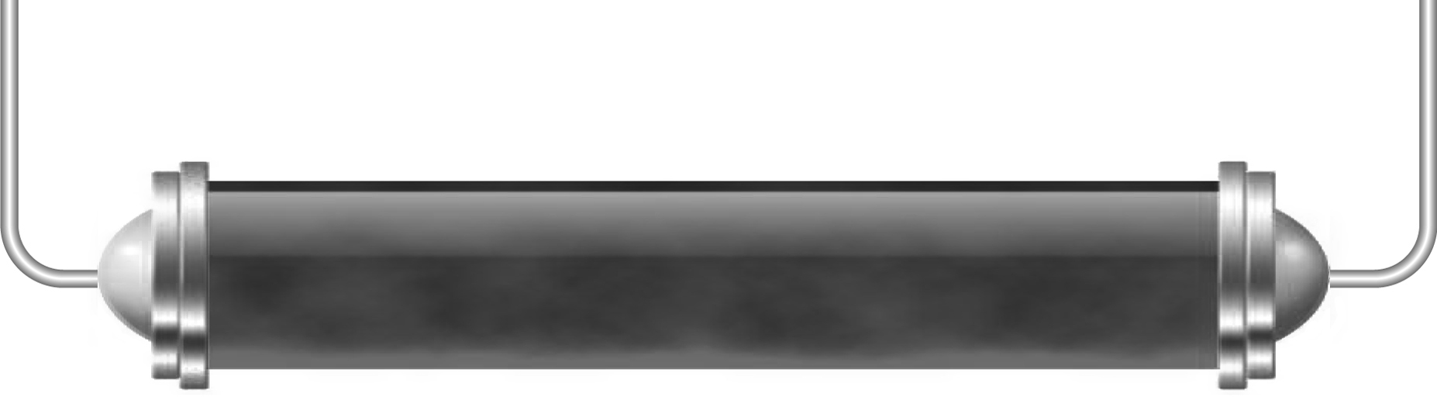
Gravity in space

Task 1: Life without gravity (Levels 4–5)

Astronauts going into space have to get used to weightlessness. Why is this?

Think about something very ordinary that you do every day, for example getting up and getting ready for school; travelling to school; having a maths lesson; eating your lunch.
Choose one of these things and write about what it would be like if there was no gravity! In what ways would it be easier and it what ways would it be harder?

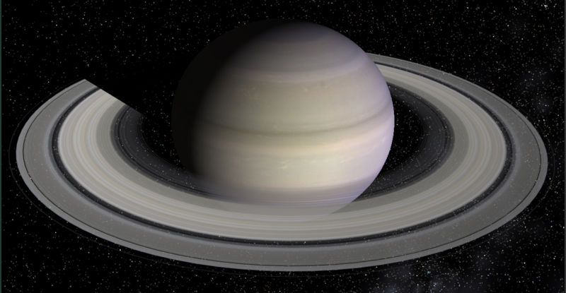
Task 2: Gravity on other planets (Levels 5–6)

Look at this table of information about the planets. Fill in the left-hand column with the names of the planets.

Planet | Diameter (km) | Mass  (× Earth’s mass) | Order of Gravity  1 to 8 | Distance from Sun  (million km)
 | 4880 | 0.06 |  | 69.7
 | 12 104 | 0.82 |  | 109
Earth | 12 756 | 1 |  | 152
 | 6787 | 0.11 |  | 249
 | 142 800 | 318 |  | 816
 | 120 000 | 95 |  | 1510
 | 51 000 | 14.5 |  | 3010
 | 49 500 | 17.2 |  | 4540

Which column do you need to think about to decide which planet has the most gravity? Put the planets into order of the one with the most gravity first and the least gravity last.
If you were travelling in space, what else would affect the gravity you felt from each planet?

Task 3: Artificial satellites (Levels 6–7)

What are artificial satellites used for? We will look at this in more detail in a later lesson but for now research their uses and see if you can find out what the term ‘geostationary’ means.

