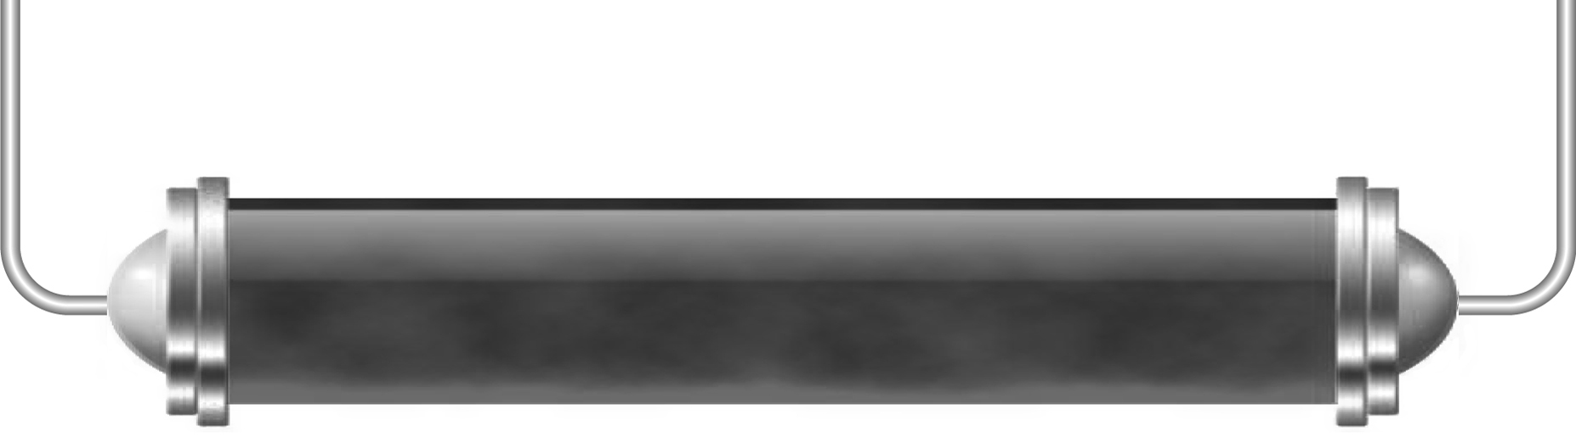
Gravity and weight

Task 1: Gravity and forces (Levels 4–5)

Think about what happens when you throw an object up in the air. Draw arrows on these diagrams to show the forces acting on the ball at each stage of its flight.
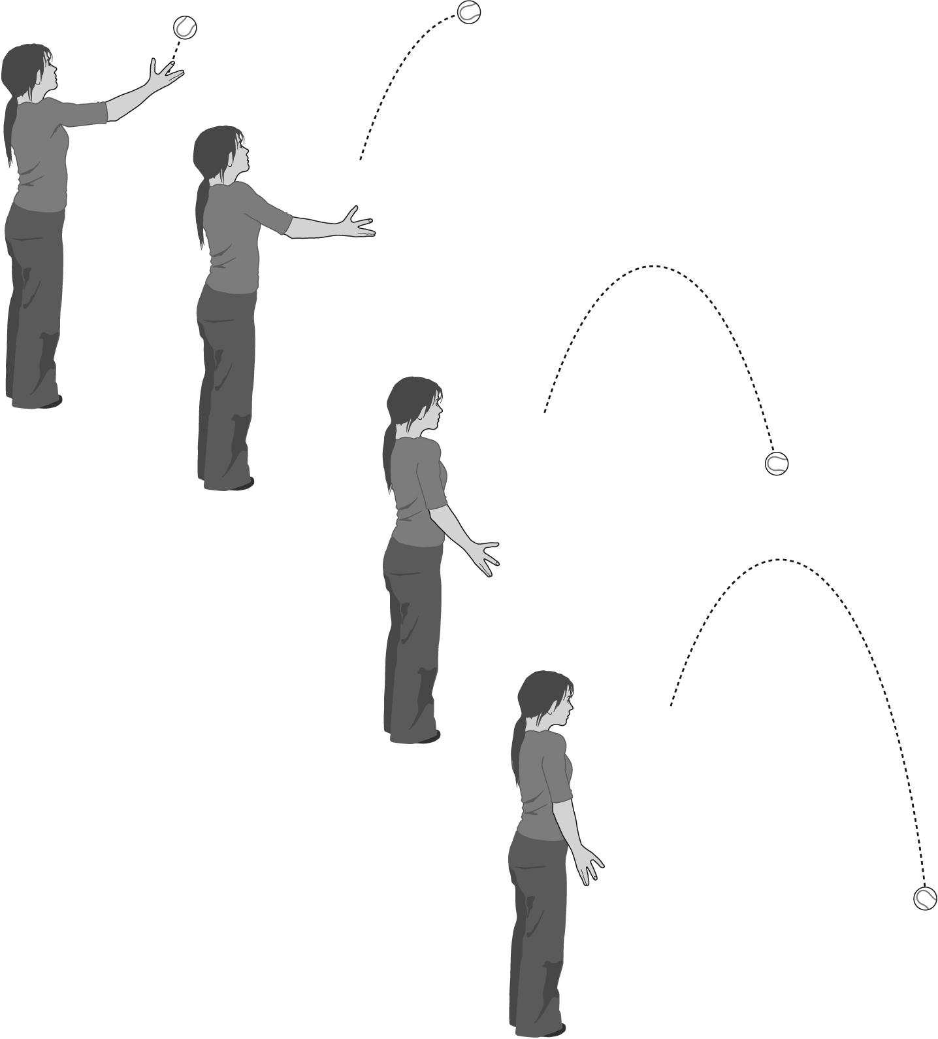

In which direction does the force of gravity act?

Task 2: Weight on other planets ([Levels 5–6)

Look at this table of information about gravity on other planets.

Planet | Diameter (km) | Mass  (× Earth’s mass) | Gravity  (× Earth’s gravity)
Mercury | 4880 | 0.06 | 3.8
Venus | 12 104 | 0.82 | 9
Earth | 12 756 | 1 | 10
Mars | 6787 | 0.11 | 3.8
Jupiter | 142 800 | 318 | 27
Saturn | 120 000 | 95 | 12
Uranus | 51 000 | 14.5 | 9.3
Neptune | 49 500 | 17.2 | 12

Complete the table to show the weights of various objects as they travel from planet to planet; some have been done for you. Think carefully about how you will do the calculations – especially for the last column.

Mass of object | Weight on Earth (Newtons) | Weight on Mars (N) | Weight on Jupiter (N) | Weight on Neptune (N) | Weight on the Moon  (N)
A person of mass 50 kg | 500 |  |  | 600 | 84
An astronaut in a spacesuit with a mass of 120 kg |  |  | 3240 |  | 200
A book with a mass of 0.5 kg |  | 1.9
An apple with a mass of 100 g | 1

Task 3: Life on other planets (Levels 4–6)

Choose a planet in our Solar System and use your knowledge of the conditions on that planet (such as the gravity, the temperature and whether it is rocky or gaseous) to design an animal that you think could have evolved to live in those conditions. Explain how each of the features of your creature has helped it to survive on your chosen planet.

