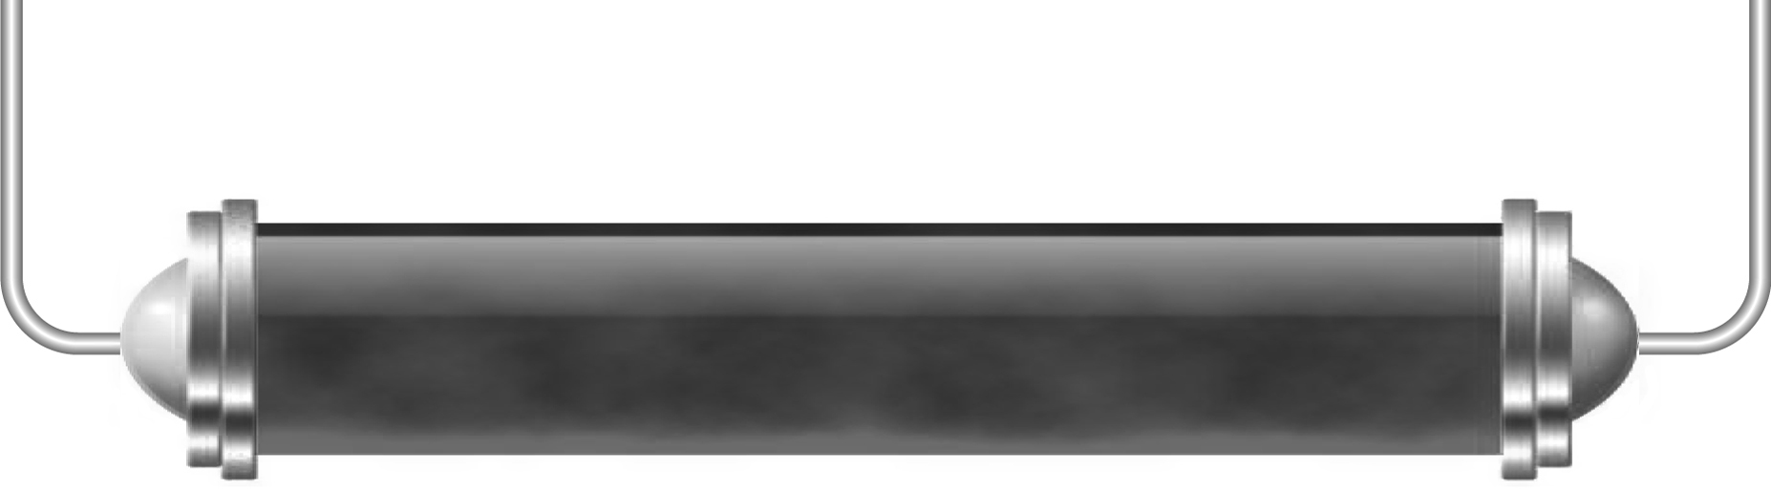
Satellites

Task 1: Satellite history (Levels 4–5)

Satellites are a big part of all our lives today – but just 50 years ago they were very
new indeed.
Below are some facts about satellites and space probes and the dates when they happened. Arrange them into a timeline of satellite history.
The Hubble Space Telescope, 1990
Pathfinder, 1996 – robot vehicle sent to survey the surface of Mars
Sputnik, 1957 – first communications satellite
Giotto, 1985 – first images from Halley’s comet
Zond 3, 1965 – unmanned probe transmitted pictures from the far side of the Moon
Lunar 2, 1959 – unmanned probe became first manmade object to land on the Moon
Pioneer 8, 1967 – solar probe still transmitting from solar orbit
Voyager 1, 1979 – sent images from Saturn and Jupiter
Pioneer 10, 1973 – flew past Jupiter and was first spacecraft to leave our Solar System
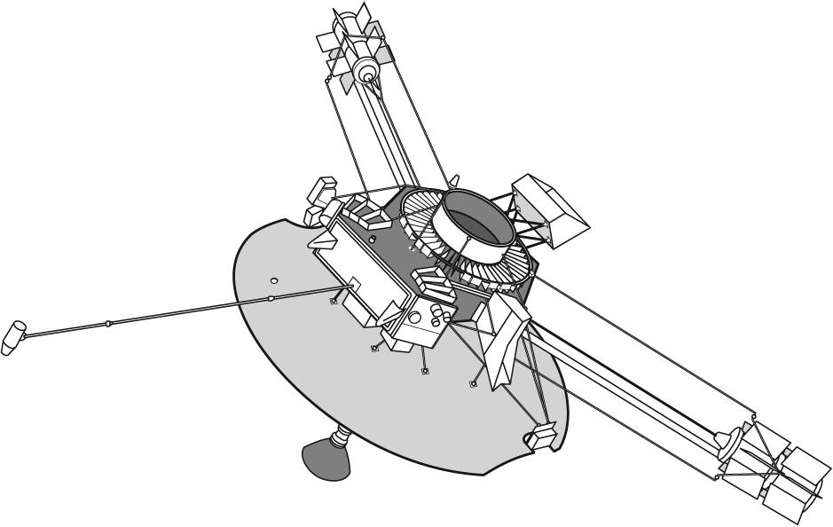

Task 2: Satellite uses (Levels 5–6)

Work in a group. You teacher will either give you a use of satellites to research, or you will be allowed to choose a use yourself. Find out as much as you can using the internet and produce an interesting presentation for the rest of the class.
You should include pictures and video clips along with an explanation of the type of orbit of your kind of satellite uses and the history of using satellites in this way.

Task 3: Geostationary and polar orbits (Levels 6–7)

Find out the key features and uses of each of these kinds of orbit and record them in the table below.

Geostationary orbits | Polar orbits
Main features: | Main features:
Uses: | Uses:

Choose one use of each kind of satellite orbit and explain why the orbit is suitable for
the purpose.

