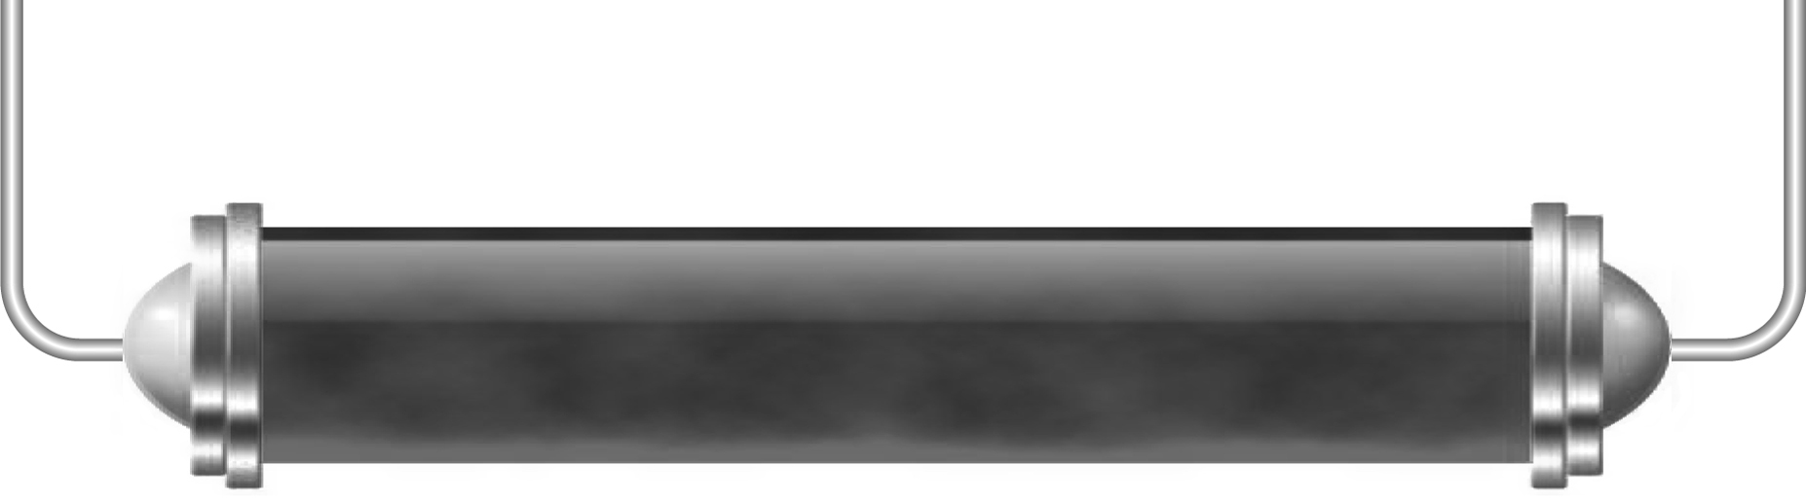
Space travel

Task 1: History so far (Levels 3–4)

What have been the key milestones in the history of space travel so far?
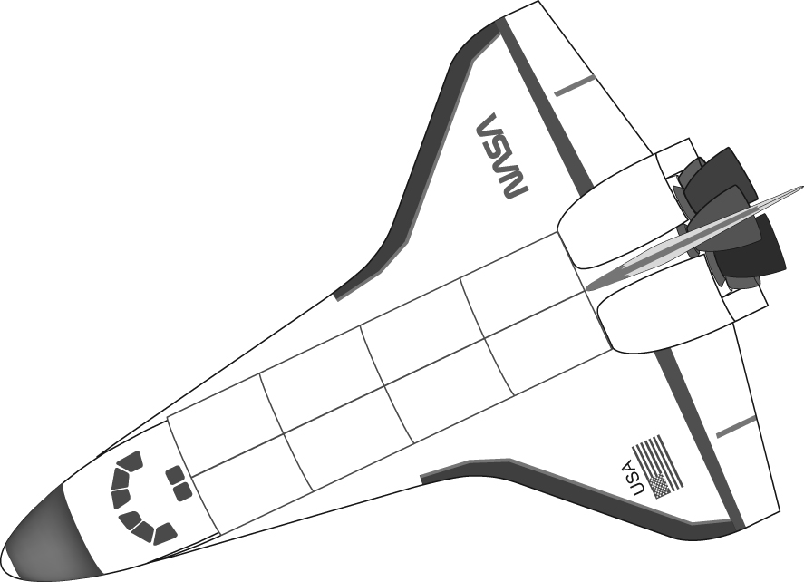
Work with a partner and try and find five key events and their dates – compare your list with another pair to see if they are the same or different.

Task 2: Space travel – the future (Levels 4–6)

Work in a group and find out all you can about one aspect of space travel – produce a poster or fact file that can be added to the work of other groups and make up a whole-class display all about space travel.

Task 3: Hello out there! (Levels 4–5)

Even if we do not send people to far-flung planets, we need to send some information about ourselves and our planet.
Describe what you would put in a space capsule to be found by the inhabitants of another planet and explain why you have chosen those items.

