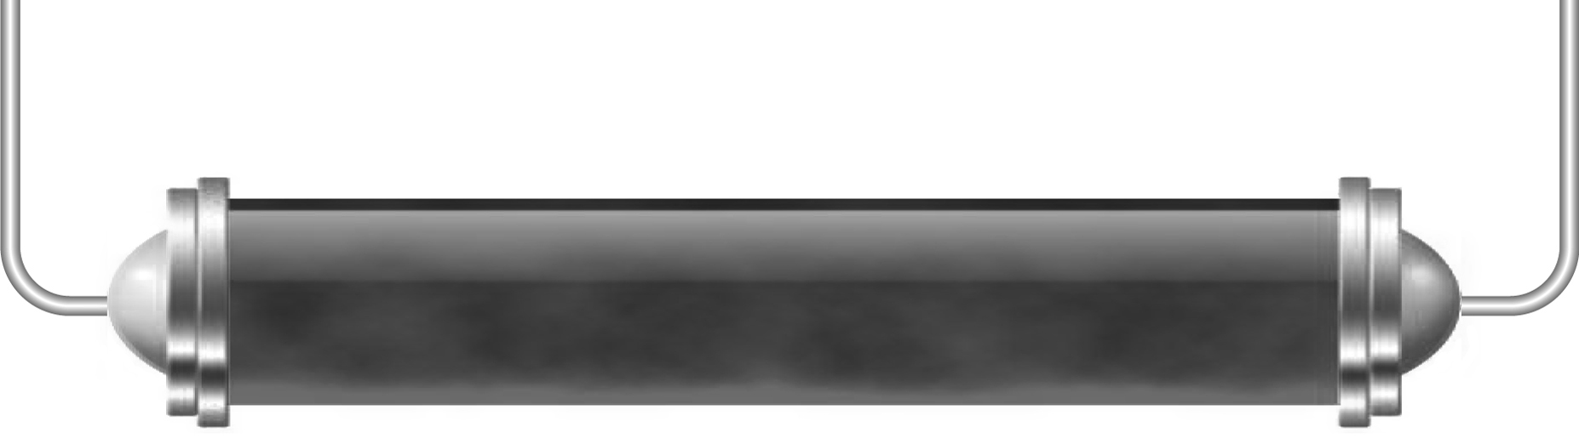
Exploring further

Task 1: Means of exploration (Levels 4–5)
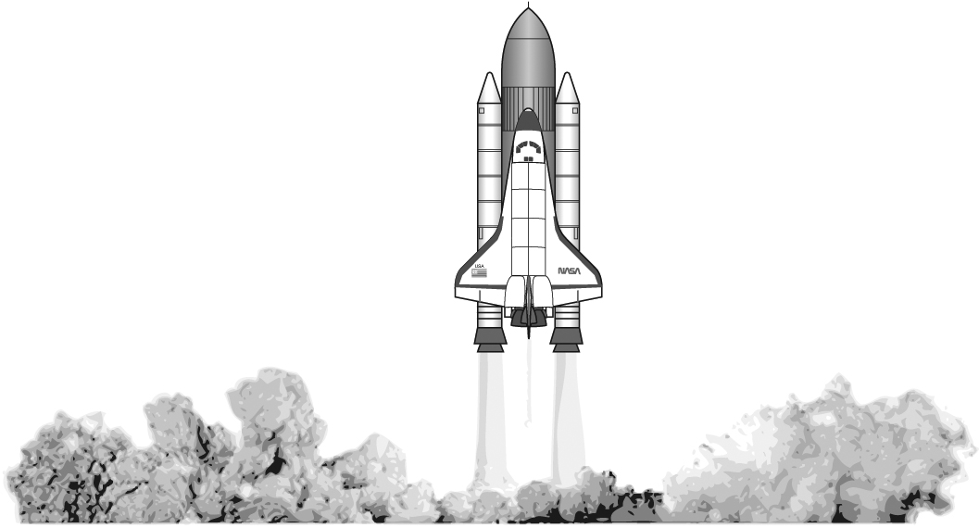
For each of the ways of finding out more about distant objects, record any advantages and disadvantages you can think of in the table below. Compare what you have written with some friends – do you all agree or disagree?

Ground telescopes | Advantages:
Ground telescopes | Disadvantages:
Space telescopes | Advantages:
Space telescopes | Disadvantages:
Space probes | Advantages:
Space probes | Disadvantages:
Manned space flight | Advantages:
Manned space flight | Disadvantages:

Task 2: Famous space probes (Levels 4–6)

Choose one of the famous space probes described on page 205 of you Pupil Book. Produce a poster, fact file, mind map or PowerPoint presentation covering the most important points about your chosen probe – be prepared to present what you have found to the rest of the group so make sure you find some interesting images as well as facts!
Since Pioneer 10 was launched over 30 years ago, Hubble nearly 20 years ago and the Cassini-Huygens project just over 10 years ago, you should investigate how expectations and methods have developed over the years.

Try looking at the web pages listed below.
Pioneer 10
nssdc.gsfc.nasa.gov/nmc/masterCatalog.do?sc=1972-012A
www.solarviews.com/eng/pn10-11.htm
Hubble Space Telescope
hubblesite.org/
hubblesite.org/the_telescope/hand-held_hubble/
Cassini-Huygens mission
www.esa.int/SPECIALS/Cassini-Huygens/SEMVOZ1VQUD_0.html
www.nasa.gov/mission_pages/cassini/multimedia/latest-images-collection_archive_1.htm

Task 3: Space project summary (Levels 4–6)

In this topic you have produced a number of posters, fact files and presentations.
Put them all together into a space project.

