2:3:2
Dissolving
This table shows the mass of potassium chloride that dissolves in 100 g of water at different temperatures.
Temperature (°C) | Mass of potassium chloride that dissolves in 100 g of water
0 | 27
10 | 32
20 | 35
30 | 38
40 | 41
50 | 44
60 | 47
70 | 50
80 | 52
90 | 54
100 | 56
- Use the information in the table to complete the graph.
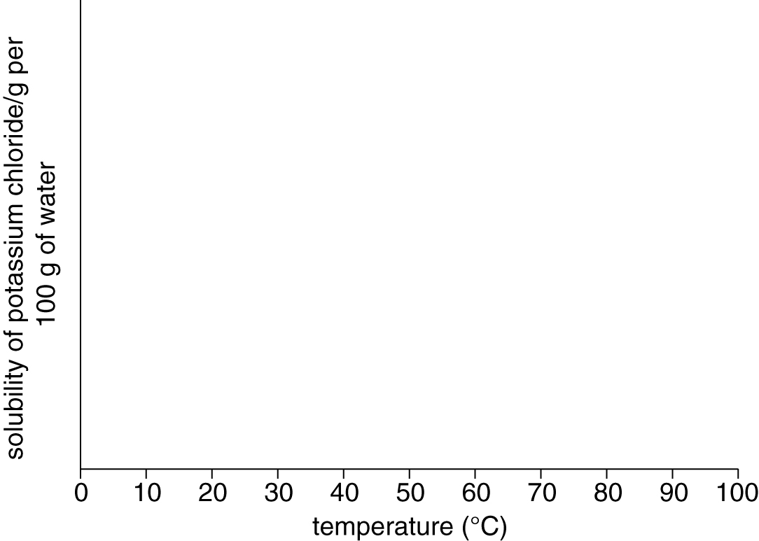
- How does the temperature of the water affect the solubility of the potassium chloride?
- Why does the table not give values for the amount of potassium chloride that dissolves below
0 °C and above 100 °C?

