2:3:6
Better distillation
Distillation can be used to separate a mixture of ink and water.
1 Use these words to label the diagram:
thermometer pure water condenser distillate
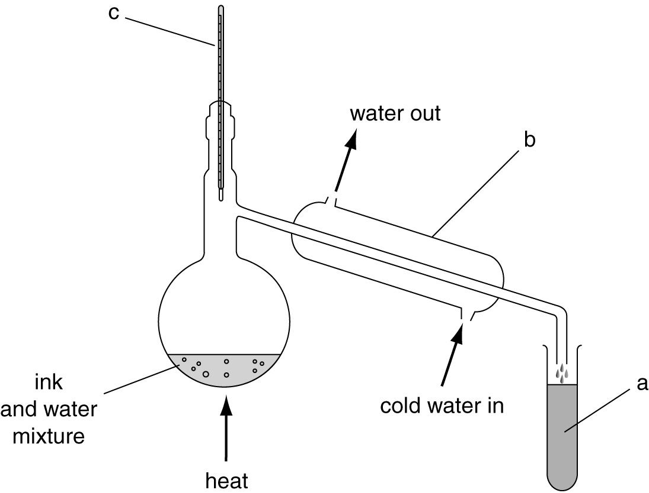
2 In the flask the liquid water changes into water vapour. Give the name of the process which is taking place in the flask.
.....................................................................................................................................................
3 State the temperature you would expect to read on the thermometer during distillation?
.....................................................................................................................................................
4 What does the condenser do?
....................................................................................................................................................
....................................................................................................................................................
5 Why is water put into the bottom of the condenser and not into the top?
....................................................................................................................................................
....................................................................................................................................................
6 Explain why the remaining ink mixture gets darker during the process.
....................................................................................................................................................
....................................................................................................................................................

