2:5:5
Electromagnets
You are going to make an electromagnet strong enough to separate magnetic and non-magnetic materials.
Collect:
- A battery which has four 1.5V cells
- A switch
- Connecting leads
- Crocodile clips
- An iron nail
- Coils of plastic-covered wire (the plastic must be stripped off the ends)
- A small pile of paperclips and paper
Make your electromagnet by making a circuit like the one below.
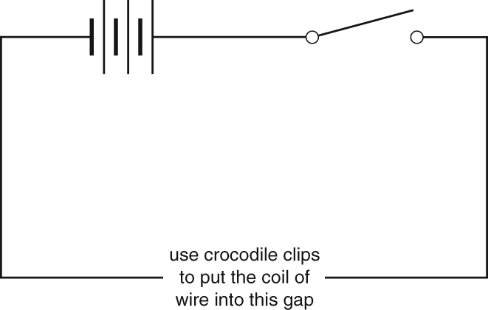
When the switch is pressed down the coil of wire is an electromagnet which picks up magnetic objects. Test your electromagnet by checking that it can:
- pick up a paperclip when the switch is closed
- drop the paperclip when the switch is open.
If your electromagnet is stronger it can pick up more magnetic objects.
To make the electromagnet stronger there are several changes you can make:
- Increase the number of cells used. This increases the current.
- Add an iron nail (a soft magnetic material) inside the coil of wire
- Increase the number of turns on the coil of wire
- Which changes worked to make the electromagnet strongest?

- Use your electromagnet to separate the paperclips and the paper into two piles.
Explain how you did this.

