Extracting natural aromas

Aim
You are going to attempt to extract citrus oils from orange peel.

Materials required
- 1 large orange, rinded
- 250 cm³ round-bottomed flask
- delivery tube with bung to fit flask or condenser and still head to fit
- Bunsen burner, tripod and gauze
- heatproof mat
- measuring cylinder 100 cm³
- anti-bumping granules

Safety
! Wear eye protection.
! Take care with hot apparatus.
! Limonene (product) can irritate skin and eyes.

What to do
Experiment 1: Extracting a natural oil
1 Rind the outer peel of the orange with a rinder (alternatively use a peeler and finely chop it with a knife). In either case, make sure that you only use the outer orange-coloured peel.
2 Put the grated or chopped peel into a large flask and add distilled water so that it just covers the peel.
3 Connect the apparatus as shown using a wire gauze to dissipate heat. When you have done this, ask your teacher to make sure that your apparatus is set up safely. Make sure that the water is turned on.
4 Light the Bunsen burner and heat the flask using a blue flame. When the water has boiled, turn down the Bunsen burner so that the water is just gently boiling.
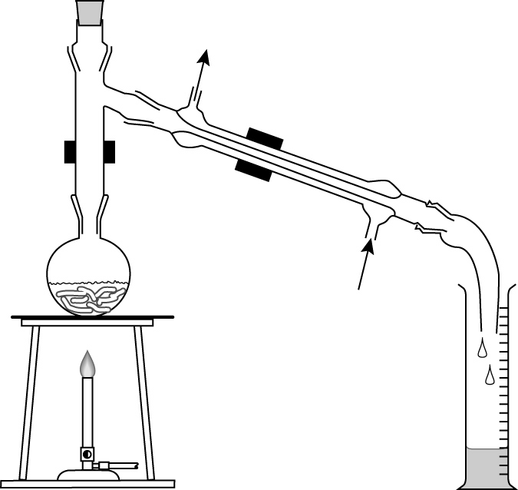
clamp
condenser
water in
clamp
flask
orange
peel
measuring
cylinder
water out

5 Collect about 50 cm³ of liquid in the measuring cylinder. Observe what the liquid in the measuring cylinder looks like.
6 Turn off the Bunsen burner and allow the apparatus to cool.
7 When the apparatus has cooled, clear it away as instructed by your teacher.
8 If you have a layer of oily liquid floating on top of the water in the measuring cylinder, try to remove this using a pipette and put it in a test tube. Test it with bromine water.

Analysis of your results
Experiment 1
1 What is the approximate temperature of the vapour in the neck of the round-bottomed flask?
2 Why do you see droplets of liquid forming in the delivery tube or condenser?
3 Describe the appearance of the liquids in the measuring cylinder. From your tests, what functional group(s) are present in the molecule?
4 Citrus oil is an aroma chemical. Suggest why the amount of citrus oil you collected in the measuring cylinder may be less than expected
5 When might steam distillation be used in industry? Why is the orange peel not heated directly?

