Surface Area to Volume Ratio

Why do some organisms need gas exchange and transport systems?

Single-celled organisms, such as bacteria and amoeba (below), can obtain nutrients and excrete waste simply by diffusion.

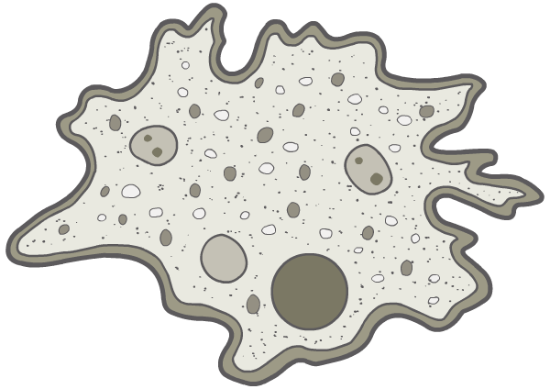
nutrients
waste products

Multi-cellular organisms, such as insects, fish and mammals, require more specialised gas exchange and transport systems. Why is this? (also for heat energy conservation/loss)

Surface Area to Volume Ratio

In larger organisms, diffusion of substances would occur far too slowly to enable them to survive: the rate of diffusion increases with the square of the distance it has to travel.

This is not just because of its size, however: more important is an organism’s surface area to volume ratio. (also substance size/solubility, conc. grad., material passing through)

Single-celled organisms have a very large surface area to volume ratio and the diffusion pathway is short.

Surface area is measured in units ².
Volume is measured in units³.
Therefore Surface Area to Volume ratio is measured in units²units⁻³.

1 2 3 4

Side length (cm) | 1 | 2 | 3 | 4
Surface Area (cm²) | 6 | 24 | 54 | 96
Volume (cm³) | 1 | 8 | 27 | 64
SA:volume | 6:1 | 3:1 | 2:1 | 3:2
SA / vol (cm²cm⁻³) | 6 | 3 | 2 | 1.5
(< 1:100 in a human being)
As organisms get bigger their surface area: volume ratio gets smaller. This means that as organisms become bigger it becomes more difficult for them to exchange materials with their surroundings. bacteria = all surface with not much inside, whales = all insides with not much surface.

This problem sets a limit on the maximum size for a single cell of about 100 μm.
In anything larger than this materials simply cannot diffuse fast enough to support the reactions needed for life.
- very large single cells like birds' eggs are mostly inert food storage with a thin layer of living cytoplasm round the outside.

How do organisms larger than 100 μm exist?
Firstly, organisms larger than 100 μm are multicellular, which means that their bodies are composed of many small cells, rather than one big cell. Each cell in a multicellular organism is no bigger than about 30 μm, and so can exchange materials quickly and independently. Each human contains about 10¹⁴ cells.

Secondly, large organisms all have specialised exchange systems with a large surface area. These systems include lungs, gills, intestines, roots and leaves.

Heat Exchange.
Organisms also exchange heat with their surroundings, and here larger mammals and birds have an advantage as they have a smaller surface area : volume ratio.
They lose heat less rapidly than small animals.
e.g. human babies lose heat more quickly than adults, which is why they need woolly hats

NB it is the rate of heat loss relative to its generation which is important when maintaining a constant body temperature.

Large mammals/birds maintain their body temperature quite easily and don't need much insulation or extra heat generation. Small mammals/birds lose their heat very readily, so need a high metabolic rate in order to keep generating heat, as well as thick insulation.

Large mammals can feed once every few days while small mammals must feed continuously.

