Surface Area to Volume Ratio

Why do some organisms need gas exchange and transport systems?

Single-celled organisms, such as bacteria and amoeba (below), can obtain nutrients and excrete waste simply by _____________ .

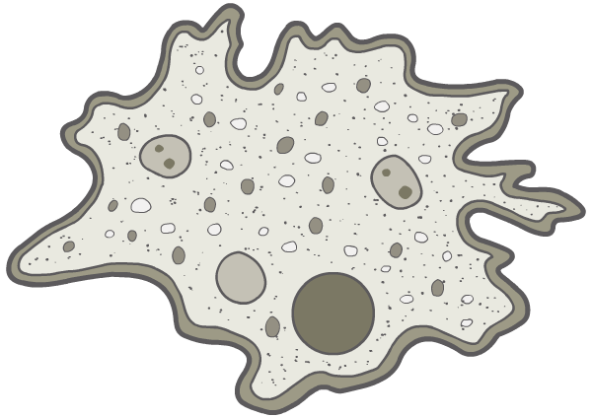
_____________
_____ _______

Multi-cellular organisms, such as _____________, _____________and _____________, require a more specialised transport system. Why is this?

Surface Area to Volume Ratio

In larger organisms, diffusion of substances would occur far too _____________to enable them to survive: the rate of diffusion increases with the square of the distance it has to travel.

This is not just because of its size, however: more important is an organism’s surface area to volume ratio.

Single-celled organisms have a very _____________surface area to volume ratio and the _____________ _____________ is short.

Surface area is measured in ___________ .
Volume is measured in __________ .
Therefore Surface Area to Volume ratio is measured in __________ .

1 2 3 4

Side length (cm)
Surface Area (cm²)
Volume (cm³)
SA:volume
SA / vol (cm²cm⁻³)

As organisms get __________ their surface area: volume ratio gets __________.
This means that as organisms become bigger it becomes more difficult for them to __________ materials with their __________.

This problem sets a limit on the maximum size for a __________ cell of about ______ μm.
In anything larger than this materials simply cannot __________ fast enough to support the __________ needed for life.
- very large single cells like birds' eggs are mostly inert food storage with a thin layer of living cytoplasm round the outside.

How do organisms larger than 100 μm exist?
Firstly, organisms larger than 100 μm are __________, which means that their bodies are composed of _______ ______ cells, rather than one big cell. Each cell in a multicellular organism is no bigger than about _____ μm, and so can exchange materials __________ and __________. Each human contains about _______ cells.

Secondly, large organisms all have specialised __________ __________ with a
__________ __________ __________ .
These systems include _________, _________, _________, _________ and _________.

Heat Exchange.
Organisms also exchange __________ with their surroundings, and here __________ mammals and birds have an __________ as they have a __________ SA:Vol.
They lose heat __________ __________ than __________ animals.
e.g. human babies lose heat more quickly than adults, which is why they need woolly hats

It is the __________ of heat loss relative to its generation which is important when maintaining a constant body temperature.

__________ mammals/birds maintain their body temperature quite easily and don't need much __________ or extra ______ __________ . __________ mammals/birds lose their heat very __________ , so need a high __________ rate in order to keep generating __________ , as well as __________ __________ .
NB – all animals lose heat, it is the rate of heat loss which is important.

