Xerophytic Plants
Plants in different habitats are adapted to cope with different problems of water availability.
Xerophytes plants adapted to a dry habitat. These must balance the opposing needs of for efficient gas exchange and the limitation of water loss. Halophytes = adapted to a salty habitat – in practice this is effectively a dry habitat. Hydrophytes = adapted to a freshwater habitat. Mesophytes = adapted to a habitat with adequate water.
The prickly pears, Opuntia, belong to the cactus family and are native to the Americas.
They are xerophytes, adapted for environments where little water is available.

Cuticle
The epidermis of a prickly pear is covered in a waxy layer known as the cuticle. This is thicker than that of the average plant to reduce evaporation through the tissue surface by increasing the diffusion distance. not enough to simply state cuticle, must be thick.

Leaves
Opuntia displays only very small, temporary leaves. (These have a small surface area which reduces evaporation NB not small SA:vol, this actually increases but the reduced SA is the important factor).
The majority of photosynthesis occurs in the stem, which forms thick (more small SA:vol), fleshy pads, adapted for efficient water storage. Channels of pale mucilage cells hold additional water.

Spines
The spines on a cactus protect it from herbivores, which it is susceptible to as a source of water.
They also reflect some light to lower the internal temperature of the plant, and may trap a layer of (still) air at the plant’s surface reducing evaporation.
(This still air quickly becomes saturated with water diffusing out of the plant. This reduces the water potential gradient between the inside and outside of the plant thus slowing evaporation.
Hairs/ trichomes can carry out the same function, as can rolled leaves, as in marram grass).
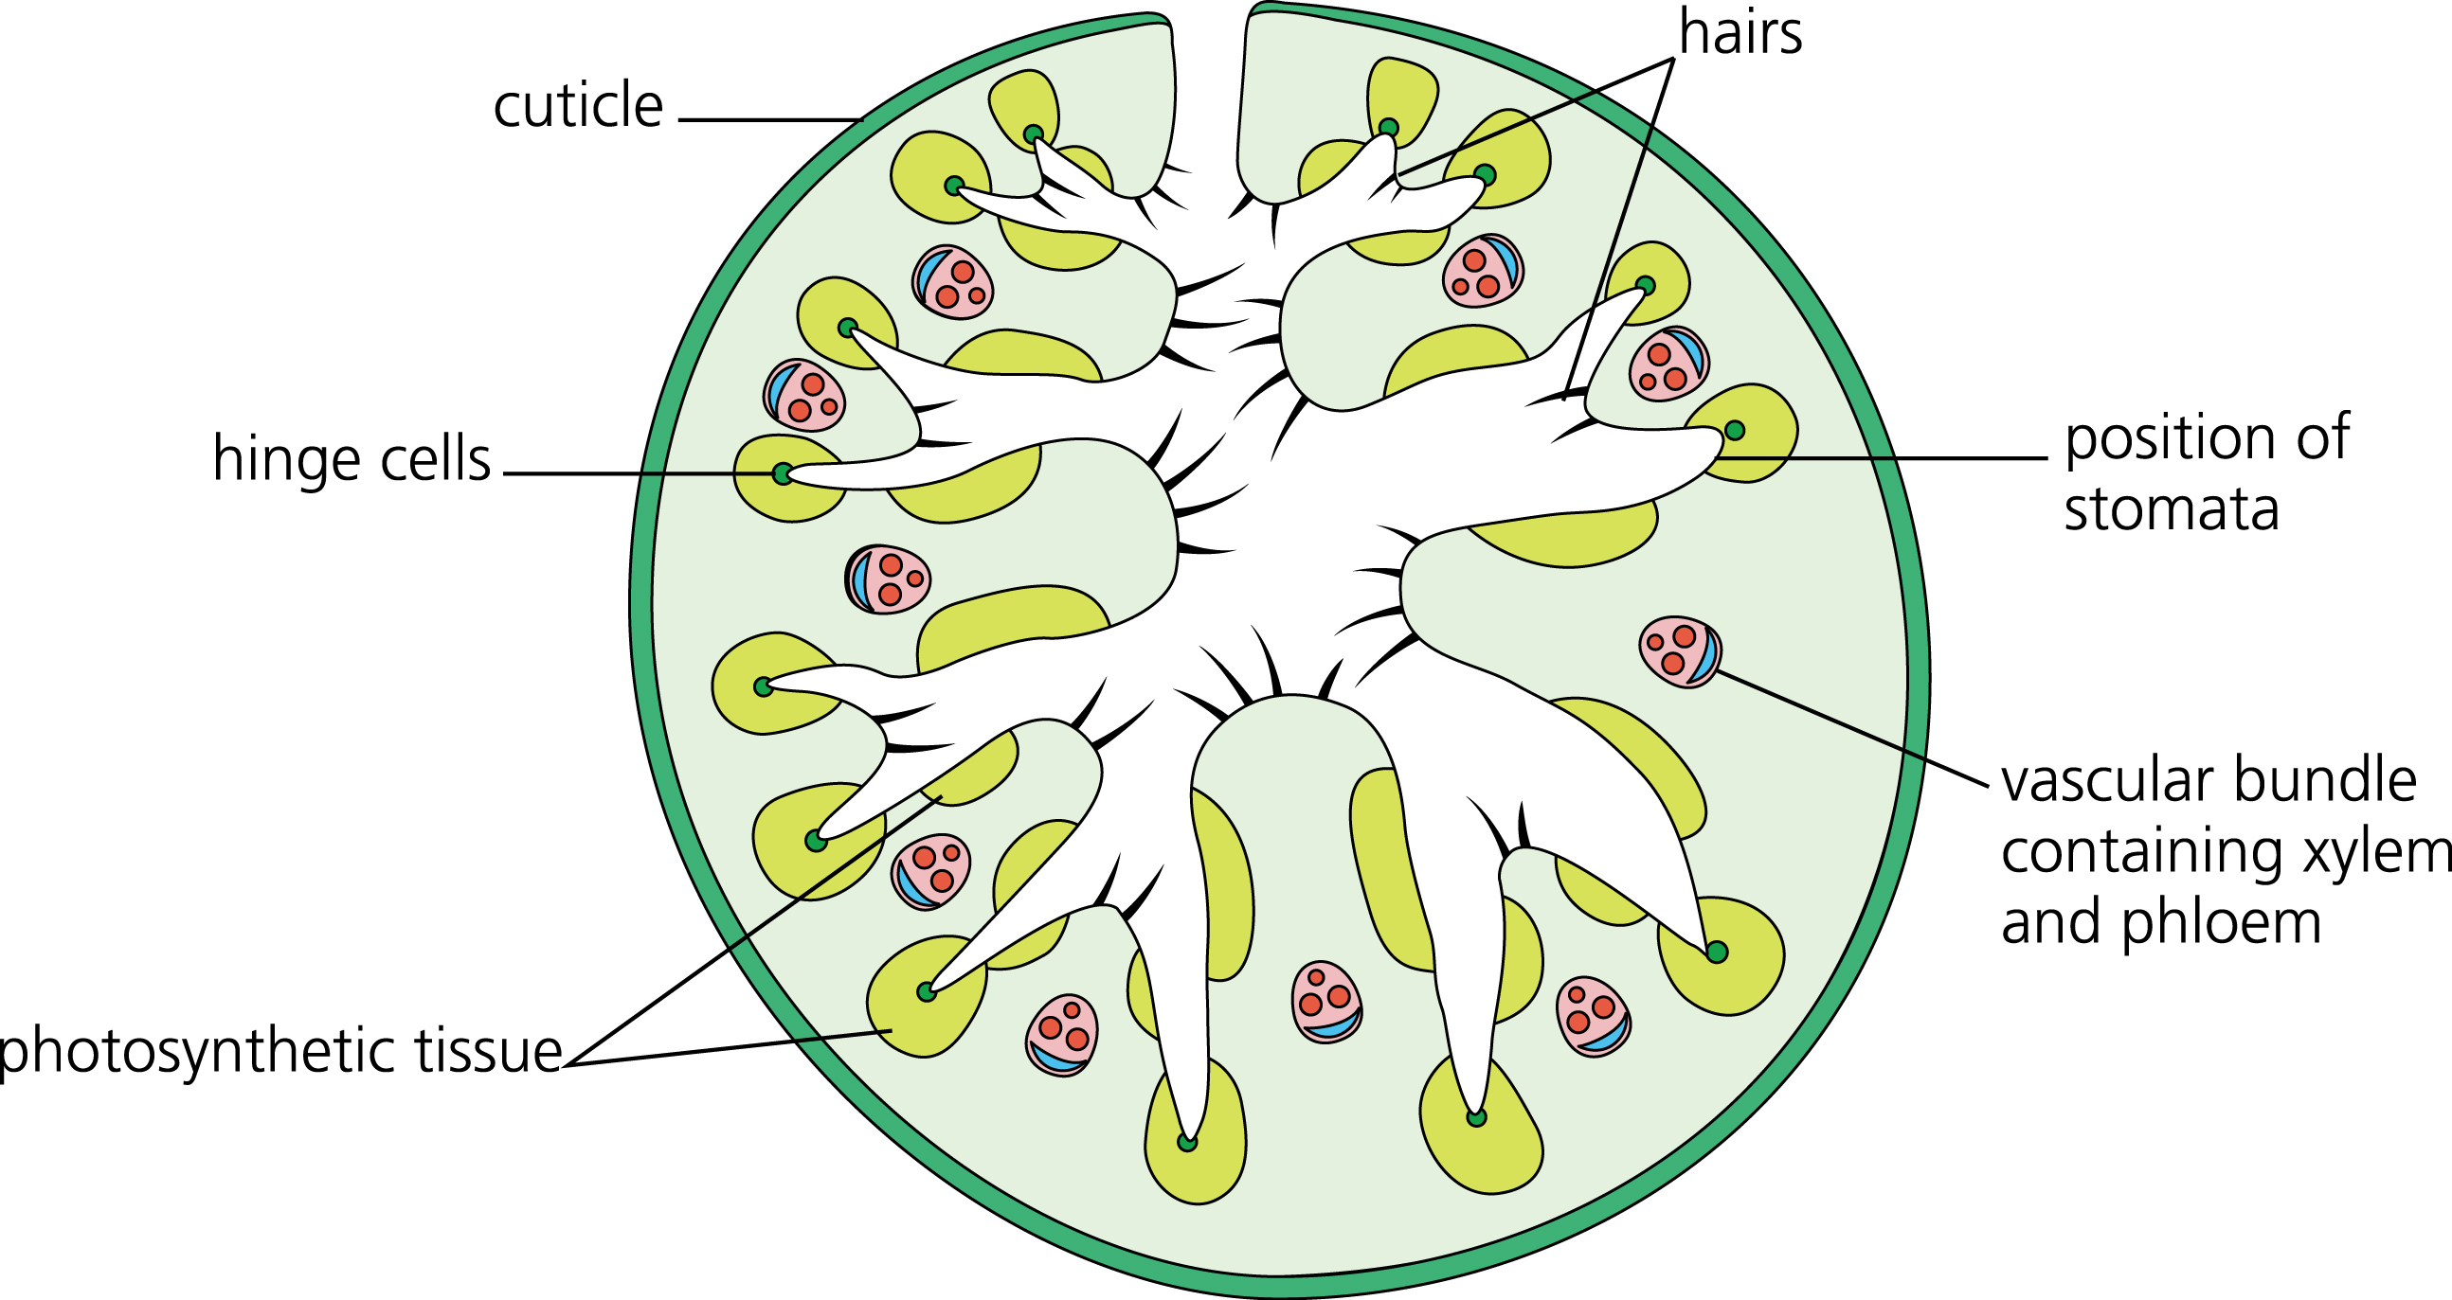
Stomata
Opuntia stomata are mainly found on the stem, and are fewer in number (lower density) than on most plants.

(Some xerophytes’ stomata are sunken into pits or have hairs around them to trap a layer of still air, which quickly becomes humid, as described above.)

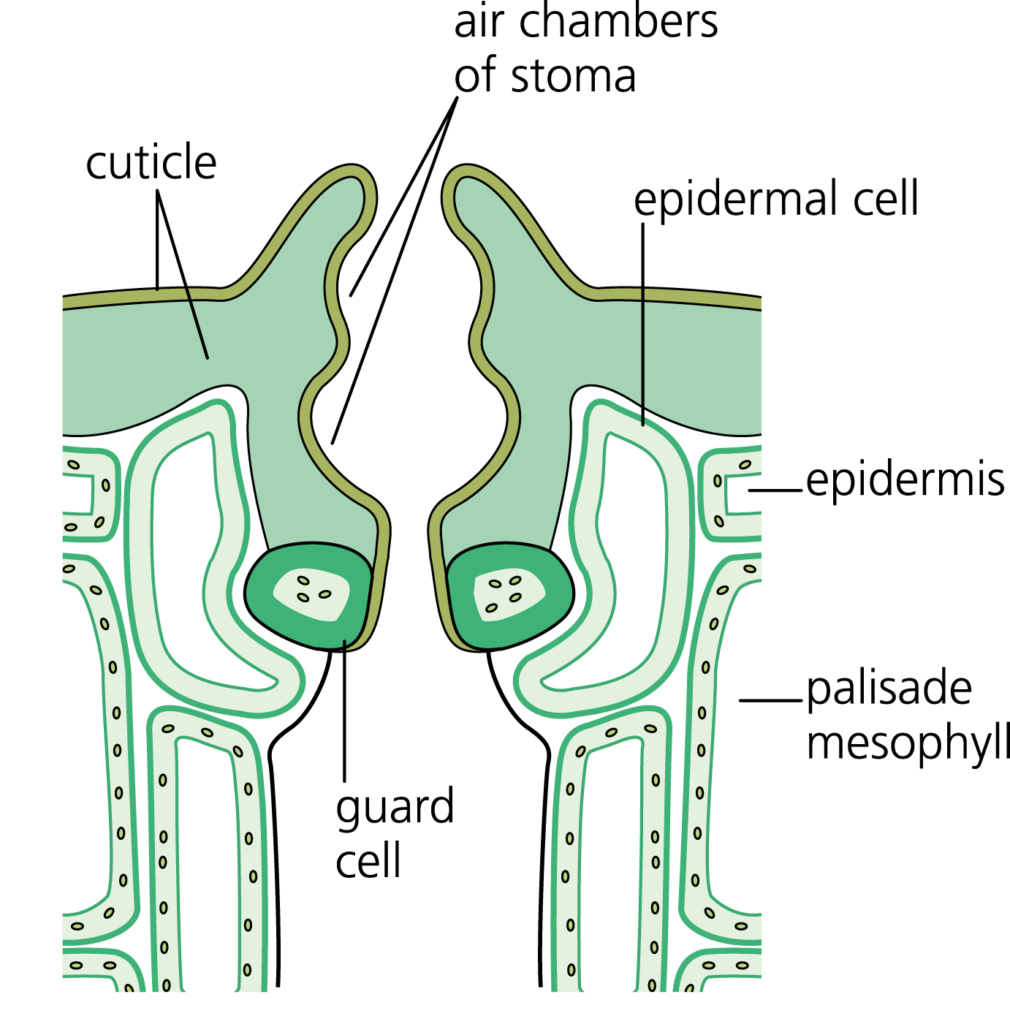
They open at night rather than during the day to reduce water loss. The CO₂ absorbed is then fixed for use during the day when the plant is photosynthesising.

NB – when describing Xerophytic adaptations think about SA:vol ratio, diffusion, evaporation, water potential and water potential gradients, increasing diffusion pathway etc.

