Xerophytic Plants
Plants in different habitats are adapted to cope with different problems of water availability.
____________ plants adapted to a ____ habitat. These must balance the opposing needs of for efficient _____ ____________ and the limitation of _________ _________.
The prickly pears, Opuntia, belong to the cactus family and are native to the Americas.
They are xerophytes, adapted for environments where little ___________ is available.

Cuticle
The epidermis of a prickly pear is covered in a ________ layer known as the _________.
This is ________ than that of the average plant to reduce ________ through the ________ surface by increasing the ________ ________.

Leaves
Opuntia displays only very ________, temporary leaves.
(These have a small surface area which reduces evaporation. NB not SA:vol, this actually increases but the reduced SA is more important).
The majority of _____________ occurs in the stem, which forms _______ (more small SA:vol), fleshy pads, adapted for efficient water ________.
Channels of pale mucilage cells hold additional water.

Spines
The spines on a cactus protect it from herbivores, which it is susceptible to as a source of water.
They also ________ some light to lower the internal ____________ of the plant, and may trap a layer of (still) ______ at the plant’s surface reducing ______________.
(This still air quickly becomes saturated with water diffusing out of the plant. This reduces the water potential gradient between the inside and outside of the plant thus slowing evaporation.
Hairs/ trichomes can carry out the same function, as can rolled leaves, as in marram grass).
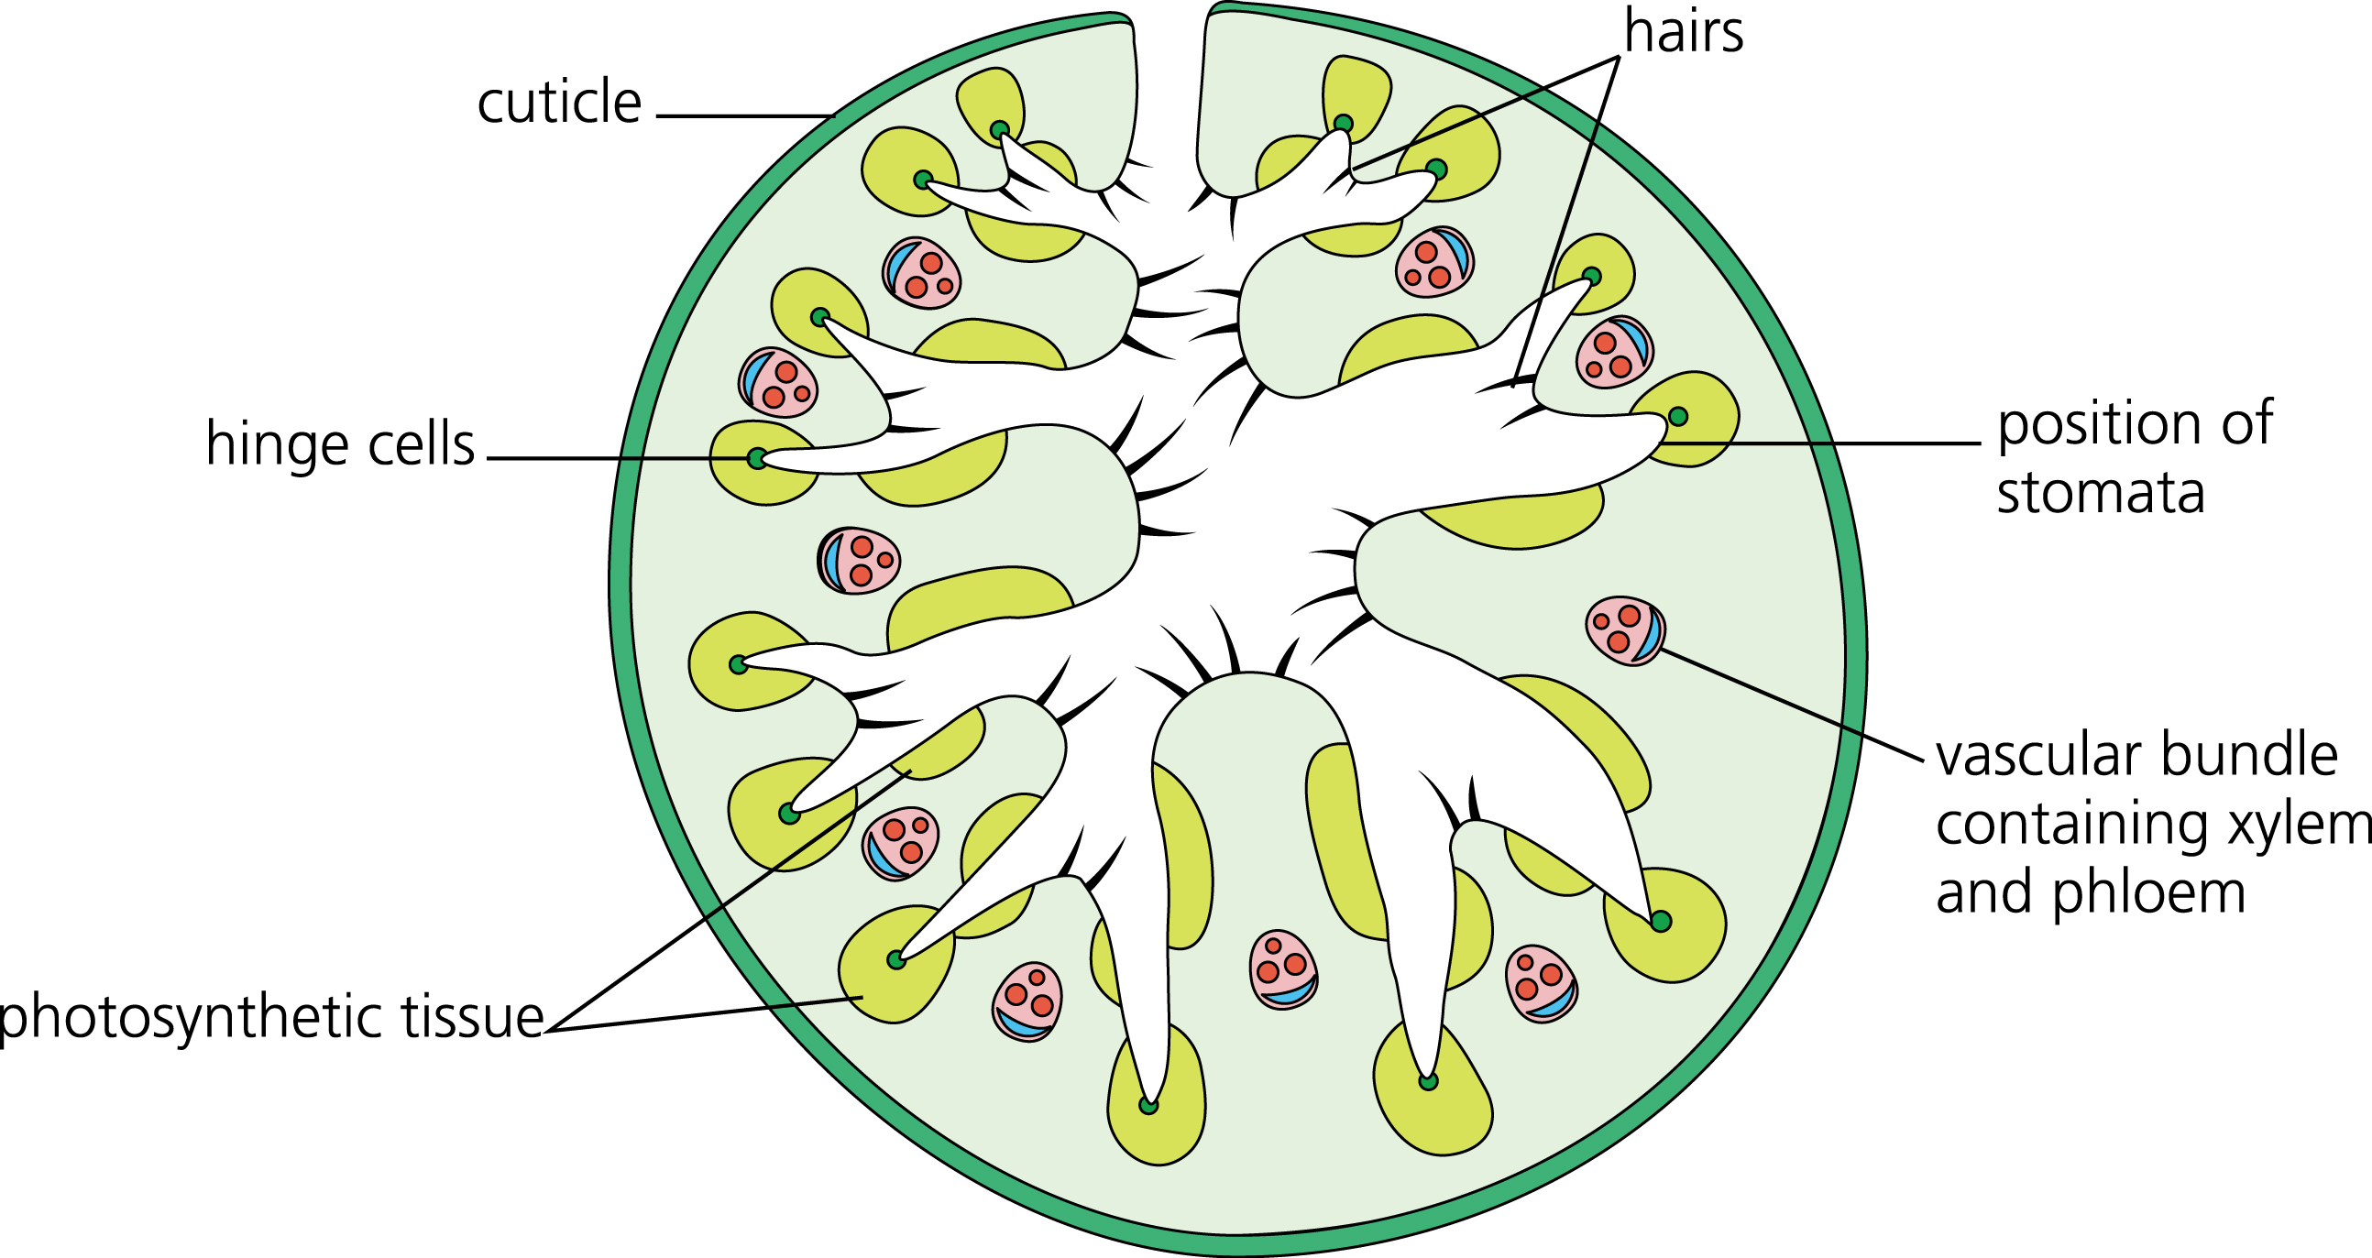
Stomata
Opuntia stomata are mainly found on the ________, and are fewer in number (lower density) than on most plants.

(Some xerophytes’ stomata are sunken into pits or have hairs around them to trap a layer of still air, which quickly becomes humid, as described above.)

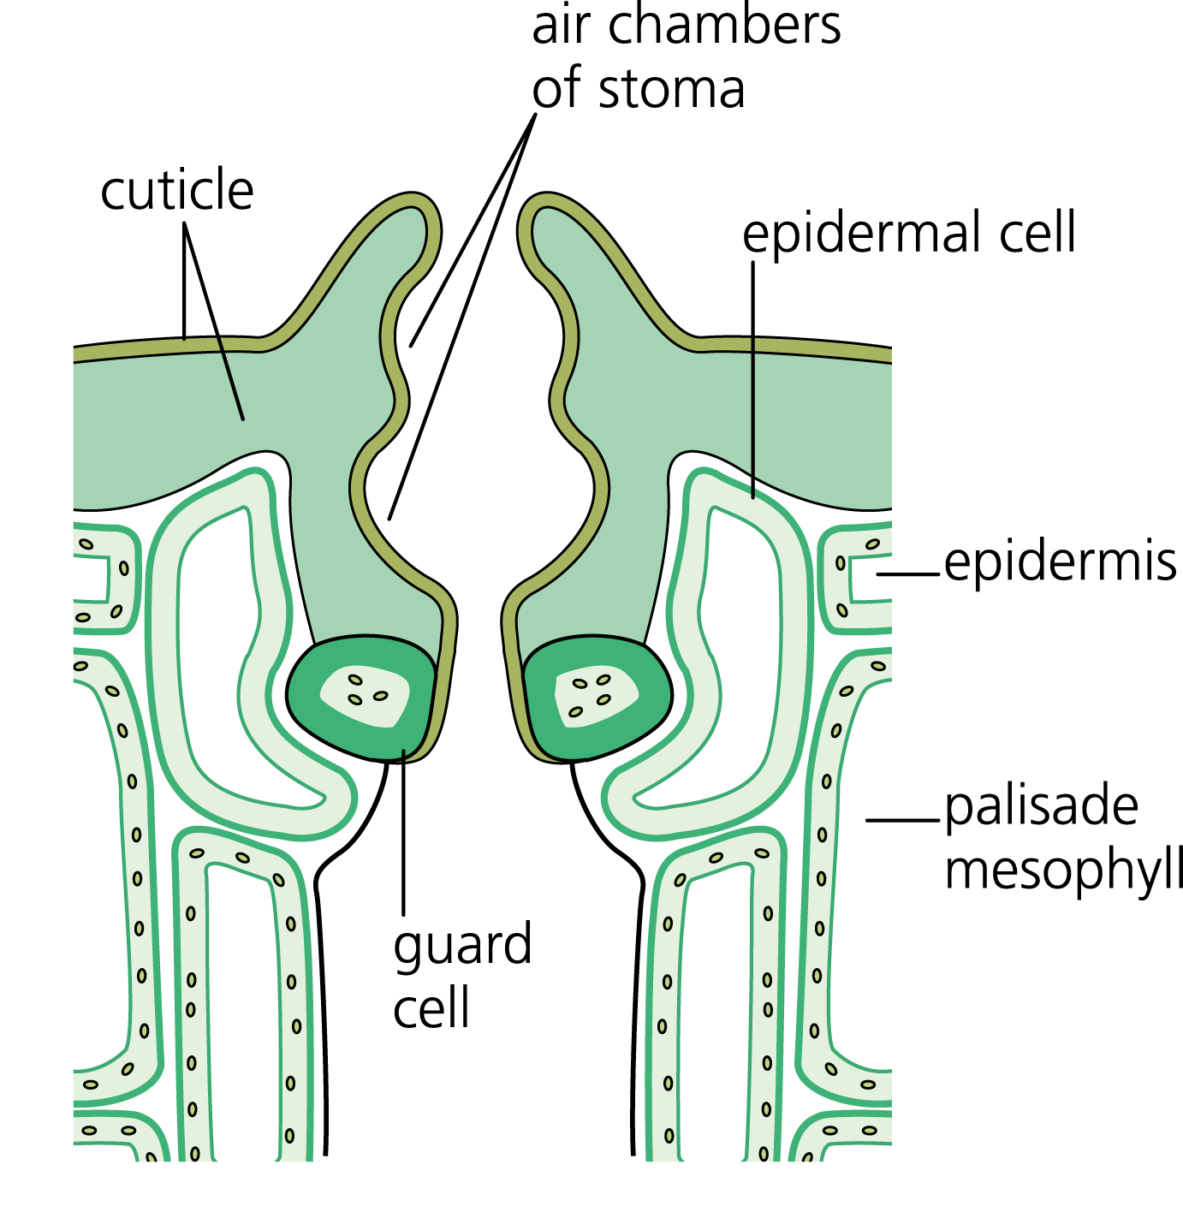

They open at ________ rather than during the ______ to reduce water loss.
The _____ absorbed is then ______ for use during the day when the plant is _____________ .

NB – when describing xerophytic adaptations think about SA:vol ratio, diffusion, evaporation, water potential and water potential gradients, increasing diffusion pathway etc.

