Haemoglobin
Haemoglobin is a protein making up 95% of the dry mass of a red blood cell.
It is the means of transport of oxygen around the body.
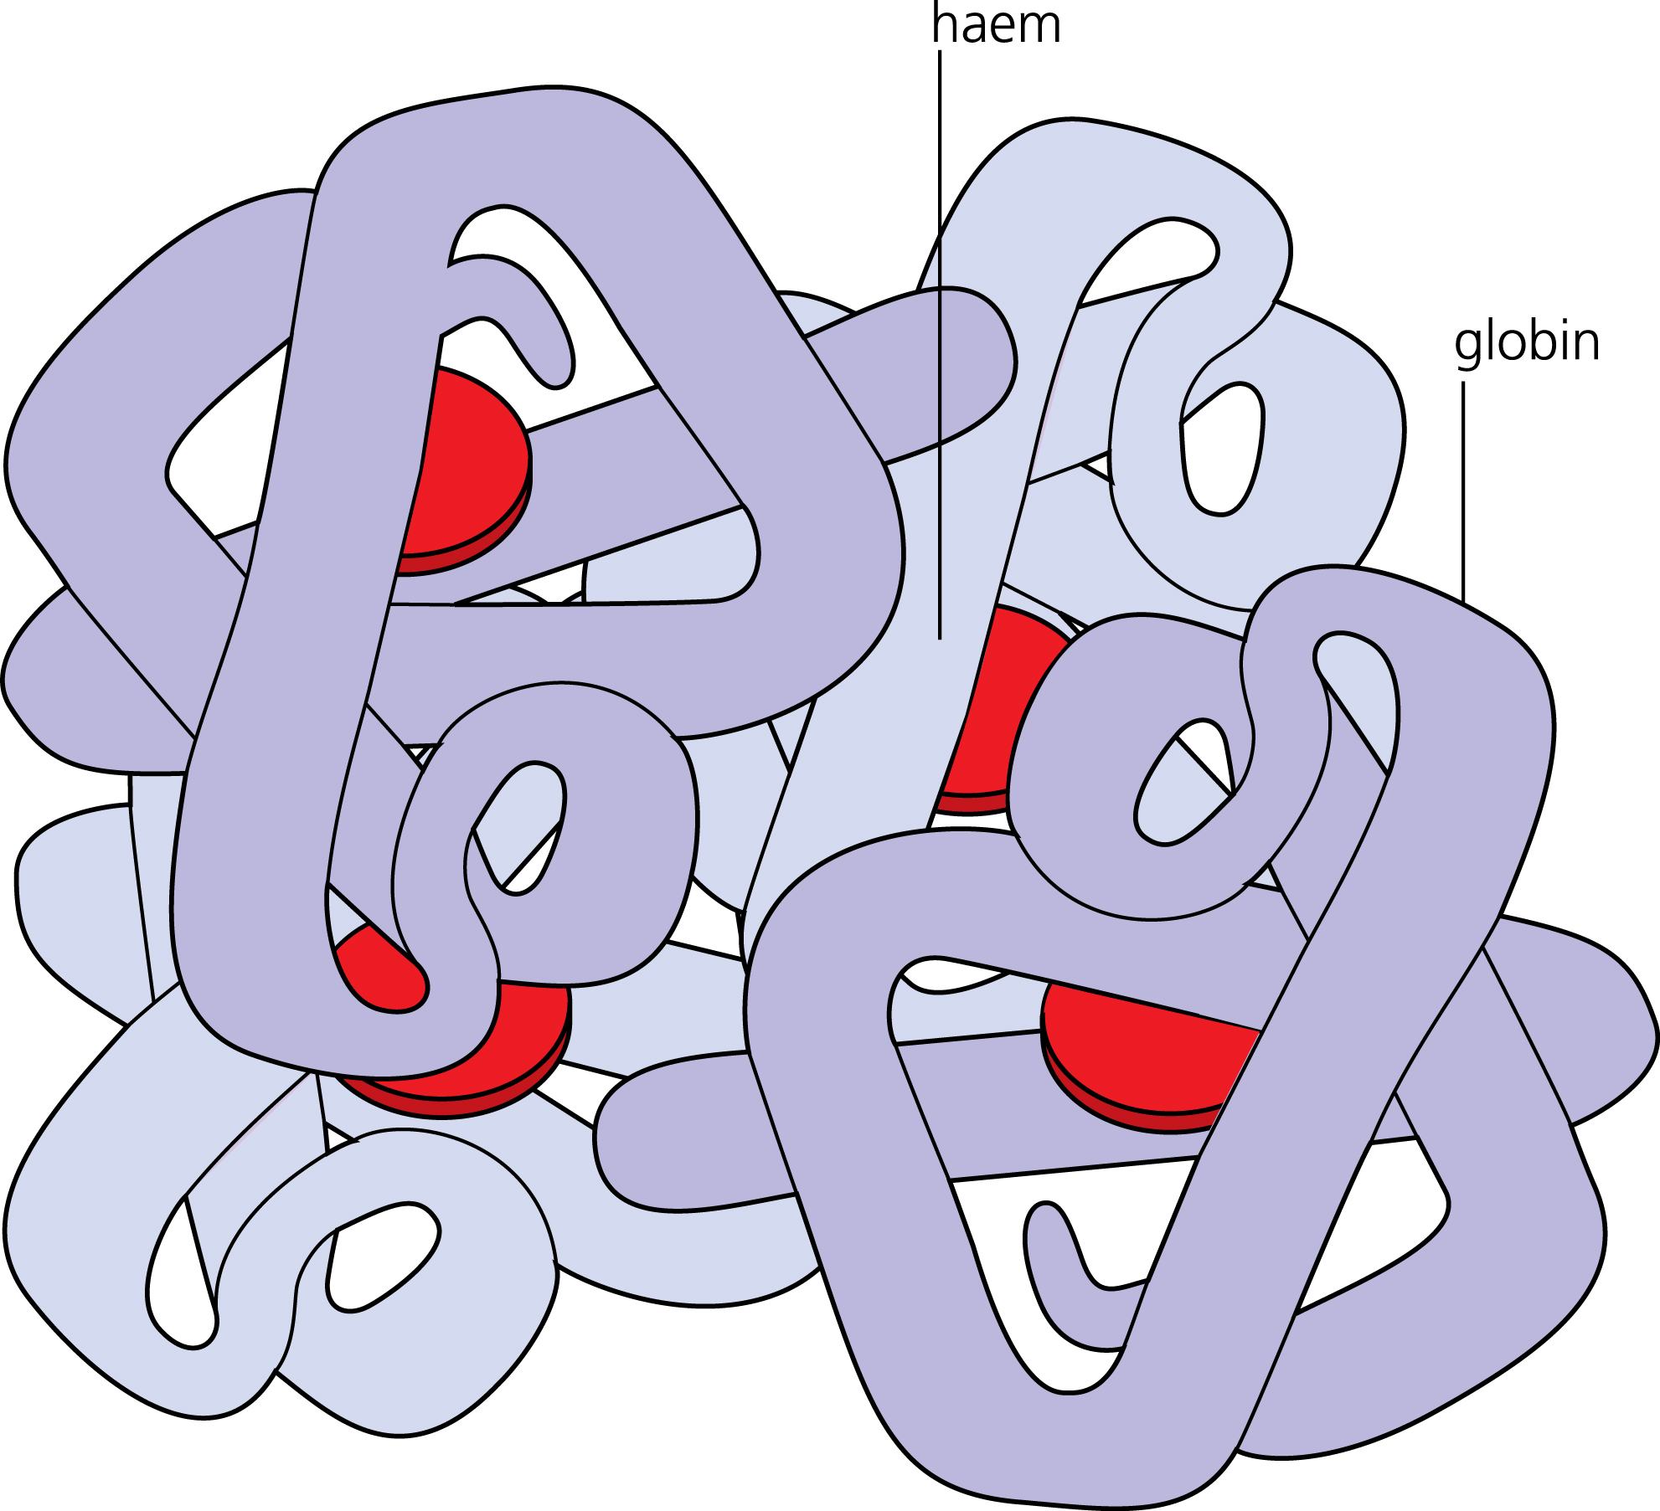
Haemoglobin is made up of four polypeptide chains,
each bound to one haem group.
Each haem group can combine with one oxygen molecule,
so that one molecule of haemoglobin can combine with a
maximum of four oxygen molecules.
This forms oxyhaemoglobin.

Oxygen Concentration
Oxygen binds to haemoglobin when oxygen is at a high concentration, and dissociates from haemoglobin when oxygen is at a low concentration.
The concentration of a gas in a mixture of gases can be quantified in terms of its partial pressure. This is the amount of pressure exerted by the gas relative to the total pressure exerted by all the gases in the mixture.
Partial pressure is measured in kilopascals (kPa) and is written as p(O2), p(CO2), etc.

The Oxygen Dissociation Curve
The oxygen dissociation curve is a graph that shows the percent saturation of haemoglobin at various partial pressures of oxygen.
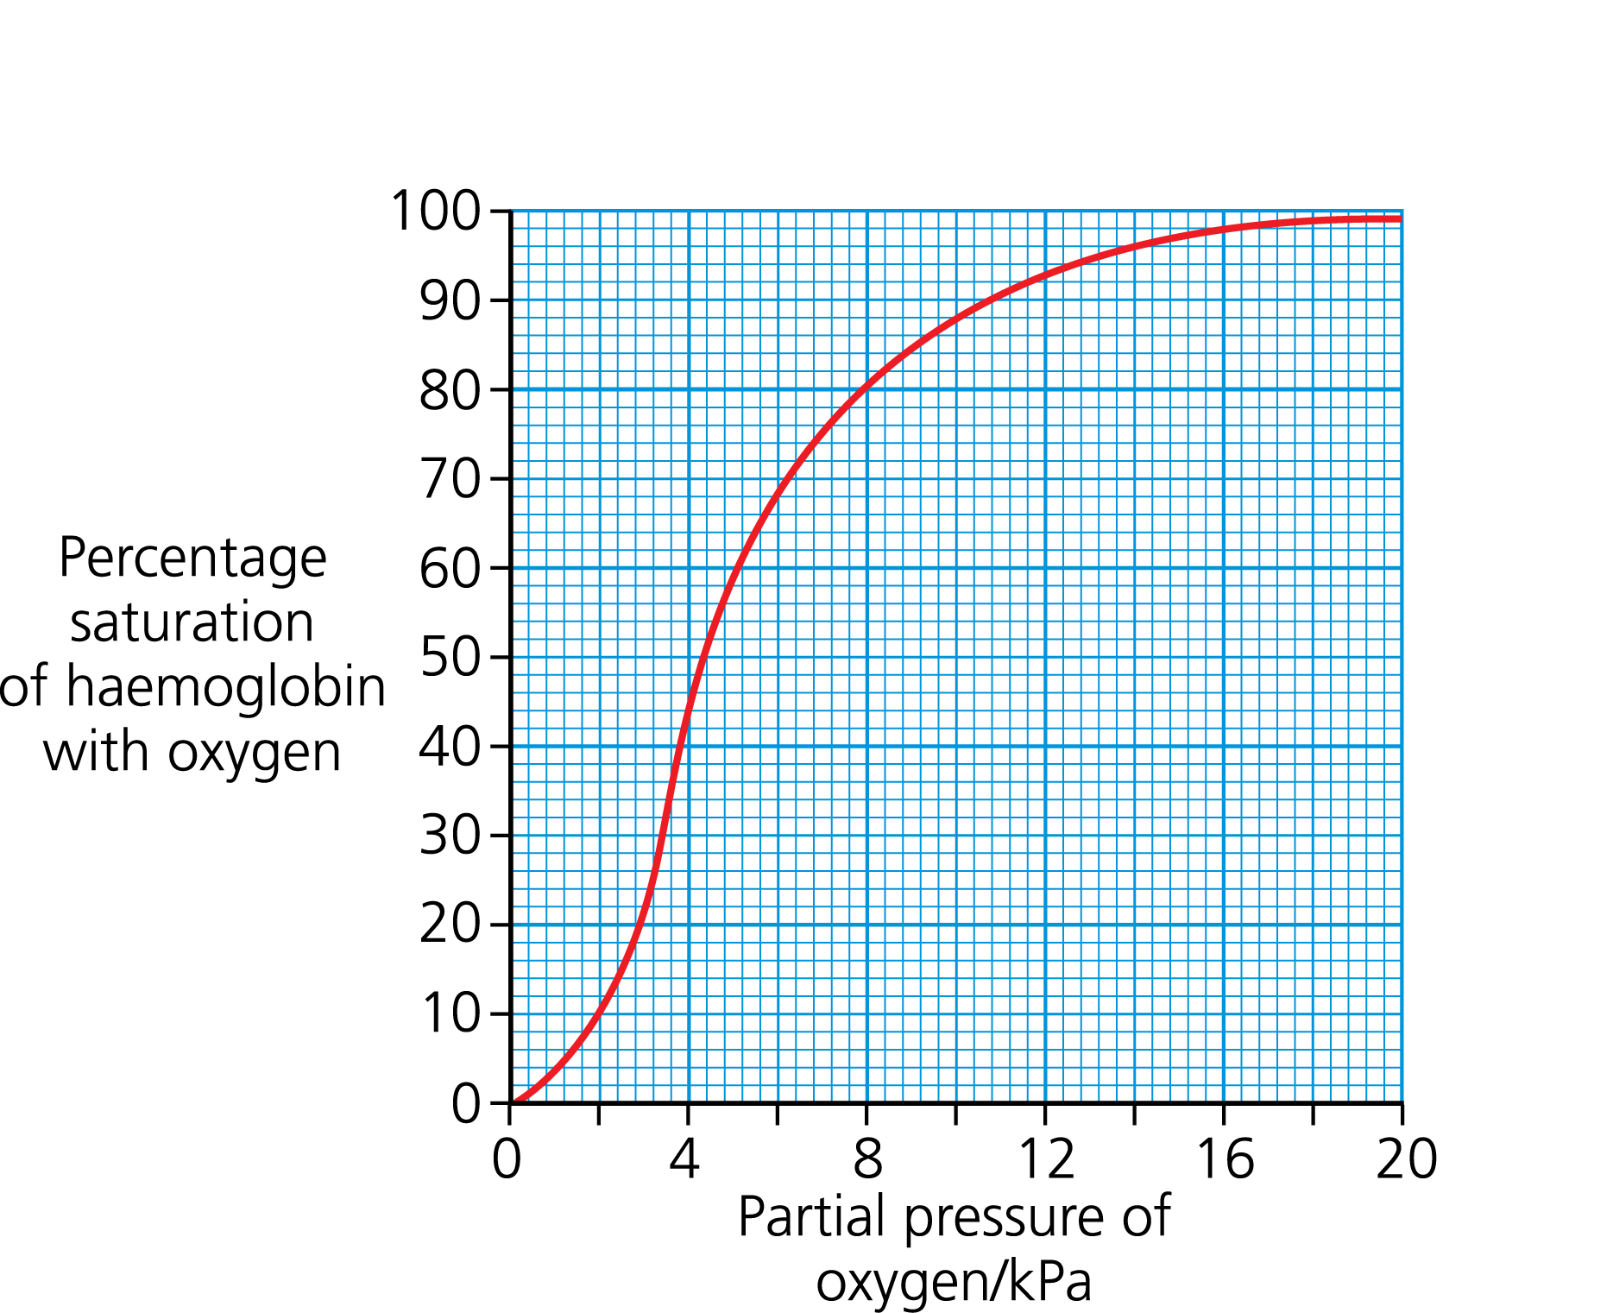

At low partial pressures (of oxygen),
the ratio of oxyhaemoglobin to haemoglobin
is correspondingly low.
Most haemoglobin molecules will only take
up one oxygen molecule, or none at all.

Once a haemoglobin molecule has picked up one
oxygen molecule, its oxygen affinity increases.
A small increase in oxygen availability thus leads
to a large increase in saturation, and (the gradient
of) the graph gets steeper.

Once a high enough saturation is reached, some
molecules will be unable to take on any more oxygen.
Further rises in partial pressure thus make less
difference to the saturation, and the graph levels out.

In the lungs, the oxygen partial pressure is high,
so most haemoglobin becomes saturated with oxygen.
The normal range of partial pressure in the lungs is

between 12 and 14 kPa.

In metabolising tissues, the oxygen partial pressure is
much lower (approx 4-6kPa due to the use of O₂ in
respiration) so the oxygen saturation of haemoglobin
drops dramatically, releasing oxygen to the tissues.
The result is the transport of oxygen from the lungs to
the tissues.
Factors Affecting Oxygen Dissociation

The Bohr Shift
The oxygen affinity of haemoglobin depends not only on its saturation, but also on physical and chemical factors such as temperature and pH.

An increase in CO₂ in a tissue, such as during exercise, lowers its pH.
This lowers the oxygen affinity over all partial pressures, leading to increased release of oxygen (at the same partial pressure of oxygen). This is known as the Bohr shift.
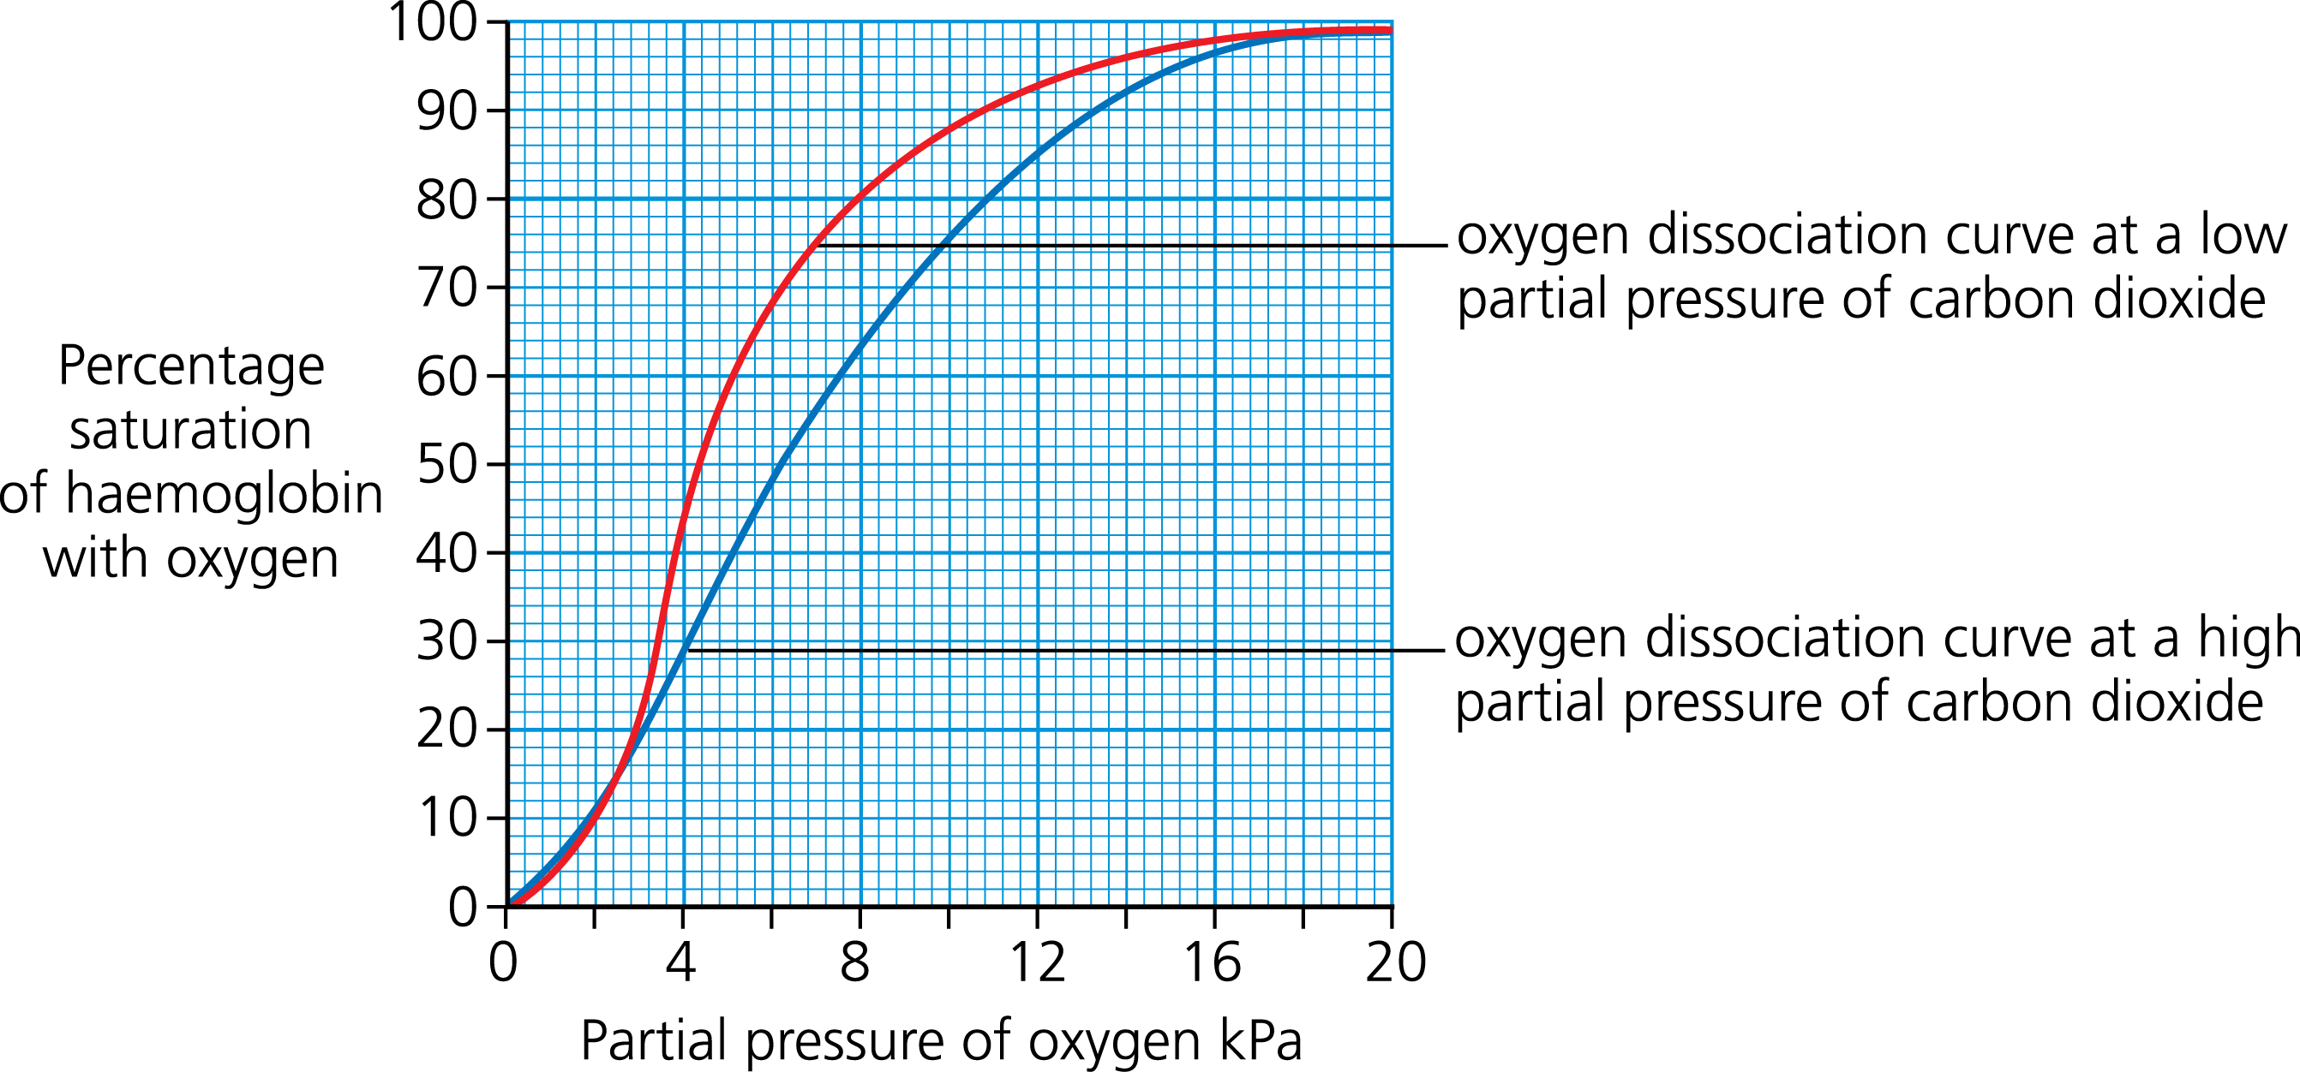

Temperature
A decrease in temperature increases haemoglobin’s oxygen affinity slightly. This means that hypothermia reduces the blood’s ability to release oxygen into metabolising tissue.

More significantly, an increase in temperature shifts the curve to the right (similar to above).
This means that rapidly respiring tissues, which release increased heat energy, will be supplied with more oxygen at the same partial pressure of oxygen.

Other Respiratory Pigments
Foetal haemoglobin
The red blood cells in the foetal bloodstream contain a special form of haemoglobin known as foetal haemoglobin.
Foetal haemoglobin has a higher affinity for oxygen than adult haemoglobin.
This helps maximise oxygen uptake from the mother’s blood stream, which has already lost some of its oxygen by the time it reaches the placenta.
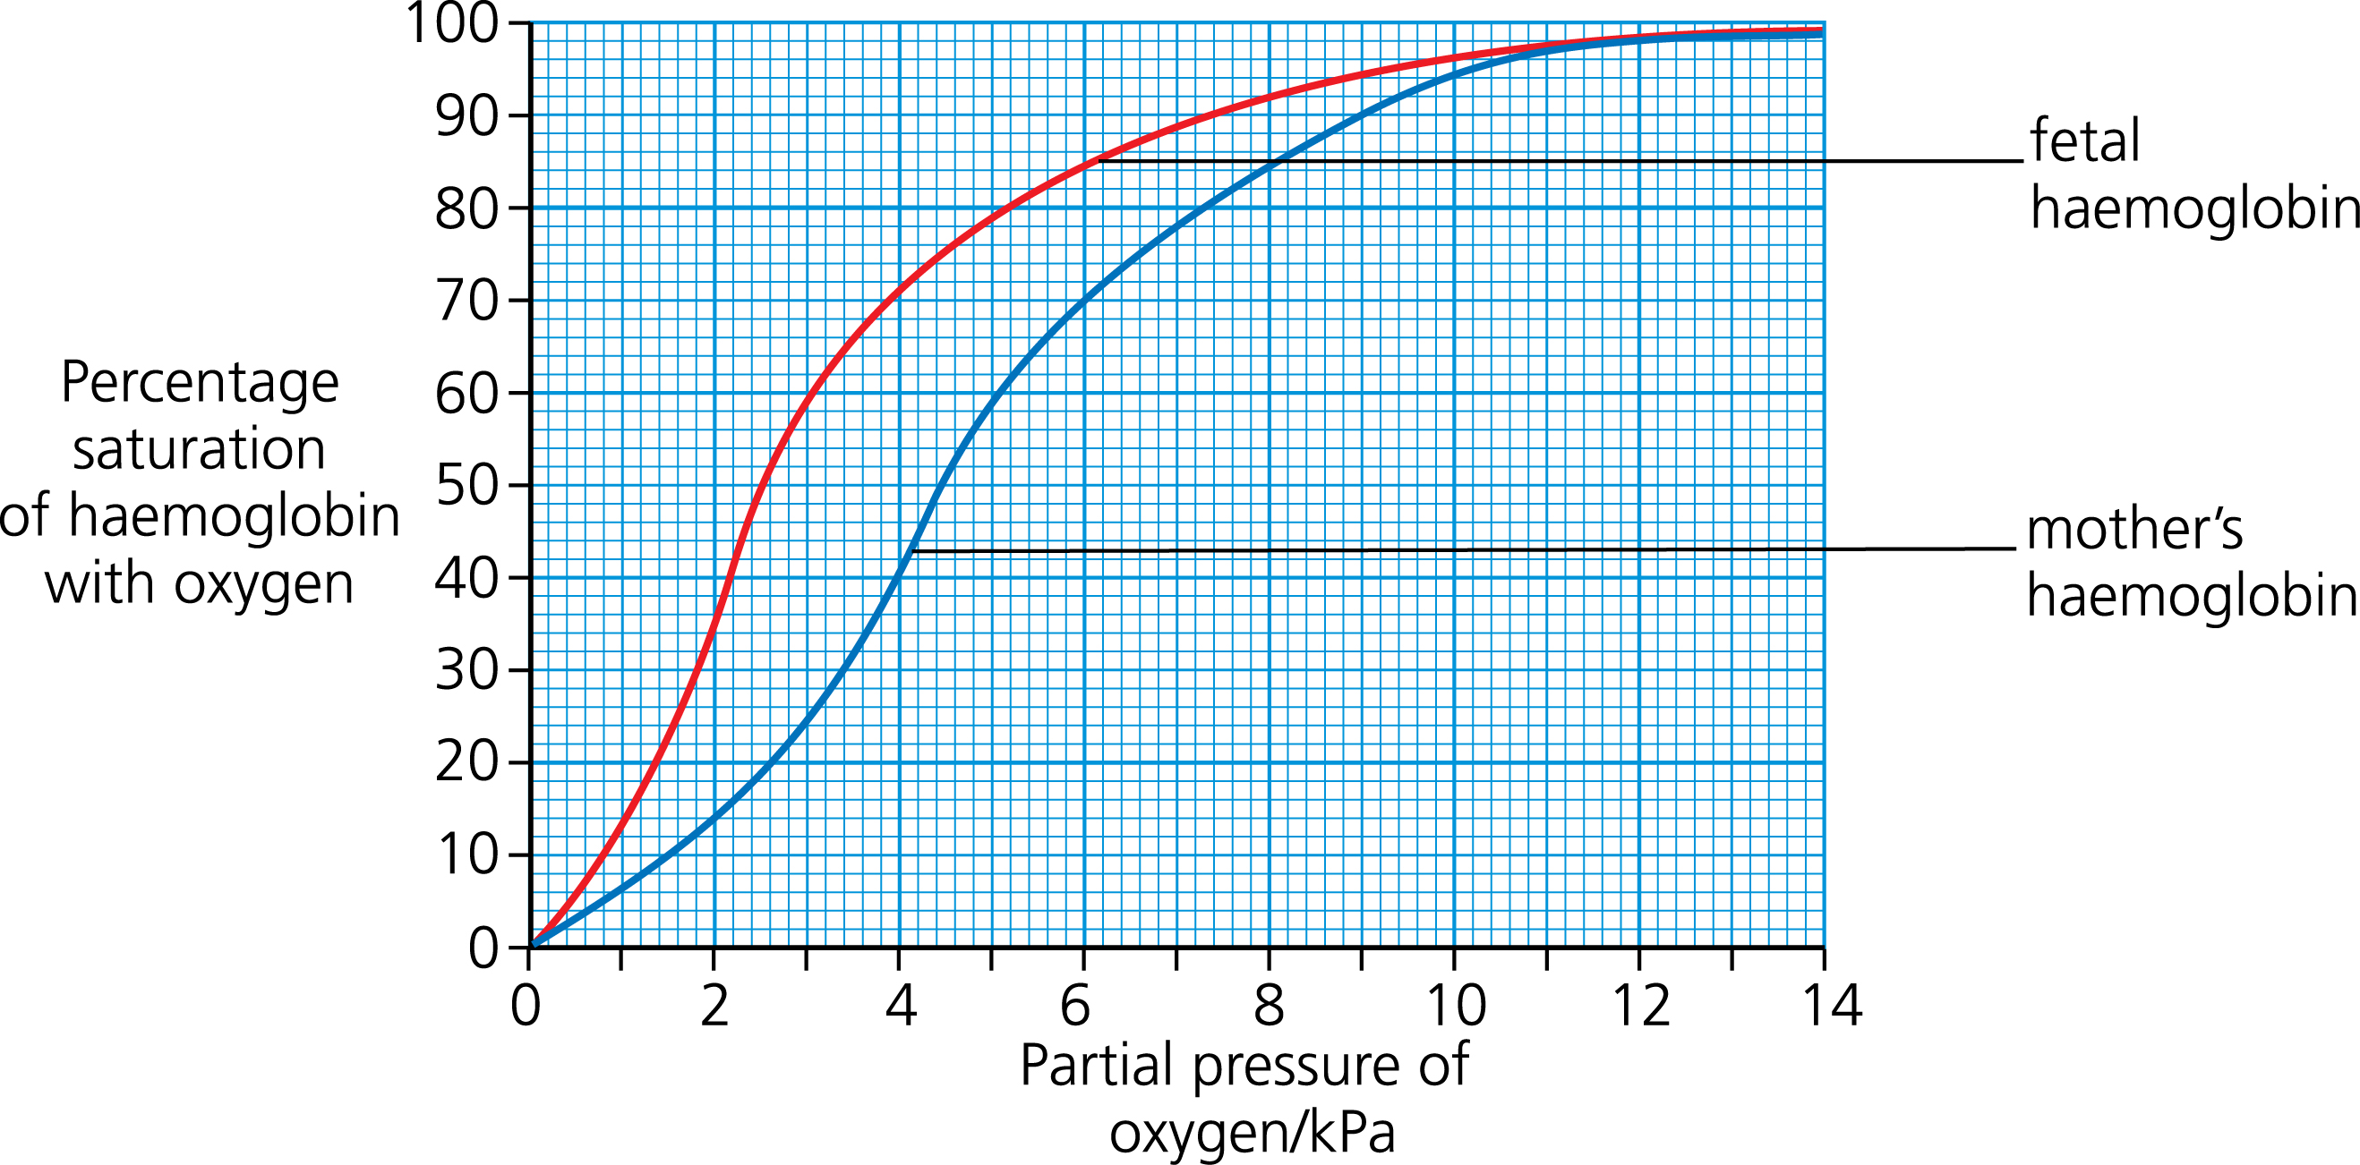

Myoglobin
Myoglobin is a molecule with a similar structure to haemoglobin, but with only one haem group.
Myoglobin has a very high affinity for oxygen, even at very low partial pressures.
This means oxymyoglobin will only dissociate when oxygen levels are very low.
It is found in muscle cells, where it acts as an oxygen reserve.
Myoglobin

Haemoglobin

Myoglobin and similar molecules are often used by organisms which live in low oxygen environments, such as sludge worms, to allow them to extract oxygen even from the relatively oxygen-poor medium. As shown above the pigment would be almost saturated at 4kPa.

