An Introduction to the
L98A2 General Purpose Rifle

Parts of the L98A2
Normal Safety Precautions (NSPs)
In the low Port Position
- Check the safety catch is on safe (S)

- Tilt the weapon slightly to the right and pull the working parts to the rear, USING YOUR LEFT HAND and apply the holding open catch

- Carry out a 4-point check (chamber/magazine housing/face of the bolt/chamber) and check that the weapon is clear

- Use the bolt release catch, allow the working parts to go forward and forward assist

- Point in a safe direction

- Put the safety catch to fire, operate the trigger taking an aimed shot

- Put the safety catch to safe (S), check sights, do the dust cover up

7 Point Safety Check
Check the following:
- CHAMBER
- MAGAZINE HOUSING
- FACE OF THE BOLT
- MAGAZINE REMOVED
- CHAMBER
- MAGAZINE HOUSING
- FACE OF THE BOLT

On Picking Up An Unattended Weapon
- Check the safety catch is on safe (S) before picking up rifle

- Open the ammunition pouch (if magazine fitted)

- Remove the magazine (if fitted) & place it into the open ammunition pouch

- Close the ammunition pouch

- Tilt the weapon to the right and pull the working parts to the rear with your left hand and apply the holding open catch

- Carry out a 7-point safety check

- Operate the bolt release catch allow the working parts to go forward, forward assist

- Put the safety catch to fire

- Fire an aimed shot

- Put the safety catch to safe (S), push the sights down & close the dust cover

Handing Over a Weapon
In the low Port Position
- Check the safety catch is on safe (S)

- Pull the working parts to the rear and apply the holding open device.

- Carry out a 7-point safety check

- State that the weapon is “clear”

- The person being handed the weapon, must check that the weapon is “clear” and state that the weapon is “clear”

- Completes the full NSP then hand the weapon over

- Receiver carries out their own full NSP

Stripping the Weapon for Normal Daily Cleaning
In the Prone Position
- Check the safety catch is on safe

- Pull the working parts to the rear and apply the holding open device.

- Carry out a 3-point check

- Allow the working parts to go forward, forward assist, DO NOT FIRE THE WEAPON

THEN IN THE SITTING OR KNEELING POSITION

- Ensure the weapon is horizontal, but upside down. Pull the rear TMH pin out fully, then push it back in till it clicks once,

- Pull out the front TMH pin until it stops

- Lift off the TMH, placing the right hand on the butt, covering the recoil rod assembly to prevent accidents

- Pull out the rear TMH pin until it stops, using a cupped right hand, remove the recoil rod assembly, pull the bolt carrying assembly to rear with cocking handle then remove handle then remove bolt carrying assembly

- Open the top cover, grip the gas cylinder and push the piston against the spring, disengage from the cylinder and withdraw it from weapon at a slight angle

- Remove the gas cylinder by sliding it off from the gas plug

- Remove gas plug by depressing the plunger and withdrawing out through the gas block with the plunger in the 3 or 9 o’clock position, be sure not to turn 90˚ while removing

L98A2 Rifle Stripped
Assembling the Weapon
In the Seated Position
- Visually check the barrel is clear and that the bolt carrying assembly operates correctly and that the firing pin protrudes 6-8mm

- Push the gas plug through the gas block, with the plunger in the 3 or 9 o’clock position, Ensure the plunger is not in the 12 or 6 o’clock position. Rotate plug to the “N” normal position (9 o’clock)

- Replace the gas cylinder and gas piston in reverse to stripping

- Close the top cover

- Replace the bolt carrier and cocking handle

- Hold the recoil rod assembly under pressure and then push the rear TMH pin in to the first click

- Replace the TMH and push in the front TMH pin and then the rear TMH pin until they stop

Function Test
In the Prone Position
- Check the safety catch is at safe (S)

- Pull the working parts to the rear allowing the working parts to go forward and forward assist

- With the safety catch at safe operate the trigger, It should not fire

- Put the safety to fire (F) and operate the trigger, the weapon should fire. DO NOT RELEASE THE TRIGGER.

- Whilst holding the trigger back, cock the rifle, forward assist and then release the trigger. You should then hear a loud click this is the safety sear. If no loud click inform your instructor immediately

- Operate the trigger and the weapon should fire

- Set the safety catch to safe (S) and close the dust cover

THE COMMANDS
Load
In the Prone Position
- Check the safety catch is on safe (S)

- Open the ammunition pouch

- Remove a magazine from the pouch, check the top rounds are seated correctly and fit the magazine into the weapon, pushing the magazine up into the weapon and listening for an audible “click”, pull down to check that the magazine is securely fitted

- Close the ammunition pouch

- Place the left hand back onto the hand guard and await further orders

Ready
In the Prone Position
- Check the safety catch is on safe (S)

- Raise the sights and check they are set to the correct setting – small aperture (hole)

- Pull the working parts to the rear and forward assist

- Await further orders

Unload
In the Prone Position
- Check the safety catch is on safe (S)
- Open the ammunition pouch
- Remove the magazine, placing it into the open ammunition pouch
- Close the ammunition pouch
- Pull the working parts to the rear and apply the holding open catch
- Carry out a 7-point check
- Operate the bolt release catch, forward assist
- Put the safety catch to fire (F)
- Operate the trigger taking a well aimed shot
- Put the safety catch to safe, put sights down and close the dust cover
- Pick up any ejected round and clean it
- Open the ammunition pouch
- Remove the magazine, place the ejected round into it
- Return the magazine to the ammunition pouch and close it

Make Safe – (Full unload followed by load)
In the Prone Position
- Check the safety catch is at safe (S)
- Open the ammunition pouch
- Remove the magazine and place the magazine back in the pouch
- Pull the working parts to the rear and apply the holding open catch
- Carry out a 7-point safety check
- Operate the bolt release catch, forward assist
- Put the safety catch to fire (F), operate the trigger taking an aimed shot
- Put the safety catch back to safe (S), check sights are down (large aperture) and close the dust cover
- Pick up the ejected round and clean it
- Remove the magazine from the ammunition pouch and place the ejected round back in to it
- Return magazine back into ammunition pouch
- Check safety and place a fresh magazine on to the rifle, checking the top round and making sure that it is securely fitted
- Close the ammunition pouch
- Place the left hand back onto the hand guard and await further orders

Stoppage Drills
IMMEDIATE ACTION
“Rifle fails to fire”
In the prone position
- Push the safety catch to safe (S)
- Tilt weapon to the left and observe the position of cocking handle

A: “Cocking Handle Appears To Be Fully Forward”
- Forward assist and carry on firing
- If “weapon still fails to fire”
- Push the safety catch to safe (S)
- Tilt weapon to the right and pull the working parts to the rear, apply the holding open catch
- Look inside weapon for further action

Loose Magazine
“Rounds in the magazine, but no rounds in the chamber clear”
- Push the magazine into the weapon until you hear an audible “click”
- Operate the bolt release catch, forward assist
- Put the safety catch to fire (F) and resume firing

B. “Cocking handle not fully forward, obstruction”
Obstruction
- Remove the magazine
- Tilt the weapon to the right and shake it until the weapon is clear
- Visually check inside, to ensure the chamber is completely clear of all obstructions
- Refit the magazine securely
- Operate the bolt release catch, forward assist
- Put the safety catch to fire (F) and resume firing

- DO NOT USE DAMAGED ROUNDS GIVE THEM TO A RESPONSABLE ADULT AT THE END OF THE EXERCISE/ACTIVITY

C. “Cocking handle fully to the Rear”
Empty Magazine
“No rounds in the magazine and no rounds in the chamber”

- Put the safety catch to safe
- Open the ammunition pouch
- Remove the empty magazine from the weapon, place it in the ammunition pouch
- Remove a new magazine from the pouch, check the top round is seated correctly and fit the magazine to the weapon, checking that it is secure
- Close the ammunition pouch
- Operate the bolt release catch, forward assist
- Put the safety catch to fire (F) and resume firing

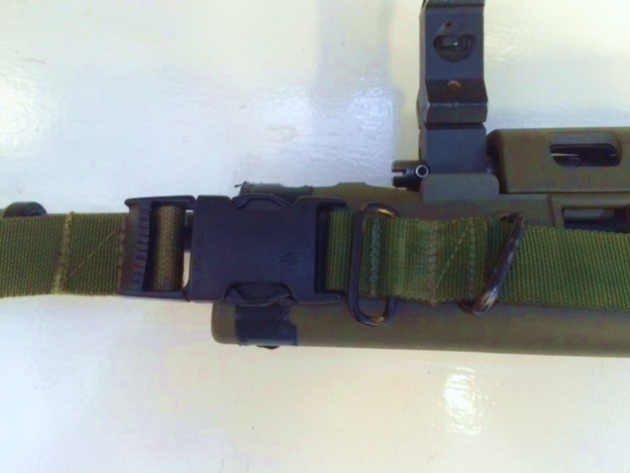
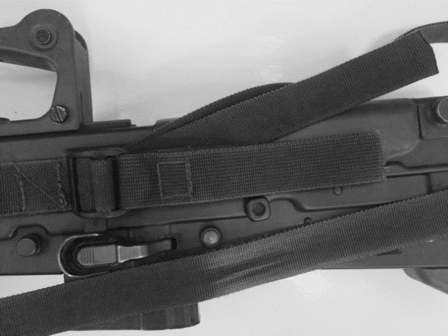
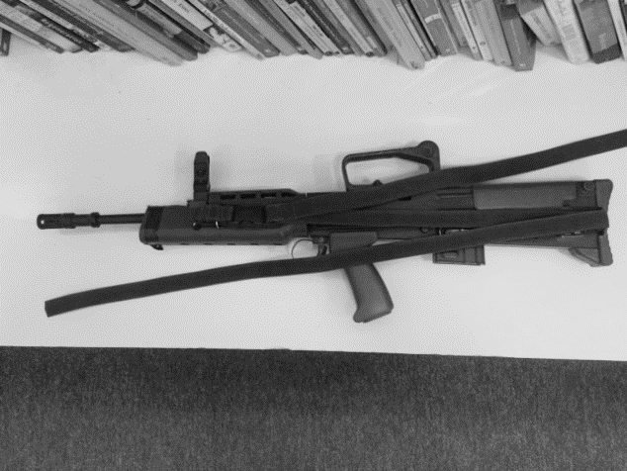
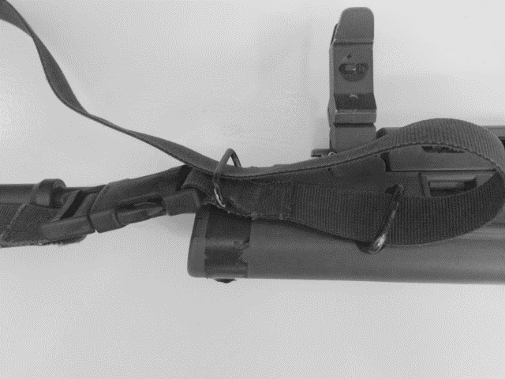
Sling Fitting
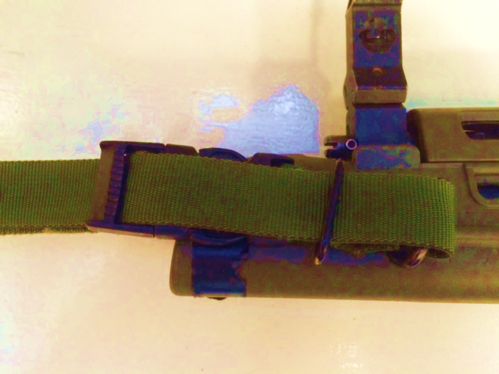
(Photos in chronological order)

