END OF YEAR PROJECT Y7-Y9
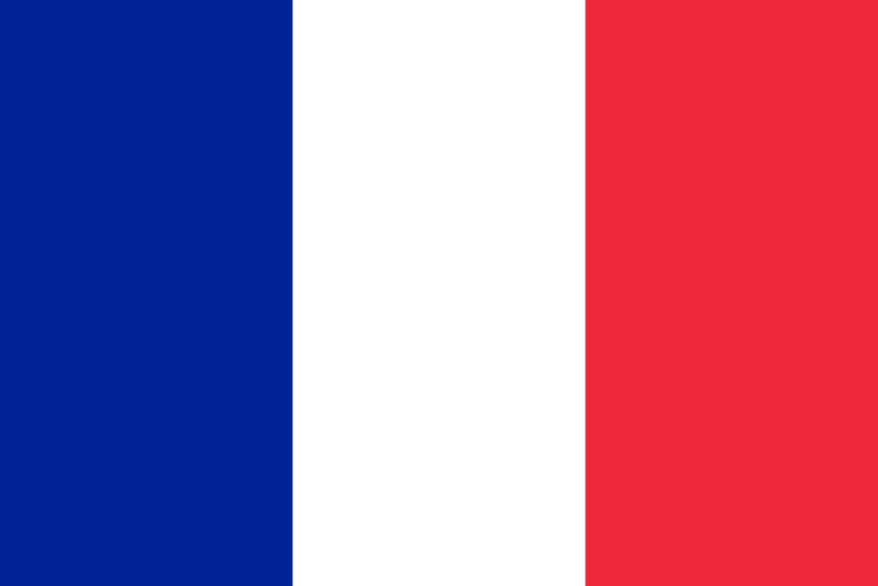
Requirements for French Speaking Country Project (Power point)

- Name of country:

- Location:
Continent, neighboring countries, bodies of water (oceans, seas, rivers, lakes), mountain ranges, etc.

- Population of Country:

- Languages:

- Currency and equivalent in £

- Largest Cities (different from the capital):

- Capital City:

- Climate:

- Flora (plants) and Fauna (animals):

- Economy:
Jobs, major companies, income, currency

- Way of Life:
Customs, Traditions, Celebrations, Sports, Games, Activities, Festivals, typical dances, songs, musical instruments.

- Gastronomy: food, diet, eating customs.

- Tourism: places to visit and why, add pictures and explain why it’s such a good place to visit.

- Brief Background/History:
When did it become independent?
Other important events
Kind of government…
- Main Religions:

- Famous People:
Alive or Dead (detailed information)

- Miscellaneous Information:

Picture of flag:

Belgium
Benin
Burkina
Burundi
Cameroon
Canada
Central African Republic
Chad
Comoros
Congo
Congo, Democratic Republic of
Cote d'Ivoire
Djibouti
France
Gabon
Guinea
Haiti
Luxembourg
Madagascar
Mali
Monaco
Niger
Rwanda
Senegal
Seychelles
Switzerland
Togo
Vanuatu
Vietnam

EVERYTHING MUST BE WRITTEN IN FRENCH!

