Mitochondria

Mitochondria are situated in all living plant and animal cells.
Mitochondria are the site of aerobic respiration.

Mitochondria have two phospholipids members,

- The outer that surrounds the entire organelle,
- The inner is a highly folded membrane

The central fluid filled space is called the matrix. Inside the matrix are free enzymes that catalyse reactions in some for the stages of respiration which ones?

The highly folded inner membrane causes cristae this means the membrane has a large internal surface area.

Also the membrane holds many enzymes which are used in the final stages of respiration, such as ATP production needing oxygen (oxidative phosphorylation). aka?
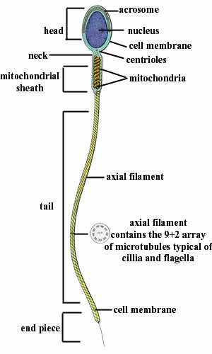
Mitochondria are also helpful during sexual reproduction as the sperm contain many mitochondria to produce ATP to power themselves to fertilise the egg.

They are also involved in cells that use active transport to provide the ATP required via aerobic respiration.

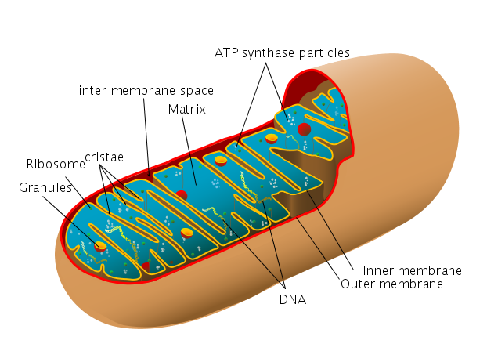

Chloroplasts

They are flattened discs 3-10µm in diameter bounded by two membranes.
They are found in the green parts of a plant which is mainly the leaves and the young stem.

Chloroplasts main function is to make the sugars that form the basis of all carbohydrates by photosynthesis.

Like mitochondria the chloroplasts have two bilyered phospholipids membranes.

- The outer surrounds the organelle
- The inner membrane is highly folded.

The folds create thylakoids and in between them is a fluid called stroma

In areas of the chloroplasts thylakoids are grouped together in structures called grana, which look to the eye like as a pile of green coins

These thylakoids contain chlorophyll molecules. These molecules collect the sunlight’s energy.

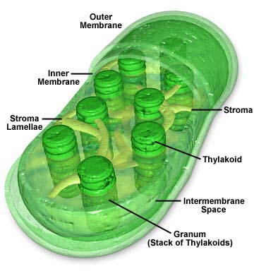
The piles of thylakoids (grana) are where the first stage of photosynthesis occurs. Called? What happens in the stroma?

