Resting and Action Potential

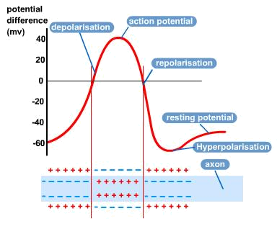
In the cell membrane of an axon, there are protein carriers, which actively pump Na⁺ ions out of the cytoplasm and out of the cell, and pump in K⁺ into the cell. This action requires energy from ATP as it is transporting ions against a concentration gradient. For every 3Na⁺ pumped out, 2K⁺ are pumped in, resulting in a net movement of positive ions out, making the inside of the cell negatively charged, relative to the outside. This is called Resting Potential

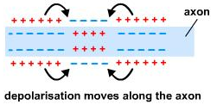
When a receptor is stimulated it will create a positive environment inside the cell. Protein channels allow Na⁺ to flood into the cytoplasm down the concentration gradient by facilitated diffusion. As this is happening the membrane is being depolarized, i.e. the resting potential starts to decrease. If the depolarization reaches a high enough point, the threshold level is reached and an Action Potential has been generated and the impulse will be carried on, however if this threshold is not reached, the impulse will stop.
Once depolarization is complete, the Na⁺ channels close and the Na⁺/K⁺ protein pumps start again. The cytoplasm is repolarised and the environment is negative again. There is a period of time after depolarization where the neurone cannot be depolarized again, and this is called a refractory period, this also helps to keep the system one-way.

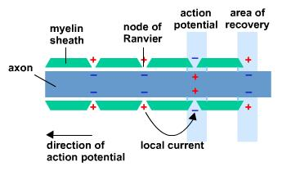
Generally, animal nerve cells are covered in a fatty myelin sheath and so the positive ions cannot flow in and out of the cytoplasm. There are spaces down the cell called nodes of Ranvier and because of these; the action potential will jump from one node to the next. This process is called Saltatory Conduction and is a faster method than unmyelinated.

