The Eye

Basic Structure and Function

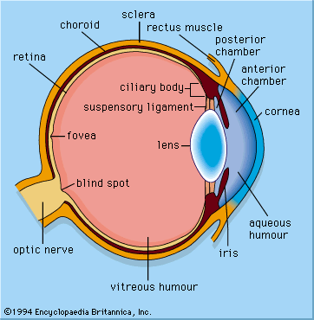
Conjunctiva

Conjunctiva - protects the front surface of the eye, e.g. from dirt.
Cornea - the transparent window at the front of the eye that refracts light as it enters.
Sclera - tough, white outer coat of the eye, contains many collagen fibres, and is curved to focus light (contains cornea at the front of the eye).
Iris - controls the amount of light entering the eye by varying the pupil size. Consists of involuntary muscles.
Lens - adjusts the focusing of the eye for near and distant vision (divides the eye into 2 chambers).
Ciliary Muscle/Body and Suspensory Ligaments - they alter the shape of the lens to focus on near and distant objects.
Aqueous Humour - a clear liquid in front of the lens. Exerts pressure on the wall of the eyeball, important in the role of the focussing mechanism, keeps shape of retina smooth.
Vitreous Humour - a transparent jelly behind the lens. Also exerts pressure on the wall of the eyeball.
Blind Spot - Where the optic nerve leaves the brain (no rods of cones present, hence ‘blind’ spot).
Optic Nerve - Carries nerve impulses to and from the brain.
Fovea - It has a high density of cones, involved in colour vision, has high acuity.
Retina - Contains all light sensitive cells (rods and cones).
Choroid - Contains the blood supply to the eye.
Eye Muscles (as labelled “Rectus Muscle”) - Control the movement of the eye.

Muscles Involved in the Eye

The amount of light that enters the eye is controlled by the muscles in the iris. These muscles are called circular and radial muscles. This changes the size of the pupil and is controlled by a reflex arc, with the light receptors in this arc located in the retina. In bright light the circular muscles contract, and the radial muscles are relaxed, causing a reduction in size of the pupil. In dim light the radial muscles contract, and the circular muscles are relaxed, this increases the size of the pupil by pulling the edges away from the centre.

When focussing an object onto the eye the light is refracted by the cornea and lens, which focuses the light onto the retina. When looking at a distant object the Ciliary muscles are relaxed and the suspensory ligaments are pulled taut. This causes the lens to become flat and thin.
When focussing on a near object the Ciliary muscles are contracted, and the Suspensory ligaments are slack. This causes the lens to be more spherical/fatter.

The Retina

The retina is the sensory area of the eye. It is covered in photoreceptors called rods and cones, after their shape. The rods and cones connect to bipolar neurones which then connect to ganglion cells. The fibres of the ganglion cells join together to make the optic nerve.

In the outer segment membrane of each rod or cone are embedded photo pigments. Rhodopsin is the pigment found in the rod cells, and iodopsin is the pigment found in the cone cells.

When light hits the rhodopsin it breaks down to retinal and opsin. This is known as bleaching. This causes the rod cell to become more negatively charged inside (hyperpolarisation). Before the rod cell can be stimulated again the retinal and opsin must be recombined into rhodopsin.

For colour vision iodopsin breaks down in the cone cell outer segment membrane. There are three types of iodopsin, each is sensitive to red, green or blue light, and only one type is found in each cone cell. The brain perceives different colours as the relative stimulation of each type of iodopsin. This is the trichromatic theory of colour vision.

Cone cells are found mostly at the fovea, where they are closely packed, although they appear over the whole retina. Rod cells are mostly used in dim light conditions whereas cones are used in high light levels. Each cone cell connects to one bi-polar neurone. This allows the brain to determine exactly where the impulse originated.
Rod cells are grouped several to one ganglion, so the brain is unable to determine where exactly the impulse originated from. Therefore rods have a low visual acuity; cones have a high visual acuity.

