The Brain

The brain is formed from the anterior end of the central nervous system and contains several distinct areas, which are themselves sub-divided. The cerebrum makes up the vast majority of the brain and is the centre of intellect, memory, language and consciousness. It consists of two cerebral hemispheres (left and right), which are connected by a section of white matter called corpus callosum. The white matter gets its name from the lipid sheaths that surround its cells, giving the tissue its white appearance, Each hemisphere controls the opposite side of the brain ie. the functioning of the left side of the body is controlled by the right hemisphere and vice versa. The cerebral hemispheres have an outer cerebral cortex with a high density of cell bodies, which give it a grey colour (grey matter). The cerebral cortex has motor area which control voluntary movement by sending nerve impulses to skeletal muscle, sensory areas which receive and interpret sensory information, and association areas which are responsible for learning, emotions, decision-making and integrating sensory and motor regions.

The Visual Cortex is part of the cerebrum and is found at the rear of the brain. The cortex is present in both cerebral hemispheres so imformation is received from both eyes. The visual cortex “sees” the image whilst the visual association interprets the image. The brain enables us the see a single 3D image and have a perception of distance.

The speech centre is located in the left cerebral hemisphere (95% of the population). Wernicke’s area (nearer the back of the brain) receives impulses from the primary visual cortex and the primary auditory cortex. It acts as the language comprehension area. A bundle of nerve fibres called the arcuate fasciculus link the Wernicke’s area to the Broca’s area (nearer the front of the brain), the area responsible for control of the muscles producing speech.
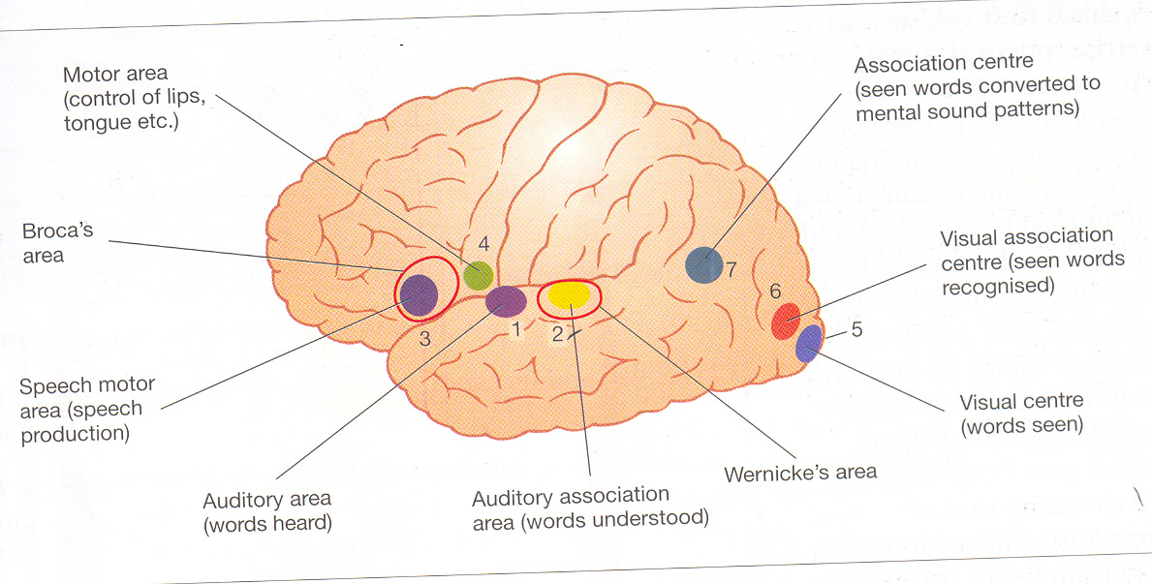

There are a few other important areas of the brain found outside the cerebrum:

Cerebullum- found at the base of the hind-brain, the cerebullum is responsible for smooth, co-ordinated movement, balance, posture and muscle tone. It also regulates emotions such as feelings of anger and pleasure.

Hypothalamus- contains the centres responsible for thermoregulation and fluid balance (osmoregulation). It controls and regulates the autonomous nervous system, thus regulating heart rate, movement of food through the gut by peristalsis and contraction of the urinary bladder. It also released the anti-diuretic hormone.

Medulla oblongata- acts as a relay centre for both sensory and motor impulses between other parts of the brain and the spinal cord. It contains vital and non-vital reflex centres which form part of the autonomic nervous system.

Pituitary body- controls the secretion of hormones which control homeostasis and trophic hormones which stimulate other endocrine glands.

