Classification

Taxonomy: -
Within every classification system there is a hierarchy, which means a larger group is subdivided into subgroups, which in turn is subdivided into smaller groups with no overlap.

The Kingdom of Hierarchy: -
This is the most commonly used taxonomic system in biology and is based on 5 large groups called kingdoms. Members of these kingdoms all share some features, which make them living organisms. This hierarchy comprises phylum, class, order, family, genus and species. Here is a table showing the kingdom hierarchy: -

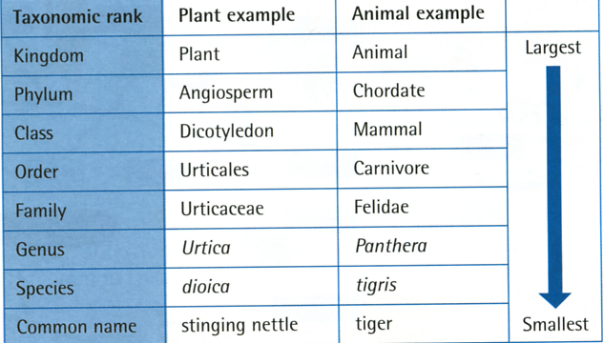

Biological Classification: -
Biological classification is based on phenotypic similarities between organisms. Classification depends upon the number of common features shared by a group of organisms. As selection occurs, some genes remain in the pool and are shared by all organisms; other genes are not common to all pools. Thus classification reflects the changes in organisms due to selection and evolution. Classification based on patterns of evolutionary history places organisms in phenogenetic groups depending on the number of common features.
A common gene pool is shared by all. Over time, groups of organisms became isolated, taking with them some of the genes from the original pool. As each group of organisms evolved to form a new species, some genes were lost and others added to the new gene pool. Over time, more and more species developed, giving rise to a large number of different gene pools.

Naming Organisms: -
Organisms are named using an international convention called the binomial system. The genus name is written first, starting with an upper case letter, followed by the species name, starting with a lower case letter. The binomial is written in italics or underlined if hand-written. Closely related organisms have the same genus name and a different species name.

