|  |  |  |  |
| --- | --- | --- | --- |
| **0** | **1** |  |  |

Use words from the box to complete the sentences.

**displayed alkenes oxides general**

**propane alkanes methane**

The compounds in crude oil are mostly . They have the formula CnH2n2. The compound with the formula CH4 is called . (3 marks)

|  |  |  |  |
| --- | --- | --- | --- |
| **0** | **2** | **.** | **1** |

What is the name of the process that is used to change large molecules into smaller ones?

Tick (✓) **one** box.

fractional distillation

combustion

cracking

reduction (*1 mark*)

|  |  |  |  |
| --- | --- | --- | --- |
| **0** | **2** | **.** | **2** |

High temperatures are needed to change large molecules into smaller ones.

What alternative conditions are needed?

Tick (✓) **two** boxes.

high pressure

a catalyst

steam

hydrogen

oxygen (*2 marks*)

|  |  |  |  |
| --- | --- | --- | --- |
| **0** | **2** | **.** | **3** |

The equation below shows a large molecule being broken into smaller ones.

C10H22 → C5H12  C3H6  C2H4

Which two compounds are alkanes?

Tick (✓) **two** boxes.

C10H22

C5H12

C3H6

C2H4 (*2 marks*)

|  |  |  |  |
| --- | --- | --- | --- |
| **0** | **2** | **.** | **4** |

Suggest why changing large molecules into smaller molecules is useful.

(*2 marks*)

|  |  |  |  |
| --- | --- | --- | --- |
| **0** | **3** |  |  |

The properties of molecules in crude oil depend on their size.

Match the properties of molecules in crude oil with their sizes. Draw **four** lines.

|  |  |  |
| --- | --- | --- |
| **Property** |  | **Size of molecules** |
|  |  |  |
| gases at room temperature |  |  |
|  |  | small molecules |
| high boiling point |  |  |
|  |  |  |
| low viscosity |  |  |
|  |  | large molecules |
| very flammable |  |  |

(3 marks)

|  |  |  |  |
| --- | --- | --- | --- |
| **0** | **4** |  |  |

A student measured the boiling points of some alkanes. **Table 1** shows his results.

**Table 1**

|  |  |  |
| --- | --- | --- |
| Name | Formula | Boiling point in°C |
|  | C4H10 | 0 |
| pentane | C5H12 | 36 |
| hexane | C6H14 | 69 |
| heptane | C7H16 |  |
| octane |  | 126 |
| nonane | C9H20 | 151 |
| decane | C10H22 | 174 |

|  |  |  |  |
| --- | --- | --- | --- |
| **0** | **4** | **.** | **1** |

What measuring instrument did the student use?

(*1 mark*)

|  |  |  |  |
| --- | --- | --- | --- |
| **0** | **4** | **.** | **2** |

The alkanes belong to a homologous series.

Name the hydrocarbon with the formula C4H10.

(*1 mark*)

|  |  |  |  |
| --- | --- | --- | --- |
| **0** | **4** | **.** | **3** |

Octane has eight carbon atoms.

Give the formula of the hydrocarbon named octane.

(*1 mark*)

|  |  |  |  |
| --- | --- | --- | --- |
| **0** | **4** | **.** | **4** |

Draw the **displayed** formula for pentane, C5H12. (1 mark)

|  |  |  |  |
| --- | --- | --- | --- |
| **0** | **4** | **.** | **5** |

The student plotted a graph of the results (**Figure 1**).

**Figure 1**

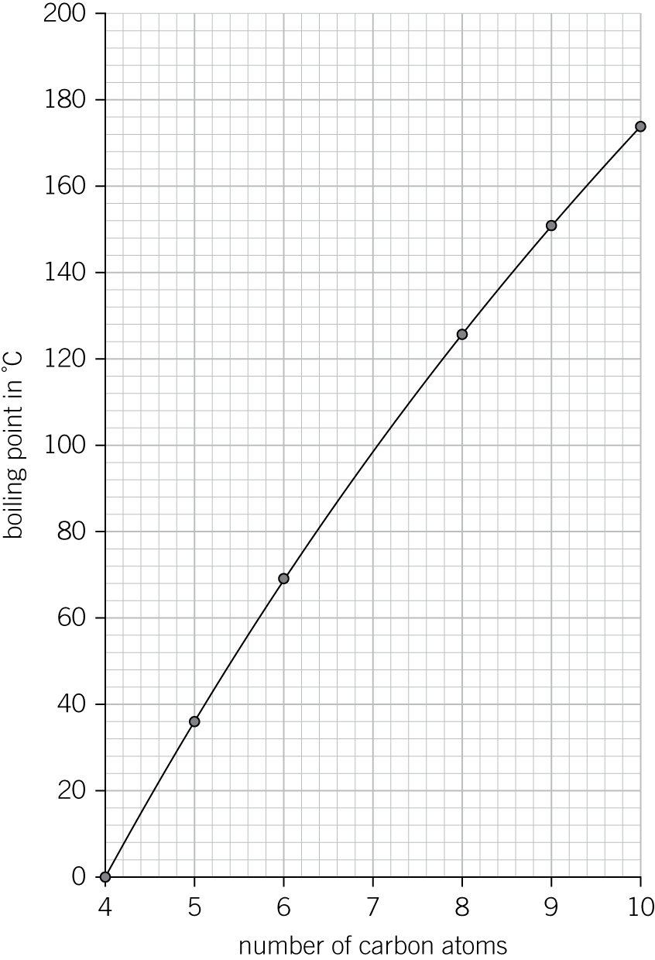

Use the **graph** to estimate the boiling point of heptane, C7H16.

°C (*1 mark*)

|  |  |  |  |
| --- | --- | --- | --- |
| **0** | **4** | **.** | **6** |

Use **Table 1** to estimate an approximate boiling point of propane, C3H8.

°C (*1 mark*)

|  |  |  |  |
| --- | --- | --- | --- |
| **0** | **4** | **.** | **7** |

Describe **and** explain how the boiling point of alkanes changes with number of carbon atoms.

(*2 marks*)

|  |  |  |  |
| --- | --- | --- | --- |
| **0** | **5** |  |  |

Crude oil is a mixture of many different chemical compounds.

|  |  |  |  |
| --- | --- | --- | --- |
| **0** | **5** | **.** | **1** |

Fuels, such as petrol (gasoline), can be produced from crude oil.

Fuels react with oxygen to transfer energy to the surroundings.

Name the type of reaction that releases energy from a fuel.

(*1 mark*)

|  |  |  |  |
| --- | --- | --- | --- |
| **0** | **5** | **.** | **2** |

Fuels react with oxygen to produce carbon dioxide.

The reaction of a fuel with oxygen can also produce a different oxide of carbon.

Name this different oxide of carbon and explain why it is produced.

(*2 marks*)

|  |  |  |  |
| --- | --- | --- | --- |
| **0** | **5** | **.** | **3** |

Most of the compounds in crude oil are hydrocarbons.

Hydrocarbons with the smallest molecules are very volatile.

**Figure 2**

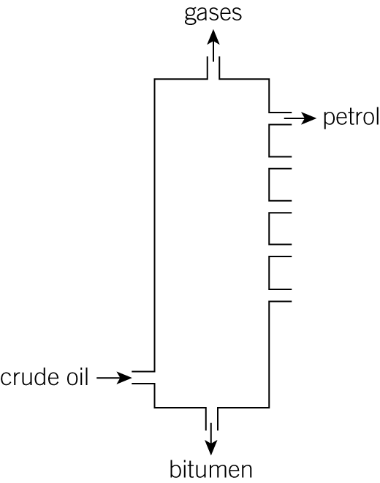

Describe and explain how **petrol** is separated from the mixture of hydrocarbons in crude oil.

Use **Figure 2** and your knowledge to answer this question.

(*6 marks*)

*AQA, 2013*