### Translocation

Translocation is the movement of …………………… (dissolved substances) in the phloem as sap

- the solute is mainly sucrose

Translocation can occur either ……… or …………… the stem

- from a …………………… e.g. a ……………………

* to a …………………… e.g. the ……………/……………/…………..

Different tissues can be sources or sinks at different times

e.g. when a plant is …………………………. the leaves are ……………… and the roots are a …………………… .

however in the spring many plants use …………………… stored in the roots to grow leaves. In this case the roots are a ………… and the developing leaves are a …………

## Key Features of Phloem

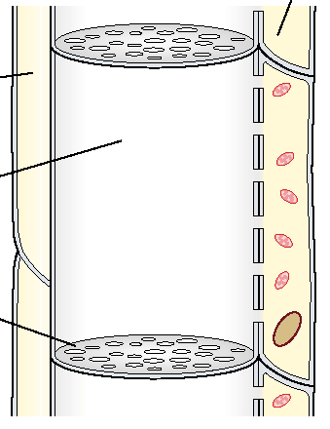

The phloem is actually composed of two different types of cell:

- ……… ……… …………..

- ……………………. …………..

Sieve tube elements are …………………..

They have strands of cytoplasm (but lack …………………..)

Sieve tube element cell walls are not lignified

They remain ………………….. to water and solutes

They are separated by ……… ………….. which have holes in

Companion cells are associated with sieve tube elements and possess many ………………..

**Movement around the phloem:**

The exact mechanism of translocation is not yet clearly understood but it is certainly too ………… to rely on simple …………………. alone.

**Evidence includes:**

Ringing trees in summer causes ………………. above the ring and reduced ……………. below it

No swellings occur if this is done in ………………….

Chen’s work showed most substances were transported ……………….. the phloem

He separated the xylem and phloem with pieces of waxed paper them  
 - this prevented movement of ………………….. between them

- this also prevented the movement of any …………………….. substances

Additional evidence is provided by ringing shoots and removing leaves

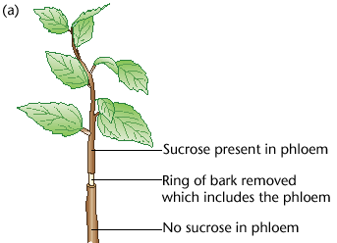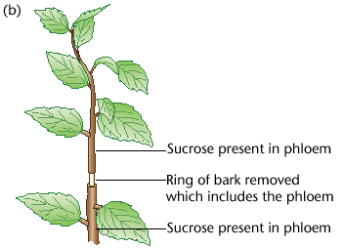

If the leaves below the missing phloem are If the leaves are left intact below the ringing

removed no sucrose is found lower down then sucrose is found in the lower phloem

Sucrose is found above the ringing

…………………. experiments can be used to sample the contents of the extremely thin phloem.

Aphids fee by inserting their hypodermic syringe-like mouth-parts into the phloem.

Since the contents of the phloem are under ……………… they are forced out and can be sampled.

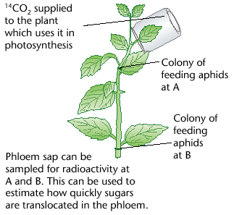

By using aphid stylets the movement of

solutes around the phloem can be investigated

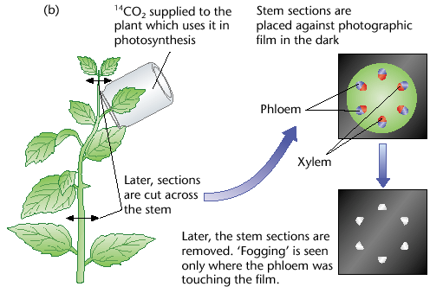

A more aphid friendly alternative is to use

autoradiographs taken of the ends of the

stems

## The Mass Flow Hypothesis

This seeks to explain how solutes are moved around the plant

Relies on …………………………. (energy from the Sun)

and ………… ……………………. (energy from ATP but also the result of

solar energy via photosynthesis)

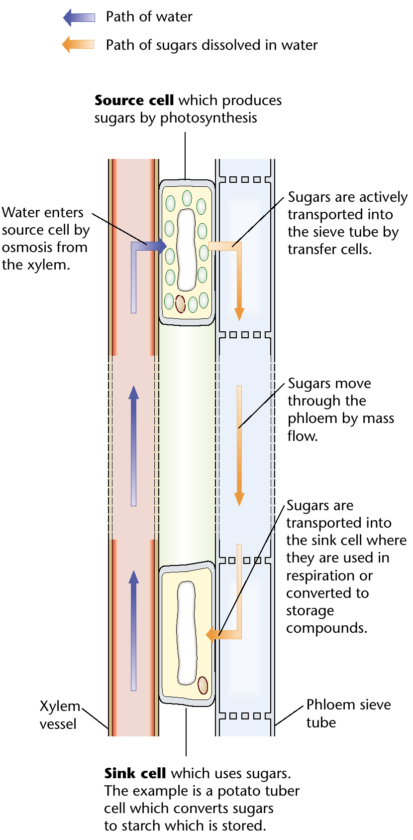

**At Source:**

1. Companion cells …..…… ………. sucrose ……..

the sieve tubes

2. This causes the …..…… ………. in the ………

to …………………

3. Therefore water ………. in from the nearby

………. by ……….

4. The influx of water ………..…. the ………………

pressure in the ……….

5. The hydrostatic pressure …………… the sap

………………. (this is mass flow)

**At Sink:**

6. Sucrose is actively pumped ….. of the phloem

7. This causes the water potential in the phloem

to ……………..

8. At the same time …………. are being actively pumped into the …………….. of the …………..

9. Therefore the …………….. has a much ………………. water potential than the ……………

10. Water diffuses by …………………….. from the ………………… into the ………………..

11. This creates ……………………….. pressure which ……………. water and ions ..…. the xylem

(Aided by …………………….. from the leaves - also mass flow)

12. This replaces the water moving ………… of the xylem at the source

# Munch’s Experiment

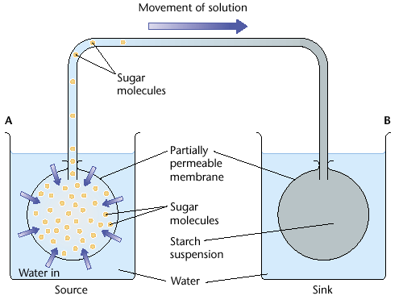

Two beakers containing water represent the source (A) and sink (B).

Partially …………………………. membranes are placed in both

at the ……………… (e.g. leaf cell) it holds sucrose solution

at the ……………… (e.g. root cell) it holds starch

At the source the …………….. water potential causes water to diffuse in by ………………….

The increase in the content’s ……………… forces the contents along the top tube (the ………… ) by mass flow.

This forces the contents into the ‘sink cell’.

The increased ……………… increases the ……………… within the membrane.

Thus water is forced …………… and into the surroundings

If the two beakers were joined by another tube (the ……………….)

water would flow between them from sink to source.

**Inconsistencies**

This hypothesis can explain the ……………….. of translocation but it has several flaws:

it can not explain how different ……………………. can move at different ……………………. or even in different ……………………. in the phloem at the …………. time.

it does not explain why sucrose does not ………… flow to the ……………… sink.

it does not explain the presence of …………. ……………., they seem to be ……………. .

…………………..streaming must play an important part.

This is the movement of molecules (by active transport) and small organelles around and between cells on the ……………………… .