**Year 9 Heart and blood Practice Questions**

**Q1.** The graph shows the rate of blood flow through different organs at rest and during exercise.

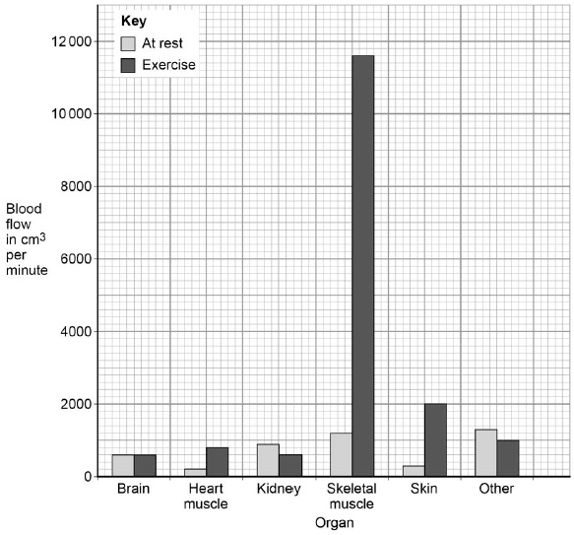

(a)     Determine the total volume of blood that flows through the brain in 1 hour.

___________________________________________________________________

___________________________________________________________________

Volume = ____________________ cm3

**(1)**

(b)     Look at the blood flow through the skeletal muscle.

Calculate how many times the blood flow increases by during exercise compared to at rest.

___________________________________________________________________

___________________________________________________________________

___________________________________________________________________

Answer = ____________________ **(2)**

(d)     Arteries and veins have different structures and different functions.

Explain how the different structure of arteries and veins relates to their different functions.

___________________________________________________________________

___________________________________________________________________

___________________________________________________________________

___________________________________________________________________

___________________________________________________________________

___________________________________________________________________

___________________________________________________________________

___________________________________________________________________

___________________________________________________________________

___________________________________________________________________

___________________________________________________________________

___________________________________________________________________

**(6)**

**(Total 12 marks)**

**Q2.**

The circulatory system transports substances such as glucose and oxygen around the body.

(a)     Name **two** other substances that the circulatory system transports around the body.

1. _________________________________________________________________

2. _________________________________________________________________

**(2)**

(b)     (i)      Blood is a tissue. Blood contains red blood cells and white blood cells.

Name **two** other components of blood.

1. ____________________________________________________________

2. ____________________________________________________________

**(2)**

(ii)     The heart is part of the circulatory system.

What type of tissue is the wall of the heart made of?

______________________________________________________________

**(1)**

**(Total 5 marks)**

**Q3.** The diagram shows a human heart.

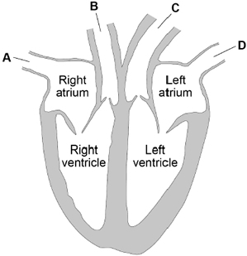

(a)  Which blood vessel carries deoxygenated blood away from the heart to the lungs?

Tick (**✓**) **one** box.

|  |  |  |  |  |  |  |  |
| --- | --- | --- | --- | --- | --- | --- | --- |
| **A** |  | **B** |  | **C** |  | **D** |  |

**(1)**

(b)  The natural resting heart rate is controlled by a group of cells that act as a pacemaker.

Where in the heart are ‘pacemaker cells’ found?

Tick (**✓**) **one** box.

|  |  |
| --- | --- |
| Left atrium |  |
| Left ventricle |  |
| Right atrium |  |
| Right ventricle |  |

**(1)**

Beta blockers are another type of drug that slows the heart rate.

The table shows information for people who do not take beta blockers and for people who do take beta blockers.

•   Stroke volume is the volume of blood pumped out of the heart each time it beats.

•   Cardiac output is the total volume of blood pumped out of the heart each minute.

|  |  |  |  |  |
| --- | --- | --- | --- | --- |
|  | **No beta blockers taken** | | **Taking beta blockers** | |
| **At rest** | **During exercise** | **At rest** | **During exercise** |
| **Heart rate in beats per minute** | 68 | 150 | 52 | 88 |
| **Stroke volume in cm3** | 80 | 120 | **X** | 98 |
| **Cardiac output in cm3 per minute** | 5440 | 18 000 | 2800 | 8624 |

(d)  Calculate stroke volume **X** in the table above.

Use the equation:

cardiac output = stroke volume × heart rate

Give your answer to 2 significant figures.

___________________________________________________________________

___________________________________________________________________

___________________________________________________________________

___________________________________________________________________

Stroke volume **X** = ____________________ cm3

**(3)**

**(Total 5 marks)**

**Q4.** (a)     (i)      Name the red pigment found in red blood cells.

______________________________________________________________ **(1)**

(ii)     Describe, in detail, the function of this red pigment.

______________________________________________________________

______________________________________________________________

______________________________________________________________

______________________________________________________________ **(2)**

(b)     Describe **one** other way in which the structure of a red blood cell is different from the structure of a white blood cell.

___________________________________________________________________

___________________________________________________________________ **(1)**

**(Total 4 marks)**

Mark schemes

**Q1.**

(a)     36 000 (cm3)

**1**

(b)     11600 / 1200

**1**

9.66666r

*allow any number of decimals*

**1**

(c)     muscles need more energy (for contraction)

**1**

(so) more oxygen / glucose needed

*need at least one reference to ‘more’ for full marks*

*allow so more carbon dioxide / thermal energy needs to be removed*

**1**

(for) increased respiration

**1**

(d)

|  |  |
| --- | --- |
| **Level 3:** Relevant points (differences / functions) are identified, given in detail and linked logically to form a clear account. | 5-6 |
| **Level 2:** Relevant points (differences / functions) are identified and there are attempts at logical linking. The resulting account is not fully clear. | 3-4 |
| **Level 1:** Points are identified and stated simply, but their relevance is not clear and there is no attempt at logical linking. | 1-2 |
| No relevant content | 0 |
| **Indicative content**  •   artery has a thicker wall  •   (because) artery has to withstand higher pressure  •   artery has thicker layer of elastic tissue / fibres  •   (so) it can stretch  •   (so) artery returns to original size / shape  •   artery has thicker layer of muscle  •   to maintain a force on the blood  •   vein has valves  •   (valves) prevent backflow of blood  •   artery carries blood away from the heart  •   vein carries blood towards the heart  ignore references to oxygenated / deoxygenated blood |  |

**6**

**[12]**

**Q2.**

(a)     any **two** from:

•        carbon dioxide / CO2

•        urea

•        protein

•        water / H2O

•        hormones / insulin.

*ignore food / waste / alcohol / drugs / enzymes*

*ignore glucose and oxygen*

*allow* ***two*** *correct hormones for 2 marks*

*allow* ***two*** *correct food components for 2 marks*

*allow antibodies*

*allow antitoxins*

**2**

(b)     (i)      plasma

**1**

platelets

**1**

(ii)     (cardiac) muscle

*allow muscular*

**1**

**[11]**

**Q3.**

(a)  **B**

**1**

(b)  right atrium

**1**

(c

**1**

(d)  **X** = 2800 / 52

**1**

53.846153

**1**

54 (cm3)

*an answer of 54 (cm3) scores 3 marks*

*allow correct rounding of an incorrectly calculated value of stroke volume*

**1**

**[12]**

**Q4.**

(a)     (i)      haemoglobin / oxyhaemoglobin

*must be phonetic*

**1**

(ii)     carries oxygen **or** forms oxyhaemoglobin

*Ignore references to CO2 / iron  
cancel if extras like food / glucose*

**1**

from lungs to tissues

**1**

(b)     no nucleus **or** biconcave disc (described)

*ignore references to size  
ignore vague references to being  
‘round’ / ‘donut’ shaped etc.*

**1**

**[4]**