*A View from the Bridge*

**General Notes**



CONTENTS

1. Contents
2. Plot: Act 1
3. Plot: Act 2
4. Eddie
5. Alfieri
6. Beatrice
7. Catherine
8. Rodolpho
9. Marco
10. Themes
11. Themes
12. Dramatic Techniques
13. Historical Context
14. Example Answers
15. Past Paper Questions
16. Mark Scheme

1

**PLOT**

The play is in only 2 acts but can be divided into these parts at the times Alfieri (the Chorus) speaks.



**Act 1**

* **p.1-2** Alfieri introduces the play commenting on the importance of justice in Red Hook, as well

as the community’s mistrust of the law. He introduces the protagonist Eddie and foreshadows the ‘bloody course’ of later events.

* **p.2-15**

Eddie, Catherine and Beatrice talk: it is clear Eddie is respected by and controls the women. The ambiguous relationship between Catherine and Eddie is established. Catherine and Beatrice talk about Catherine's job offer and Eddie expresses his disapproval. They talk about the arrival of Beatrice's cousins (who are illegal Italian immigrants). Eddie and Beatrice tell Catherine the story of Vinny Balzano.

* **p.15-23**

Marco and Rodolfo arrive. They talk about the situation

in Italy and about their families. We see the total contrast

between the brothers. The audience (and characters) see the chemistry

between Rodolfo and Catherine.

* **p.23-33**

Eddie hints to Beatrice that Rodolfo is homosexual and he doesn't want Catherine to date him. They argue. Catherine and Rodolfo come home from the cinema and Eddie is angry. Catherine and Eddie argue. Beatrice tells Catherine she needs to stand up to Eddie and stop being naive

* **p.33-38**

Exasperated, Eddie goes to see Alfieri. He claims Rodolfo is homosexual.

Alfieri explains that the American law will not allow him to take action

and advises him to let Catherine make her own decisions.

* **p.38-46**

The chair scene. Tension builds as all of the characters feel anger and frustration. Eddie is angry about the relationship between Catherine and Rodolfo. He tries to undermine Rodolfo’s masculinity by teaching him to box but hitting him deliberately. Rodolfo responds by dancing with Catherine to make Eddie jealous. Marco shows that he is the real threat to Eddie (which foreshadows the ending) by using the chair as a symbol of power, status and strength when

he challenges Eddie to lift it. Eddie cannot and the scene ends

with Marco raising the chair "like a weapon" over Eddie's head.

The scene is charged with tension and shows the unspoken power

struggle between the men: Eddie, Rodolfo and Marco.





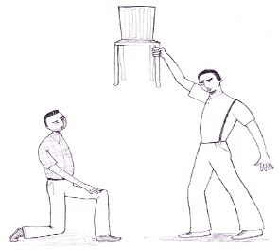

2



**Act 2**

* **p.47-53**

The kiss scene. Following his failure in the power struggle Eddie seeks to win back status and power by showing that Rodolfo is homosexual. Catherine and Rodolfo are in the flat on their own. Catherine asks Rodolfo whether he loves her for herself or for her American passport. She explains to him about her mixed emotions towards Eddie. They go to the bedroom. Eddie gets home drunk. He sees Catherine and Rodolfo coming out of the bedroom and becomes angry. He pins Catherine down and kisses her before doing the same to Rodolfo.

* **p.53-49**

Eddie returns to see Alfieri. He hints that he is going to report the cousins to the Immigration Bureau. Alfieri warns him to leave them alone. The phone glows and Eddie chooses his course. He calls Immigration and tells them about Marco and Rodolfo.

* **p.49-65**

Eddie and Beatrice are at home arguing. Beatrice begs Eddie to make

up with Catherine. Catherine comes in and Eddie finds out Marco and

Rodolfo have moved to the apartment upstairs where there is another

illegal immigrant. He is worried and begs Catherine to move them

somewhere else. Two officers arrive and search the flat. They look

upstairs and find Marco, Rodolfo and the other immigrant. Catherine

begs them to stop and shouts abuse at Eddie. Beatrice is shocked.

Eddie is defensive and denies any involvement in this. They all go out into the street where the neighbourhood is watching. Marco spits at Eddie's feet and says "I accuse that one!"

* **p.65-67**

Alfieri is with Marco and Rodolfo. Marco says that Eddie should be dead by now. Alfieri and Marco argue about justice and the law and the differences between the Sicilian code of conduct and the American law are highlighted. He persuades Marco to swear he will not kill Eddie so that he can bail him to attend Rodolfo’s wedding.

* **p. 67-72**

Beatrice and Eddie are arguing. Eddie does not want Beatrice to go to Catherine's wedding. Catherine arrives and shouts abuse at Eddie. Beatrice defends him saying they all "belong in the garbage." Rodolfo arrives and warns Eddie that Marco is coming. Eddie proudly refuses to leave his home - "this is my house!" Beatrice finally reveals Eddie's lust for Catherine. Marco arrives outside the house. Eddie goes out to get back his name in front of the neighbourhood. They fight and Eddie gets out a knife. Marco twists Eddie's hand so his own knife is plunged into his heart. Catherine finally admits her part in the tragedy - "I never meant to do anything bad to you." Eddie dies as Catherine and Beatrice support him. Alfieri closes the play.





3

Who is Eddie Carbone?

* Eddie is the **protagonist** (main character) and **tragic hero** of the play.
* In the beginning he is clearly the **man of the house**; Beatrice and Catherine respect him and no decisions are made without Eddie’s approval.
* He is very **protective** of his niece, Catherine, and as the play progresses his attitude and feelings for her are exposed to be strong and unnatural.
* He has definite ideas about **what it means to be a man**. He views himself as a real man (strong, hard-working) and Rodolfo as unnatural and suspects him of being homosexual because of his interest in cooking, music and sewing (as well as his blonde hair which he suspects him of dyeing).
* **He cannot admit his feelings for Catherine to himself**. He believes he simply wants what’s best for her and convinces himself Rodolfo wants Catherine only for her status as an American citizen. He is shocked at the end when Beatrice articulates his feelings, saying “you can never have her!” This shows he has repressed his feelings from himself (in a classic Freudian arrangement).
* His position as **dominant male** in the house is very important to him. He sees Beatrice and Catherine as his possessions and cannot stand the idea of anyone taking his place. However, he **loses power** throughout the play with the entrance of Marco and Rodolfo, younger and more attractive men. His loss of power is clearly seen in the ‘chair scene’ when Marco humiliates him and exposes himself as a threat to Eddie.
* **Justice and his name** are very important to Eddie. He warns Beatrice and Catherine to be careful that the authorities do not find out about Marco and Rodolfo and seems to immediately regret his own decision to call them. He loses his name when Marco spits at him in front of the neighbourhood and is determined to win it back. Without his name and respect from others he has nothing and he is therefore prepared to die at the end. It is **symbolic** that he dies by his own hand, a metaphor for his **own self-destruction**.



**Language Analysis**

Eddie’s dialogue is in complete contrast to Alfieri. His words are brief, short but powerful. His phrasing is uneducated, simple **‘you walkin’ wavy’** His language is frequently *ungrammatical*, using *elision:* **‘Records he buys now.’ ‘It’s eatin’ me out Mr Alfieri’.** He is often *monosyllabic* when talking to Catherine **‘No. But I got other worries….yeah…why? What worries you got?’**

Timeline

Eddie reluctantly agrees to let Catherine have a job.

Seemingly benevolent, Eddie welcomes Marco and Rodolpho into his home.

He tries to talk Catherine out of dating Rodolpho, saying he's only using her to get his citizenship.

Eddie goes to Alfieri to try and find a legal way to separate Catherine and Rodolpho.

Driven half mad when he finds the two coming out of the bedroom together, he beats up Rodolpho and forces a kiss on the boy and Catherine.

He calls Immigration, turning in Marco and Rodolpho.

Spurned by his family and community, Eddie dukes it out in the street with Marco in a vain attempt to regain his reputation.

Eddie dies by his own knife

Key Quotations

* ‘Now don’t aggravate me Katie, you’re walkin’ wavy!’ P.4
* ‘… Like Vinny Bolzano, remember Vinny! P.12
* ‘You can quicker get back a million dollars than a word you gave away.’ P. 13
* ‘You’re runnin’, you’re runnin’, Katie. I don’t think you listening anymore to me’p.28
* ‘Katie, he’s only bowin’ to his passport.’ P.29
* ‘ ‘Ats it! Now here I come, Danish! *He feints with his left hand and lands with his right. It mildly staggers Rodolpho. Marco rises’* p.45
* ‘*He reaches out suddenly, draws her to him, and as she strives to free herself he kisses her on the mouth’* p.52
* ‘I want my respect Beatrice, and you know what I’m talking about… what I feel like doin’ in bed and what I don’t feel like doin’’.p.56
* ‘He’s gonna take that back. He’s gonna take that back or I’ll kill him! You hear me? I’ll kill him. I’ll kill him’ p.65
* ‘Then why – Oh B! p.72

4

Who is Alfieri?

* Alfieri takes the role of the **CHORUS**. Traditionally, the Chorus in tragedies explains to the audience what is going to happen and yet is unable to do anything about it. (eg, in *Romeo and Juliet*) Alfieri is therefore the **narrator, commentator but also a character in the play** who can communicate with others in it. He hints at the outcome at the very beginning and explains how he is unable to change the tragedy which is going to “run its bloody course.” He therefore **symbolises the “view from the bridge”.** He is a “bridge” between the audience and characters and yet can only “view” the action of the play and not influence it.
* Alfieri **represents** **the American law**. He is an American of Sicilian descent and so understands the Sicilian code of conduct yet, as a lawyer, stands for the law. He tries to convince Eddie and Marco to follow the law and metaphorically “settle for half.” However, he realises that he cannot influence them and they will follow the duty that they perceive their Sicilian Code of Conduct requires.
* We do not learn much about Alfieri as he is mainly used as a commentator and therefore **often remains objective**. However at the end he **expresses grudging admiration for Eddie** because the tragic protagonist was fully himself and uninhibited by the expectations of those around him in the community.

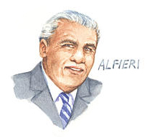

Key Quotations

* ‘In this neighbourhood, to meet a lawyer or a priest on the streets is unlucky’ p.1
* ‘Oh there were many here who were justly shot by unjust men. Justice is very important here’ p.2
* ‘Now we settle for half, and I like it better’ p.2
* ‘watched it run its bloody course’ p.2
* ‘He was a good a man as he had to be in a life that was hard and even’ p.15
* I knew, I knew then and there – I could have finished the story that afternoon’.p.37
* ‘I think I will love him more than all my sensible clients. And yet, it is better to settle for half, it must be! And so I mourn him – I admit it – with a certain… alarm.’ p.72

Timeline

Alfieri introduces the audience to the world of the play and our protagonist.

He advises Eddie to let Catherine make her own decisions.

He bails Marco and Rodolpho out of jail.

Alfieri concludes the play with a lamentation for Eddie.

Language Analysis

He has a specific style of speech: when directly addressing the audience he is engaging, deep and poetic: **‘the flat air in my office suddenly washes in with the green scent of the sea’.**

When speaking to Eddie he is both formal and precise (his lawyer’s advice) and pleading, questioning (when trying to appeal to Eddie’s better nature) ‘**you understand that, don’t you?’.**

5

Who is Beatrice?

* Beatrice is **loving and caring** to both Eddie and Catherine throughout the whole play.
* She **represents sanity and reason** and is the only character who does not clash with others in the play.
* She can be **assertive** when necessary. She warns Eddie about his unnatural feelings towards Catherine and also warns Catherine to stop acting like a child in front of Eddie and, later, to stand up against Eddie and to stop being so naïve.
* She is **aware** **of her rights as a wife**. She twice refers to the fact that she and Eddie have stopped sleeping together. She is not prepared to let Eddie ignore these rights. She herself **takes her responsibilities as a wife seriously**. Ultimately she does what Eddie asks her, even prepared to miss Catherine’s wedding, and in the final scene she is beside Eddie until the end and supports him as he dies.
* She is **the only one who recognises they all had a part in the final tragedy** when she says: “then we all belong in the garbage. You, and me too. Don’t say that. Whatever happened we all done it, and don’t you ever forget it, Catherine.” She recognises that she allowed Eddie’s feelings to develop unnaturally towards Catherine and that she should not have invited her cousins into her house. She also recognises that Catherine allowed Eddie to be overly protective towards her and enjoyed the attention he gave her.



Key Quotations

* ‘When am I gonna be your wife again, Eddie?’ p.25
* ‘I told you fifty times already, you can’t act the way you act. You still walk around in your slip’ p.31
* ‘You want soethin’ else Eddie and you can never have her! P.70
* ‘*He dies in her arms and Beatrice covers him with her body*’ p.72

Timeline

Beatrice convinces Eddie to let Catherine take a job.

She welcomes her immigrant cousins into her home.

She tries to make Eddie leave Catherine and Rodolpho alone.

Beatrice advises Catherine that it's time to grow up.

At Eddie's behest, she decides against going to Catherine's wedding.

She tells Eddie that he's in love with Catherine.

Beatrice holds Eddie as he dies.

Language Analysis

* The dialogue of the female characters often reflects their position in the social hierarchy, they often ask questions **‘Why?’** and their speech is more placatory and less aggressive **‘I’ll get it for you.’ ‘I’m worried about you’.**
* The stage directions also reflect their emotional characterisation *almost in tears…almost weak from tension*

6

Who is Catherine?

* Catherine is **young (17), innocent and naïve**. She enjoys her **close relationship with Eddie,** is constantly **looking for his approval** but genuinely does not realise there is anything wrong in it.
* She has **had little experience in life** and is excited when Marco and Rodolfo come into her life and she has contact with people who are closer to her age. She quickly becomes infatuated with Rodolfo as she is attracted to his youth, energy and enthusiasm for life.
* She is **torn** **between Eddie and Rodolfo** but, in the chair scene, she rushes to Rodolfo’s side when she thinks Eddie has hurt him. This prepares the audience for the way she chooses Rodolfo despite Eddie’s disapproval later in the play.
* After the kiss scene she **becomes** **more withdrawn and quiet**. Eddie, the man who has always loved and protected her, has scared and shocked her for the first time.
* She completely turns against Eddie after he tells the authorities about Marco and Rodolfo. She shows a strength of character previously unseen. During the play, she turns from a child into a woman, capable of making her own decisions and gaining greater **independence** and **maturity**.
* In the end **she admits she is also guilty of playing a part in the final tragedy**. She tells Eddie: “I never meant to do nothing bad to you.”



Key Quotations

* *‘Catherine, almost in tears because he disapproves:* What do you want me to do?’ p.4
* ‘Eddie, I wish there was one guy you couldn’t tell me things about’.p.4
* ‘Here! I’ll light it for you! *She strikes a match and holds it to his cigar. He puffs’* p.14
* ‘He’s a rat! He belongs in the sewer!’p.68
* ‘Eddie I never meant to do nothing bad to you’ p.72

Timeline

Catherine gets a job as a stenographer.

She dates Rodolpho.

She has physical relations of some kind with Rodolpho.

Catherine tells Eddie that she has to leave.

She gets a kiss forced on her by Eddie.

She plans to marry Rodolpho.

Catherine calls Eddie a ‘dirty rat’.

She tries to reconcile with Eddie as he dies.

Language Analysis

* The dialogue of the female characters often reflects their position in the social hierarchy, they often ask questions **‘Why?’** and their speech is more placatory and less aggressive **‘I’ll get it for you.’ ‘I’m worried about you’.**
* The stage directions also reflect their emotional characterisation *almost in tears…almost weak from tension*

7

Who is Rodolpho?

* Rodolfo is **very** **different from his brother Marco**. He is **fun-loving, lively and enthusiastic**. He **loves America** and everything it stands for: freedom, opportunity, possibility. He is a **young, modern man** and is a different sort of man to Eddie and Marco, who are hardworking family men. Rodolfo **loves fashion, music and culture**. Catherine is attracted to the way he is different and how he is completely comfortable with the way he is.
* He is **honest**. He loves Catherine but admits he would not marry her if he had to take her back to Italy. He describes to her the situation in Italy and how they would starve if they lived there.
* The **roles played by Marco and Rodolfo change throughout the play**. At first Marco is seen as the sensible, mature one but, towards the end, it is Rodolfo who tries to stop Marco from going after Eddie. He warns Eddie, despite what Eddie has done to him and even attempts to kiss Eddie’s hand, a symbol of respect and apology.
* His views are **not as black and white as Marco**. He sees both Eddie and Marco’s points of view and attempts to mediate between them.

Key Quotations

* ‘Catherine. If I take in my hands a little bird. And she grows and wishes to fly. But I will not let her out of my hands because I love her so much, is that right for me to do?’p.50
* ‘Don’t! *He pulls on Eddie’s arm.* Stop that! Have respect for her! p.52
* *‘Rodolpho flies at him in attack. Eddie pins his arms, laughing, and suddenly kisses him’* p.52
* ‘It is my fault Eddie, everything. I wish to apologise.’ p.69
* ‘No, Marco, please! Eddie, please, he has children! You will kill a family! p.70

Timeline

Rodolpho travels illegally to America to find work.

He moves in with the Carbones.

He dates Catherine.

Rodolpho gets a kiss forced on him by Eddie.

He becomes engaged to Catherine.

He gets arrested by Immigration.

Alfieri bails him out.

Rodolpho apologizes to Eddie.



Language Analysis

He is more descriptive, more metaphorical and much more symbolic **‘If I take in my hands a little bird. And she grows and wishes to fly. But I will not let her out of my hands because I love her so much, is that right for me to do?’**

This echoes his character’s more flamboyant personality, but also his more romantic nature

8

Who is Marco?

* Unlike Rodolfo, Marco has only come to America to **make money to send to his family in Sicily**. He is **a hard-working family man** and therefore gains respect from Eddie.
* He is **close to his brother** and feels a sense of responsibility and protectiveness towards him. This is evident in the chair scene when he defends Rodolfo after Eddie attempts to humiliate him by challenging Eddie to lift a chair. He shows his strength by lifting the chair and the scene foreshadows the ending.
* He has **a strong sense of justice** and does not understand American law. He believes that Eddie should die because of his betrayal telling Alfieri “in my country he would be dead now. He would not live this long.

”

* He is **prepared to take the law into his own hands**. He sees it as **his duty** to go to Eddie at the end and to kill or be killed in a final battle.



Timeline

Marco travels illegally to America to find work.

He moves in with the Carbones.

He tries to keep the peace between Eddie and Rodolpho.

Marco gets arrested by Immigration.

He calls Eddie out in front of the whole neighborhood.

He gets bailed out by Alfieri.

Marco kills Eddie with Eddie's own knife.

Key Quotations

* ‘Marco is face to face with Eddie, a strained tension gripping his jaw, his neck stiff, the chair raised like a weapon over Eddie’s head’ P.46
* ‘*Marco, as he is taken off, pointing back at Eddie:* ‘That one! He killed my children!p.64
* ‘The law? All the law is not in a book’ p.66
* Animal! You go on your knees to me! p.71

Language Analysis

His language is extremely economical, indeed he barely speaks through the play.

He is serious, never playful, and always direct **‘I see it’s a small house but soon…’ ‘I tell you the truth, if I stay they will never grow up’.**

9

Themes

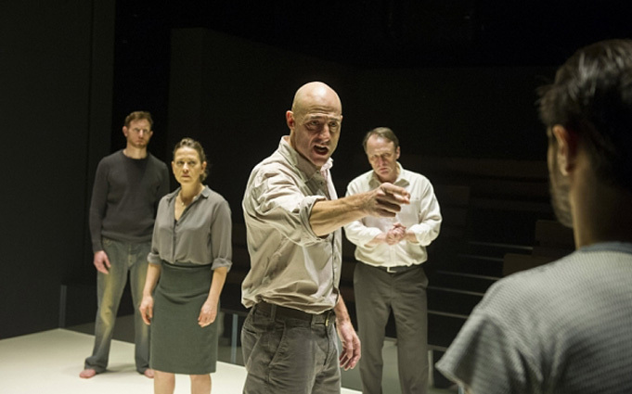

Justice and the Law

**Alfieri represents the American law** yet he acknowledges that it has limitations. The Italian community have their **own idea of justice** and they see the American law as limited. This is first shown to the audience with the story of **Vinny Balzano**, the young boy who was punished and shunned by his neighbourhood for betraying his family. The Carbone family clearly see this as the just thing to do. There is a feeling that if people obey the law then they “settle for half.” It is interesting that Eddie is actually obeying the law by reporting the illegal immigrants Marco and Rodolfo yet the lawyer Alfieri warns him that this is not the just thing to do. Marco cannot understand that there is no law against what Eddie has done and feels it is his **duty** to kill Eddie.

Power

Throughout the play there is a clear **power struggle between the men**. Eddie in the beginning is the dominant **male** in the house; he is respected and appreciated by Beatrice and Catherine. When Marco and Rodolfo enter his territory, his home, he immediately feels **threatened**. Catherine has previously idolised him and yet now she has a new interest - an exciting and good-looking young man, Rodolfo. Eddie attempts to undermine Rodolfo by suggesting he is not a real man because he has blonde hair, he sings, dances, cooks and sews. He tries to show his women, Beatrice and Catherine, that Rodolfo is not as manly as he is by teaching him to box and then deliberately hitting him. Marco then shows Eddie that he is prepared to stand up for his brother by challenging Eddie to lift a chair. He is saying to Eddie that he is stronger and more powerful than he is and is prepared to fight against him. Eddie then attempts to regain power by kissing Catherine and showing Rodolfo that she is his property and then kissing Roldolfo, showing Catherine that he is homosexual. This does not work and Eddie becomes desperate as he loses more power, status and respect. The last loss is his **name**, in front of his neighbourhood. He now feels he has nothing and is prepared to **fight to the death** in an attempt to regain power.

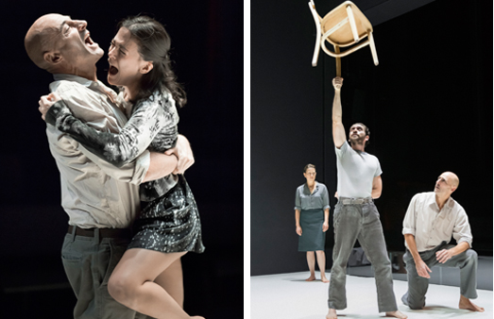

10

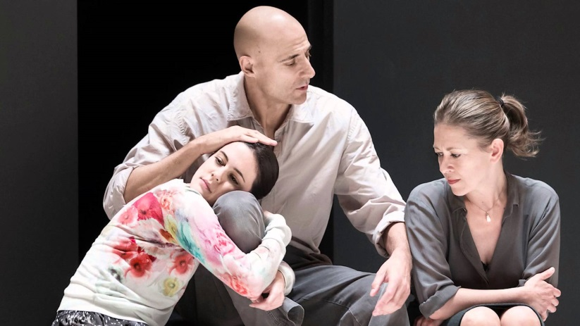

Love and Relationships

**Love**

There are different forms of love in the play:

**family love, romantic love, brotherly love,**

**fatherly love, love of a place**. Eddie’s fatherly

love for Catherine has become sexual yet he

refuses to admit this. The brotherly love between

Marco and Rodolfo motivates the final tragedy.

**Relationships**

Miller likes to write about tensions **and conflicts which naturally arise from human relationships**. In AVFTB we can see several relationships forming and changing throughout the play. The most important of these is the relationship between **Eddie and Catherine**. At the beginning it is obviously how close they are. Eddie admires Catherine but worries that, as she becomes a beautiful young woman, other men will look at her. Catherine is maturing physically but still behaves like a little girl with Eddie. Their relationship appears **ambiguous**. When Rodolfo arrives Eddie becomes aware that Catherine will no longer be his possession as he cannot compete with the youth and excitement Rodolfo offers Catherine. This results in a masculine power struggle between the three men. Catherine turns against Eddie after the kiss scene and this hostility grows when Eddie calls the authorities. Catherine is forced to grow up and stop acting like a little girl with Eddie.

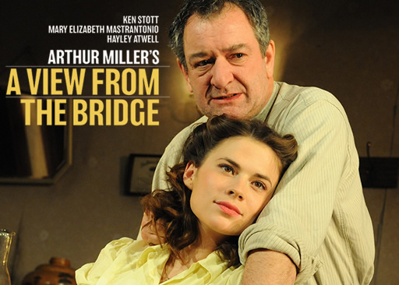

Masculinity

Eddie has a **very narrow view of what it means to be a man.** He believes he is **a real man**; he works hard to support his family and **protects his territory and possessions**. To Eddie his possessions include Beatrice and Catherine and this is why he is so protective of Catherine. Eddie is suspicious of Rodolfo because he has **“unmanly” interests: cooking, singing, sewing and dancing.** He believes he is unnatural and hints that he thinks he is homosexual, something which was regarded as a crime at the time. However Eddie’s own manliness is questioned when Beatrice confronts him about the fact that they have not slept together for a long time. Later in the play Eddie warns Beatrice never to question his manhood in this way.



**Other themes to consider:** honour, betrayal, jealousy, reputation, growing up, sexuality and community.

11

Dramatic Technique

**Tragedy**

The play is a tragedy. The genre ‘tragedy’ originates from the Greek Philosopher Aristotle in his book *Poetics*.

He classified a tragedy as a story which:

* Has a main character, the **tragic hero**.
* The tragic hero is not evil but has **a fatal flaw (hamartia)**.
* The hero has to suffer, learn of his fatal flaw (catharsis) and, usually, die.
* There is a sense of **fate** (things **had** to happen this way)
* The audience often feel pity for the tragic hero (pathos)
* There is a **Chorus** which informs the audience what is happening and how they should be feeling.

In AVFTB Eddie is our tragic hero and Alfieri is the Chorus, the character who comments and explains the action of the play.

**Dramatic Irony**

Dramatic irony is when the audience knows more about what is happening than the characters; it often adds to the rising tension. Alfieri foreshadows the events in the play numerous times, one of which is in his opening speech: ‘watch it run its bloody course’. The positioning and glowing of the telephone booth also helps foreshadow Eddie’s actions.

When Eddie calls the immigration officers and then argues with Beatrice afterwards about them being upstairs with the other two immigrants, it becomes clear that the immigration officers are coming and they are just about to be caught. The dramatic irony adds tension and move the plot along as it also foreshadows future events that lead to Eddie’s final tragedy.

**Stage Directions**

Stage directions can convey attitudes. For example, Marco is described as having a “formal stiffness” towards Eddie - Rodolpho on the other hand is not as submissive towards Eddie, who is coming “more and more to address Marco only”. This suggests a coldness and stubbornness form Eddie, who has shifted in attitude recently. Eddie suspects Catherine of being too close to Rodolpho; he is described as having “iron control” (page 22).

After speaking with Rodolpho about Eddie, Catherine is described as “near tears” and ‘trembling” (page 51). The stage directions can have a huge impact on the image of Catherine feeling the utter destruction from Eddie’s behaviour.

**Setting**

Setting is of crucial importance in A View from the Bridge from the opening description of the Carbone’s apartment to the violent climax which is set on the street. The fact that is in front of the community adds to the level of dishonour that Eddie has brought upon himself. The setting of Red Hook and the docks links to the idea of immigration and the poor area suggests a great deal about the characters who live there.

12

Historical Context

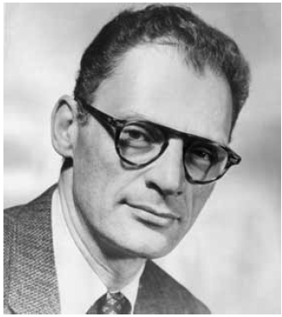

Arthur Miller (1915-2005)

Miller worked in the Brooklyn shipyards for two years, where he befriended the Italians he worked alongside. He heard a story of some men coming over to work illegally and being betrayed. The story inspired *A View from the Bridge*, which was written in 1955. It was originally a one-act play, but Miller re-worked it into a two-act play the following year.

Most of his work is set in the America of the day and portrays realistic characters and events. He deals with political and moral issues and weaves in ideas from **Greek tragedy**. He is interested in how personal relationships dictate the way one leads one's life and about people's struggles to do what is right.

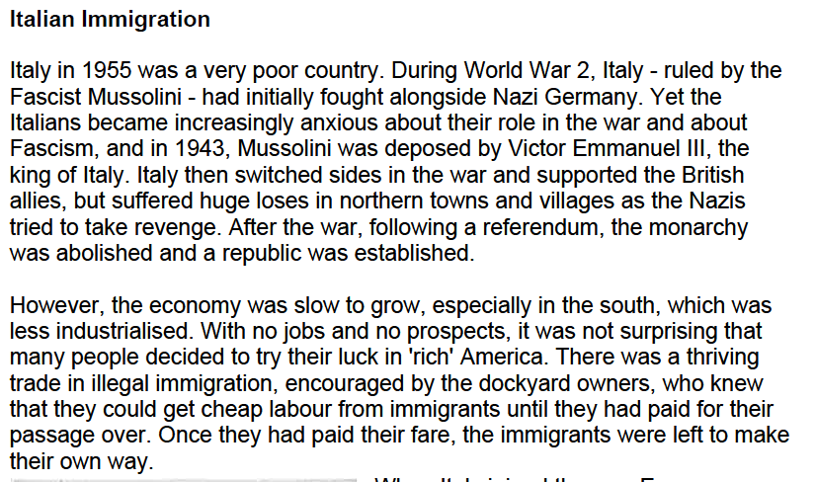

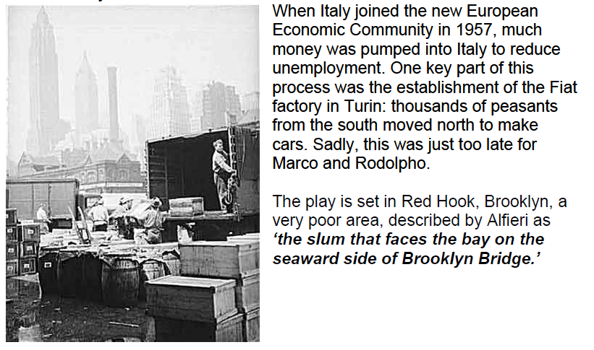

13

Example Answers

**How does Miler explore ideas about jealousy in A View from the Bridge?**

*A View from the Bridge* by Arthur Miller follows the life of an American-Italian longshoreman called Eddie Carbone in the 1950s, and his infatuation for his niece which ultimately destroys him. The key theme in this play is jealousy and is effectively highlighted by Eddie’s visit to his lawyer, Alfieri, who provides an unobstructed, objective view of the situation in his role as chorus.

Eddie and his wife Beatrice appear to be enjoying an excellent matrimony at the start of the play, with them both laughing and joking around by Eddie fooling Beatrice’s disgust with spiders, and use terms of endearment such as when Beatrice calls Eddie an ‘angel’ then tells him ‘Go, baby, set the table’. This suggests a comfortable and light-hearted marriage with a daughter-like niece, Catherine, whom they both dote on and who is Eddie’s undoing. Eddie would appear to be caring and overprotective towards her when she shows him her new skirt, desperate for his approval and nearly in tears because of it, as Eddie doesn’t approve. This is mostly due to a seemingly father-like concern over Catherine’s sexual signals, as he tells her she is ‘walkin’ wavy’ and advises her not to be so friendly. She responds light-heartedly with ‘I wish there was a guy you couldn’t tell me things about’ showing her affection towards him. He remains serious, which we can later interpret as the signs of his all-consuming jealousy.

The problem starts when Beatrice’s Italian cousins, Marco and Rodolpho, arrive and Catherine and Rodolpho start falling for each other. Eddie openly expresses his feelings of contempt towards Rodolpho, with snappy, short manners, and openly, exaggeratingly prefers Marco who is married. He repeats time after time ‘the guy ain’t right’ as Rodolpho cooks, sews, sings and has blond hair. The contempt of Rodolpho’s young and carefree flamboyance suggests a jealousy that Eddie cannot hope to replicate the bright youthfulness that Rodolpho possesses and Catherine loves. He masks the jealousy and the real reason behind his not wanting them to be a couple by claiming his pride is being ruined – at the docks ‘they call him Paper Doll’. This is a reference to the song they both love and danced to. His absolute ‘faith’ in Rodolpho not being good enough for Catherine is far too adamant for his own good, showing how his jealousy has driven him to selfishness, at a more extreme point than when he wouldn’t let her go to work – that was because he didn’t want to let her go and be independent.

Beatrice notices the gradual darkness that settles over Eddie and the breakdown of their marriage. She frequently says ‘I want this to stop, do you hear me?’ which he passes off as nagging, reluctant and unaware of his own feelings. His growing jealousy is evident enough that Catherine, once so eager to please, angrily now defies and provokes him, dancing with Rodolpho to Paper Doll right in front of him. Eddie’s jealousy is epitomised as he twists and twists the newspaper, getting tenser and tenser until it finally snaps. Beatrice snaps too and says ‘you want something else, Eddie, and you can never have her!’ This is the first direct reference to Catherine and the final trigger for Eddie, the tragic Greek hero, as the realisation completely takes him over and the mythical beast awakes, influencing his attempt to stab Marco.

But the main incident here is Eddie’s visit to Alfieri. Once, Eddie avoided Alfieri – lawyers were feared in this justice-loving community, so this shows the desperate change in Eddie that eventually leads him to betraying his own family out of jealousy and desperation to end Catherine and Rodolpho’s relationship. Alfieri advises him repeatedly to let her go, but at this visit, Alfieri jumps to the very worst conclusion at Eddie’s very appearance, which shows his drastic change. Alfieri says ‘I thought at first he had committed a murder; but then I saw it was only a passion that had moved into his body like a stranger’, referring to the all-encompassing force of jealousy that had taken over the morals he once had, evident in his ironic disgust at Vinny Bolzano’s story. Alfieri’s objective view on Eddie throughout highlights the theme of jealousy in regards to his tragic flaw extremely effectively; Alfieri is the view from the bridge, seeing both sides of the water, powerless to stop it and watching it ‘run its bloody course’. He states that ‘his eyes were like tunnels’, giving the impression of a huge well of emotion that has swallowed Eddie’s hope, life and personality.

The incident is important in highlighting the overeager, desperate Eddie to one that is ruthless and taken over by a hideous force of jealousy that ultimately destroys him. The objective view foreshadows what is about to come as well as how Eddie is feeling and what he is doing wrong. He does not want to give up Catherine because having an attractive woman depend on him is exactly the food his egotistical pride needs to feed on, and the destruction of Catherine’s respect for Eddie is shown throughout, linked with the more vocal his jealousy becomes.

14

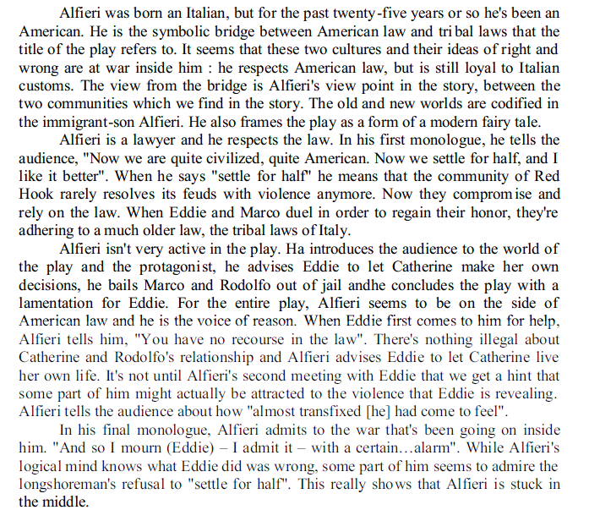

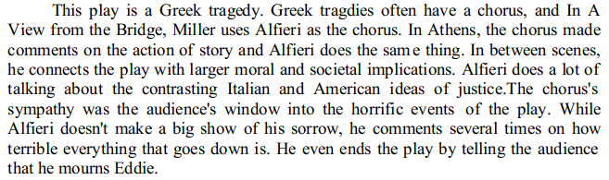

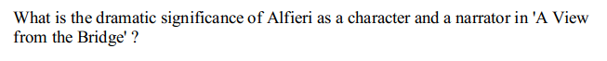

Past Paper Questions

Q) At the end of the play Alfieri says: Most of the time we settle for half and I like it better.’ How does Miller present ideas about ‘settling for half’ in the play?

Q) ‘Eddie is completely responsible for the tragic events at the end of the play.’ To what extent does Miller make Eddie seem Responsible? Explain how the methods Miller uses shape your response.

Q) The title from A View from the Bridge may be interpreted in different ways. What interpretations can you find? Support your answer with detailed reference to the text.

Q) **Catherine:** Eddie, I’m not gonna be a baby no more!’ How does Miller present Catherine growing up in A View from the Bridge?

Q) How does Miller present ideas about justice and the law in A View from the Bridge?

Q) What is the significance of Marco in A view from the Bridge and how does Miller present him?

Q) What is the importance of Alfieri in A View from the Bridge and how does Miller present him?

Q) ‘**Eddie:** I want my name! He don’t take my name, he’s only a punk. Marco’s got my name *–(to Rodolpho)* and you can tell him , kid, that he’s gonna give it back to me in front of this neighbourhood or we’ll have it out.’ How does Miller present ideas about reputation in A View from the Bridge?

Q) Write about the significance of settings in a View from the Bridge.

Q) Why is Rodolpho significant in A View from the Bridge and how does Miller present him?

15

A View from the Bridge Mark Scheme

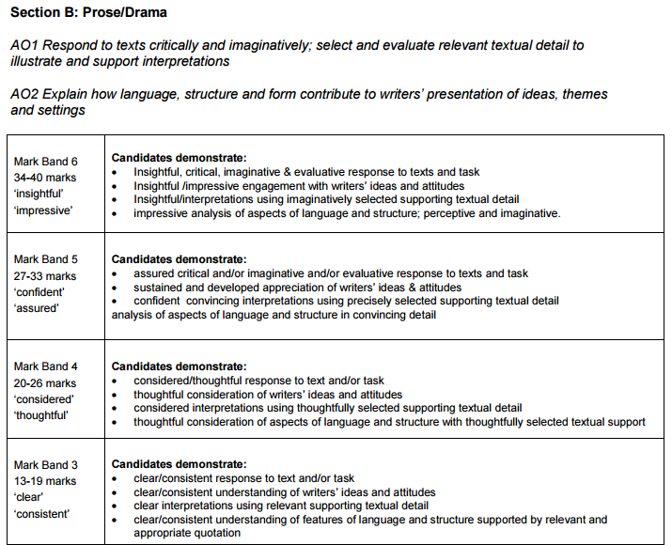

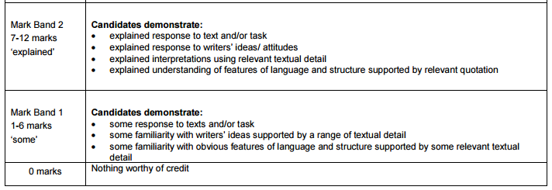

**Revision Links:**

<http://www.sparknotes.com/drama/viewbridge/>

<http://www.bbc.co.uk/schools/gcsebitesize/english_literature/dramaviewbridge/>

<https://blogs.glowscotland.org.uk/my/missross/hint-2-key-documents/higher-a-view-from-the-bridge/>

16