 Condensation polymers

Specification references

* C7.3.2 Condensation polymerisation 
* C7.3.3 Amino acids 
* C7.3.4 DNA (deoxyribonucleic acid) and other naturally occurring polymers
* MS 5b

Aims

In this worksheet you will find out how to represent condensation polymers in drawings. These include the polyesters formed from the reaction of a diol with a dicarboxylic acid and the polypeptides formed from the condensation polymerisation of amino acids.

Learning outcomes

After completing this worksheet, you should be able to:

* draw a simplified structure of the monomers for a condensation polymer when the structure of the polymer is given 
* draw a simplified structure of a range of condensation polymers, including polyesters and polypeptides, when the structure of the monomers are given .

Setting the scene

An ester is made from the reaction of an alcohol (with an –OH functional group) and a carboxylic acid (with a –COOH functional group). Water is also formed in this reversible reaction:

a carboxylic acid  an alcohol ⇌ an ester  water

If you react an alcohol that has an –OH group at each end (a diol) with a carboxylic acid that has a –COOH group at each end (a dicarboxylic acid), the reaction to make an ester can occur again and again. The product is called a **polyester**. For each ester link made, one molecule of water is formed. Hence the reaction is called condensation polymerisation:

a diol  a dicarboxylic acid → a polyester  water

An amino acid has two functional groups: an amine group (–NH2) and a carboxylic acid group (–COOH). This makes amino acids potential monomers as they have

Amino acids undergo polymerisation to form polypeptides. The link made between the amine group and the carboxylic acid group is called a peptide link. For each peptide link made, one molecule of water is made, making this a second example of condensation polymerisation.

amino acids → polypeptide  water

Proteins are examples of polypeptides.

Worked examples

**Example 1**

Draw the repeating unit of the polyester formed when ethanediol and butanedioic acid polymerise

**Step 1**

Draw out the diol and the dicarboxylic acid next to each other.

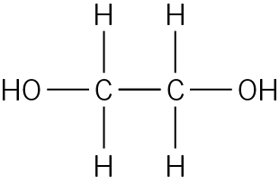 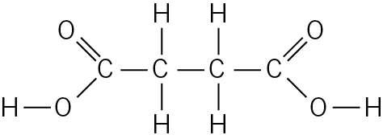

ethanediol butanedioic acid

**Step 2**

Remove a H atom from the alcohol functional group and the OH from the carboxylic acid functional group on the ends of each molecule that are nearest to each other.

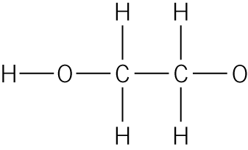 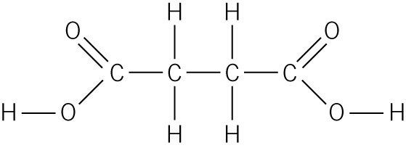

Then draw a covalent bond between the C atom of the carboxylic acid and the O atom of the alcohol. You have made one ester link.

Redraw to show approximately equal bond lengths

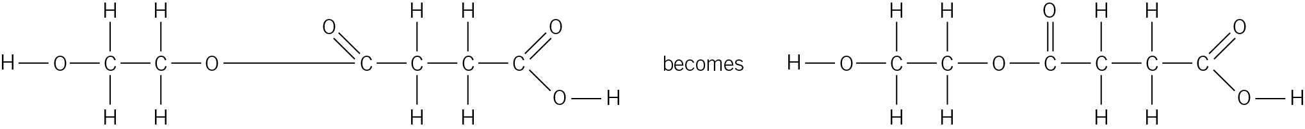

**Step 3**

To extend the chain, remove the OH from the end carboxylic acid functional group and a H atom from the alcohol functional group of the next diol molecule. These atoms form bonds with other monomers. Show this by leaving the covalent bonds in place, extending out away from the molecule.

Complete the diagram of the polyester by placing brackets around the repeating unit and adding an ‘n’ to show that the repeating unit is repeated several thousand times.

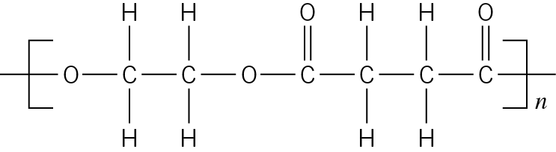

**Example 2**

Draw the dipeptide produced from the condensation reaction of two molecules of alanine.

**Step 1**

Draw out the displayed formulas of two alanine molecules, with the carboxylic acid functional group of one molecule next to the amine functional group of the other.

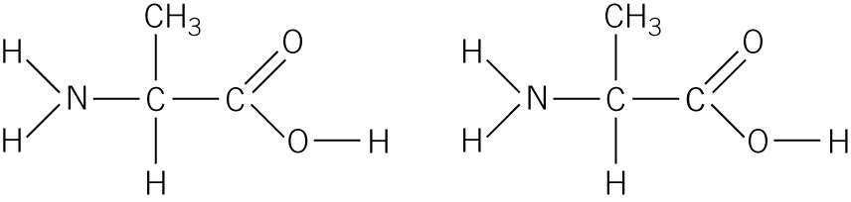

**Step 2**

Remove the OH from the carboxylic acid functional group and a H atom from the amine functional group nearest to each other.

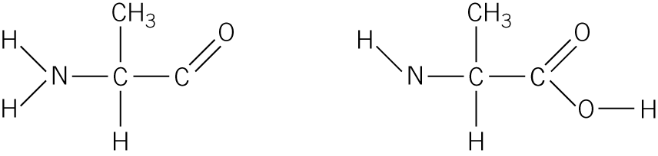

**Step 3**

Draw a covalent bond between the C atom of the carboxylic acid and the N atom of the amine to complete the structure of the dipeptide formed. One molecule of water is also produced from the removed OH and H.

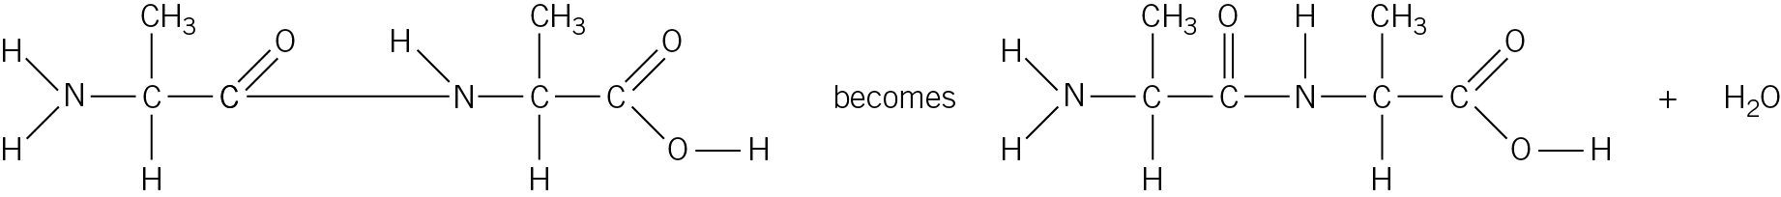

Questions

1 Match the condensation polymer to the monomers from which it is made.

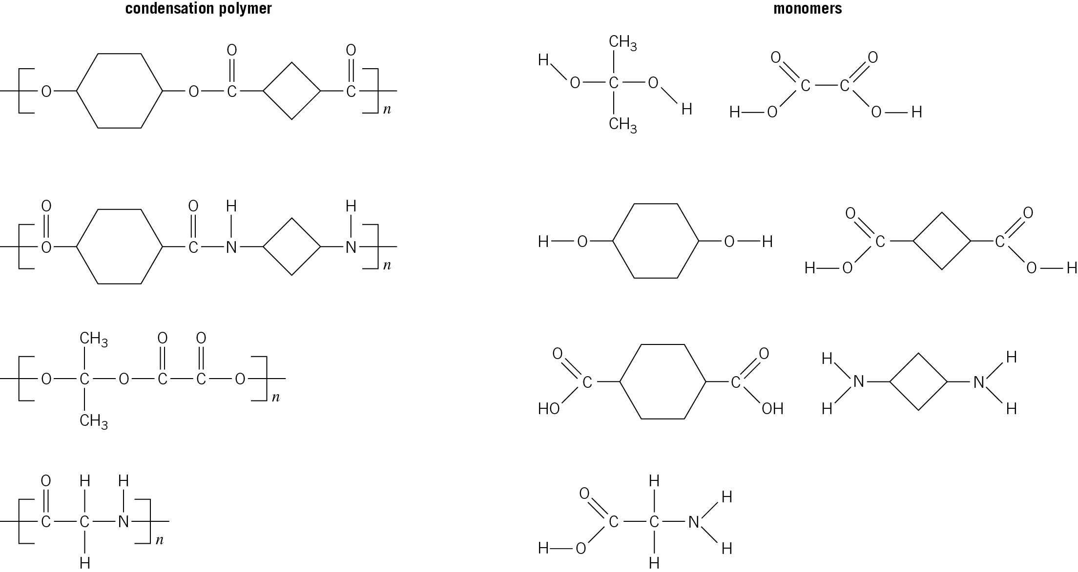

(*4 marks*)

2 In the spaces below, draw the structure of the polyester formed from:

a ethanediol and propanedioic acid

 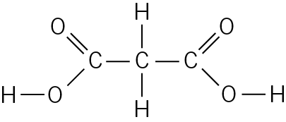

(*1 mark*)

b methanediol and butanedioic acid

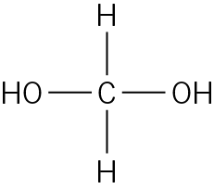 

(*1 mark*)

3 a In the space below, draw the structure of the dipeptide formed from two molecules of the amino acid serine.

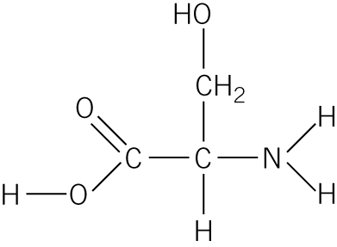

(*1 mark*)

b In the space below, draw the **displayed formulae** of the two amino acids that have reacted to make the following dipeptide.

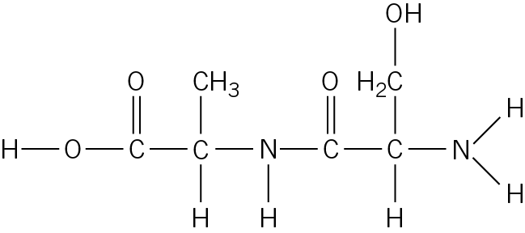

(*2 marks*)

Student follow up

1 Waseem makes a sample of the polymer nylon.

Nylon has the structure:

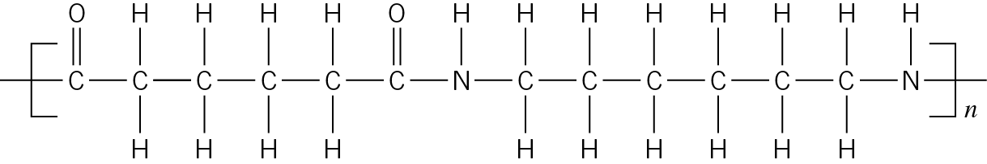

a What type of polymer is nylon? Circle your answer from the options below. (*1 mark*)

**addition polymer**

**condensation polymer**

b i In the space below, draw the structure of the dicarboxylic acid and the diamine that react to make nylon.

(*2 marks*)

ii This particular type of nylon is called **nylon 6,6**. Can you suggest why? (*1 mark*)

c Nylon is used in climbing ropes because it has a high tensile strength. Explain why, using ideas about intermolecular forces. (*1 mark*)

Maths skills links

You will also need to visualise and draw 2D and 3D forms when studying ionic and covalent compounds, and when studying crude oil and fuels, and organic reactions.