|  |  |  |  |
| --- | --- | --- | --- |
| **0** | **1** |  |  |

This question is about carbon compounds.

Draw **one** line connecting each compound to a correct statement.

|  |  |  |
| --- | --- | --- |
| **Compound** |  | **Statement** |
|  |  |  |
|  |  | is an alkane |
| propene |  |  |
|  |  | turns universal indicator orange |
| methanol |  |  |
|  |  | is an ester |
|  |  |  |
| ethanoic acid |  | turns bromine water colourless |
|  |  |  |
|  |  | has the formula CH3OH |

(3 marks)

|  |  |  |  |
| --- | --- | --- | --- |
| **0** | **2** |  |  |

**Table 1** contains information about compounds that contain four carbon atoms.

**Table 1**

|  |  |  |  |
| --- | --- | --- | --- |
| Name | Formula | Melting point in °C | Boiling point in °C |
| butane | C4H10 | –137 | 0 |
| butene |  | –185 | –6 |
| butanol | C4H9OH | –90 | 117 |
| butanoic acid | C3H7COOH | –5 | 164 |

|  |  |  |  |
| --- | --- | --- | --- |
| **0** | **2** | **.** | **1** |

Write the formula for the compound named butene.

(*1 mark*)

|  |  |  |  |
| --- | --- | --- | --- |
| **0** | **2** | **.** | **2** |

Complete **Figure 1** by drawing a bar to show the boiling point of butanol. (1 mark)

**Figure 1**

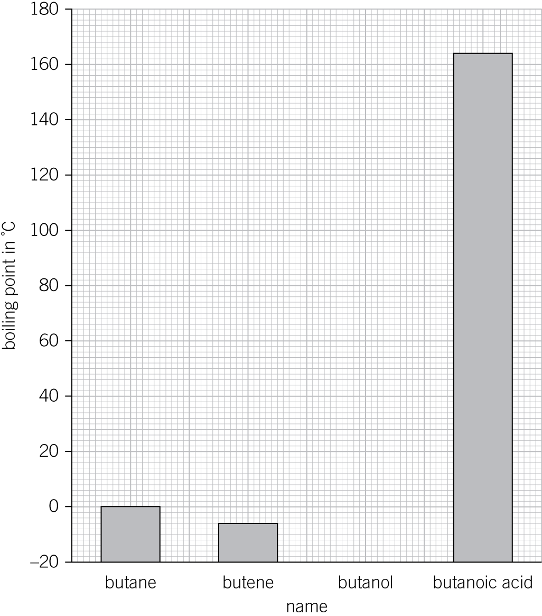

|  |  |  |  |
| --- | --- | --- | --- |
| **0** | **2** | **.** | **3** |

Explain why a bar chart is better for displaying the boiling points than a line graph.

(*1 mark*)

|  |  |  |  |
| --- | --- | --- | --- |
| **0** | **2** | **.** | **4** |

Predict which carbon compound with three carbon atoms you would you expect to have the lowest melting point.

Tick (✓) **one** box.

propane

propene

propanol

propanoic acid (*1 mark*)

|  |  |  |  |
| --- | --- | --- | --- |
| **0** | **2** | **.** | **5** |

Describe the pattern linking the melting points and boiling points of the compounds in **Table 1**.

(*1 mark*)

|  |  |  |  |
| --- | --- | --- | --- |
| **0** | **3** |  |  |

Ethene has the formula C2H4.

|  |  |  |  |
| --- | --- | --- | --- |
| **0** | **3** | **.** | **1** |

Which **two** statements about ethene are correct?

Tick (✓) **two** boxes.

ethene is an unsaturated compound

ethene reacts with hydrogen to form propane

ethene’s series has the general formula CnH2n

ethene is a carboxylic acid

ethene does not react with bromine water (*2 marks*)

|  |  |  |  |
| --- | --- | --- | --- |
| **0** | **3** | **.** | **2** |

Which word describes the reactions of ethene with hydrogen and with chlorine?

Tick (✓) **one** box.

cracking

combustion

addition

decomposition (*1 mark*)

|  |  |  |  |
| --- | --- | --- | --- |
| **0** | **3** | **.** | **3** |

Which of the following is a correct equation for the reaction of ethene with chlorine?

Tick (✓) **one** box.

C2H4  2Cl → C2H4Cl2

2C2H4  Cl2 → C4H8Cl2

C2H4  Cl2 → 2CH2Cl

C2H4  Cl2 → C2H4Cl2 (*1 mark*)

|  |  |  |  |
| --- | --- | --- | --- |
| **0** | **4** |  |  |

Alcohols can be burnt as fuels.

A group of students investigated the temperature rise when 1 g of different alcohols was burnt. They heated 50 cm3 of water in a beaker each time.

**Figure 2**

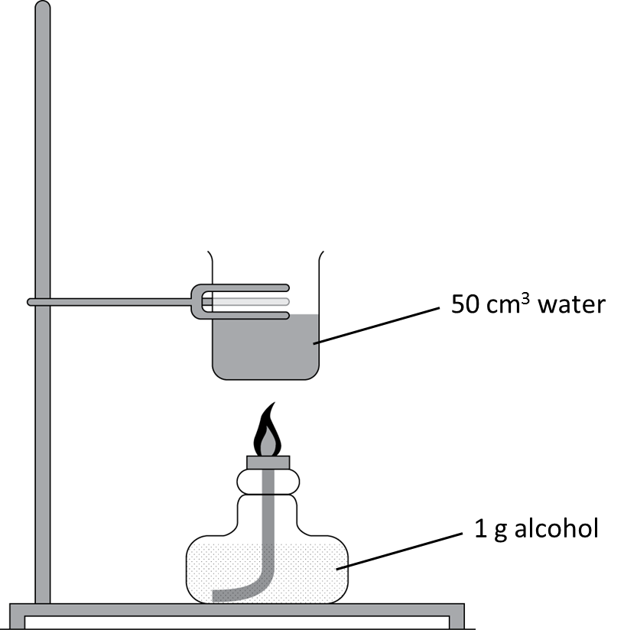

**Table 2** shows their results.

**Table 2**

|  |  |  |  |  |  |
| --- | --- | --- | --- | --- | --- |
| Name of alcohol | Number of carbon atoms in one molecule of alcohol | Temperature rise when 1 g was burnt in °C | | | |
| First trial | Second trial | Third trial | Mean |
| propanol | 3 | 15.9 | 17.6 | 16.1 |  |
| butanol | 4 | 16.8 | 17.0 | 16.6 | 16.8 |
| pentanol | 5 | 17.1 | 17.3 | 17.2 | 17.2 |
| hexanol | 6 | 17.4 | 17.4 | 17.4 | 17.4 |

|  |  |  |  |
| --- | --- | --- | --- |
| **0** | **4** | **.** | **1** |

Calculate the mean temperature rise when 1 g of propanol was burnt. Give your answer to one decimal place.

Mean temperature rise   °C (*2 marks*)

|  |  |  |  |
| --- | --- | --- | --- |
| **0** | **4** | **.** | **2** |

Estimate the mean temperature rise expected for 1 g of heptanol, C7H15OH.

Mean temperature rise   °C (1 mark)

|  |  |  |  |
| --- | --- | --- | --- |
| **0** | **4** | **.** | **3** |

Describe **one** change the students could make to the apparatus so that **all** of the alcohols produced a larger temperature rise.

(*1 mark*)

|  |  |  |  |
| --- | --- | --- | --- |
| **0** | **4** | **.** | **4** |

Complete the word equation to describe the complete combustion of propanol.

propanol  oxygen → water   (1 mark)

|  |  |  |  |
| --- | --- | --- | --- |
| **0** | **5** |  |  |

Ethanol is useful as a solvent and a fuel. It can be made from renewable resources or from non-renewable resources.

Describe **two** ways of producing ethanol.

You should name the starting materials, the products, and the reaction conditions for each process.

(*6 marks*)

|  |  |  |  |
| --- | --- | --- | --- |
| **0** | **6** |  |  |

Compound **A** has the structural formula CH3CH2CH2COOH.

|  |  |  |  |
| --- | --- | --- | --- |
| **0** | **6** | **.** | **1** |

Name compound **A**.

(*1 mark*)

|  |  |  |  |
| --- | --- | --- | --- |
| **0** | **6** | **.** | **2** |

Draw the displayed formula of compound **A**. (*1 mark*)

|  |  |  |  |
| --- | --- | --- | --- |
| **0** | **6** | **.** | **3** |

Name what the single lines represent in a displayed formula.

(*1 mark*)

|  |  |  |  |
| --- | --- | --- | --- |
| **0** | **6** | **.** | **4** |

Carboxylic acids dissolve in water to form acidic solutions.

A student tests a solution of propanoic acid by reacting it with sodium carbonate.

Complete the word equation for this reaction. (*1 mark*)

propanoic + → sodium propanoate + water + carbon

acid dioxide

|  |  |  |  |
| --- | --- | --- | --- |
| **0** | **6** | **.** | **5** |

Complete the symbol equation for the reaction in **06.4**. (*1 mark*)

2CH3CH2COOH(aq) + Na2CO3(aq) → 2CH3CH2COONa(aq) + (l) + (g)

|  |  |  |  |
| --- | --- | --- | --- |
| **0** | **6** | **.** | **6** |

Describe what observations the student would make that show a chemical reaction is taking place.

(*1 mark*)

|  |  |  |  |
| --- | --- | --- | --- |
| **0** | **6** | **.** | **7** |

Propanoic acid reacts with ethanol to produce an organic compound **B** with a pleasant fruity smell together with water.

The displayed formula of the organic compound **B** is shown in **Figure 3**.

**Figure 3**

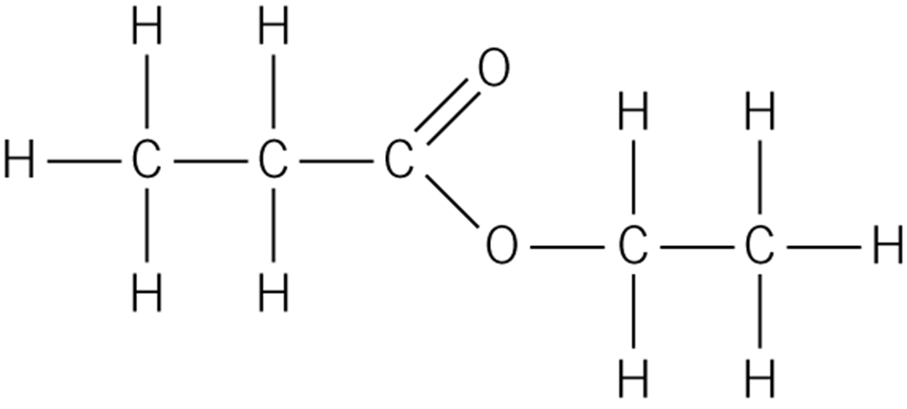

Name the homologous series that organic compound **B** belongs to.

(*1 mark*)