North Indian Instruments
North Indian classical music ensembles have only a handful of players. Most instruments are played while seated on the floor. There are usually the same three elements:
- soloist - either a singer or an instrumentalist playing the melody
- percussion - usually tabla
- drone - usually a tanpura, harmonium or electronic box

Melody instruments  The Sitar  - is a long-necked plucked string instrument with movable frets and a gourd resonator  - is played by plucking the strings with a metal plectrum  - has six or seven main strings and twelve or more sympathetic strings running underneath them, which resonate in sympathy  - has a characteristic shimmering sound  The Sarod  is a plucked string instrument  - is shorter than the sitar and has no frets  - is played by plucking the strings with a large wooden plectrum  - has main strings and sympathetic strings  - plays ornaments by sliding up and down the strings  The Sarangi  - is a fretless bowed instrument is held in the lap  - It has three main strings and as many as 36 sympathetic strings  The Esraj  - a bowed string instrument  - played sitting on the floor like the sarangi, but with frets like a sitar  - has a number of sympathetic and drone strings  The Bansuri  The bansuri is a bamboo flute with no keys. | 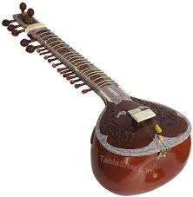  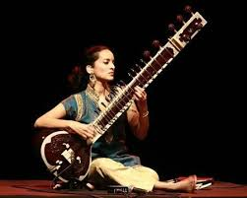  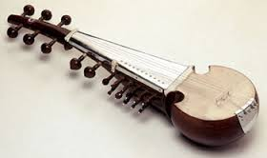  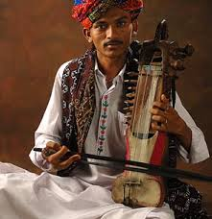  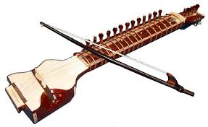

Drone instruments
The Tanpura is a stringed instrument similar to the sitar but it has fewer strings (usually four) and no frets. Unlike the sitar it plays very simple and repetitive music.
The Harmonium is a reed organ operated by bellows which open at the back. The keyboard is on top and has a range of two to three octaves.
Percussion instruments
Tabla are a pair of small drums placed side by side on the floor in front of the player. Their main role is to keep the time, but they sometimes interact with the soloist and have short solos. The heads are made out of goatskin with a central area which has a coating made from iron filings and rice flour.
The smaller drum is known as the dayan (meaning right). It is:
- tuned to Sa
- played with the fingertips of the right hand
- quite high in pitch
The larger drum is known as the bayan (meaning 'left'). It is:
- played with the left hand
- played with the heel of the hand, which is pressed into the drum to change the pitch, providing a distinctive sound
- deeper in pitch, providing a bass sound
Tabla playing is very difficult and it can take years to master the different strokes (bols). Some strokes are open (allowed to ring) and others are closed(dampened).

