**What was Sparta’s foreign policy from 499-480BC?**

**498BC The Ionian Revolt.**

When the cities on the Persian coast revolted against the Persians they sent an envoy to ask for help.

The Athenians sent 20 ships. How did Cleomenes react?

………………………………………………………………………………………………………………………………………………………………………………………………………………………………………………………………………………………………………………………...………………………………………………………………………………………………………………………………………………………………………………………………………………………………………………………………………………………………………………………...

**490BCThe Battle of Marathon**.

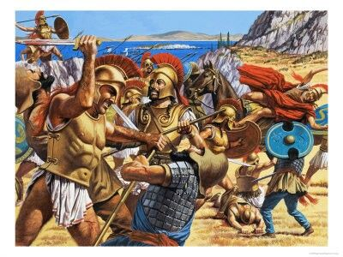

Stiring up trouble in Middle Greece before Marathon: 6.108

What does this show about Sparta’s attitude to Athens and the Rest of Greece?

………………………………………………………………………………………………………………………………………………………………………………………………………………………………………………………………………………………………………………………...………………………………………………………………………………………………………………………………………………………………………………………………………………………………………………………………………………………………………………………...………………………………………………………………………………………………………………………………………………………………………………………………………………………………………………………………………………………………………………………...

Sparta and the battle of Marathon 6.106 6.120:

What was Sparta thinking?

………………………………………………………………………………………………………………………………………………………………………………………………………………………………………………………………………………………………………………………...……………………………………………………………………………………………………………………………………………………………………………………………………………………………………………………………………………………………………………………...

Plato , Laws 693 (He says that the Spartans did not send help to Athenians as they were dealing with a Helot revolt)

What reason does this give for not fighting at Marathon?

………………………………………………………………………………………………………………………………………………………………………………………………………………………………………………………………………………………………………………………...

Arrive after the battle: 6.120

What does this show about the Spartans?

………………………………………………………………………………………………………………………………………………………………………………………………………………………………………………………………………………………………………………………...………………………………………………………………………………………………………………………………………………………………………………………………………………………………………………………………………………………………………………………...

**480BC: Xerxes and the invasion of Greece**, 

Persian invasion:

Greeks defend Tempe: 7.173 Are the Spartans involved here?

………………………………………………………………………………………………………………………………………………………………………………………………………………………………………………………………………………………………………………………...………………………………………………………………………………………………………………………………………………………………………………………………………………………………………………………………………………………………………………………...

Why did they decide not to stay at Tempe?

………………………………………………………………………………………………………………………………………………………………………………………………………………………………………………………………………………………………………………………...………………………………………………………………………………………………………………………………………………………………………………………………………………………………………………………………………………………………………………………...

Thermopylae: Read 7.201-231

On bullet points list Sparta’s actions in the battle based on Herodotus.

………………………………………………………………………………………………………………………………………………………………………………………………………………………………………………………………………………………………………………………...………………………………………………………………………………………………………………………………………………………………………………………………………………………………………………………………………………………………………………………...

………………………………………………………………………………………………………………………………………………………………………………………………………………………………………………………………………………………………………………………...………………………………………………………………………………………………………………………………………………………………………………………………………………………………………………………………………………………………………………………...

………………………………………………………………………………………………………………………………………………………………………………………………………………………………………………………………………………………………………………………...………………………………………………………………………………………………………………………………………………………………………………………………………………………………………………………………………………………………………………………...

Essay: ‘A heroic stand or a dismal failure.’ To what extent was the battle of Thermopylae a failure?’