|  |  |  |  |
| --- | --- | --- | --- |
| **0** | **1** |  |  |

A student uses chromatography to see if artificial food colourings are used in two soft drinks, **X** and **Y**.

The results are shown on the chromatogram (**Figure 1**).

**Figure 1**

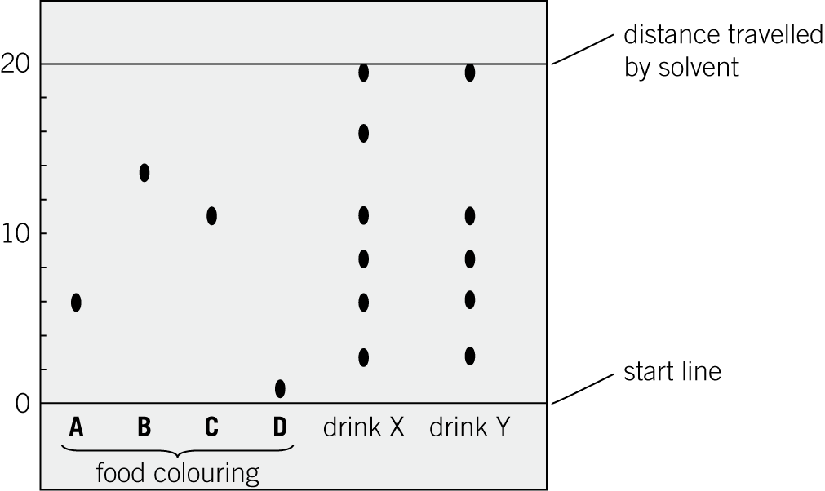

Chromatography experiments must be set up correctly to obtain useful results.

|  |  |  |  |
| --- | --- | --- | --- |
| **0** | **1** | **.** | **1** |

The student draws the start line in pencil.

Explain why.

(*1 mark*)

|  |  |  |  |
| --- | --- | --- | --- |
| **0** | **1** | **.** | **2** |

Describe what would happen if the solvent level is above the start line at the beginning of the experiment.

(*1 mark*)

|  |  |  |  |
| --- | --- | --- | --- |
| **0** | **1** | **.** | **3** |

Use the chromatogram to draw conclusions about the colourings in drinks **X** and **Y**.

(*3 marks*)

|  |  |  |  |
| --- | --- | --- | --- |
| **0** | **1** | **.** | **4** |

Artificial food colouring **A** has an *R*f value of 0.30, and travels 4.6 cm up the paper from the pencil start line.

Calculate the distance that the solvent moved up the paper.

Give your answer to an appropriate number of significant figures.

(*2 marks*)

|  |  |  |  |
| --- | --- | --- | --- |
| **0** | **2** |  |  |

A group of students had four different colourless solutions in beakers **1**, **2**, **3**, and **4**.

The students knew that the solutions were:

* sodium chloride
* sodium iodide
* sodium carbonate
* potassium carbonate.

They did **not** know which solution was in each beaker.

The teacher asked the students to plan a method that could be used to identify each solution.

She gave the students the following reagents to use:

* dilute nitric acid
* silver nitrate solution.

Outline a method the students could use to identify the four solutions.

You should include the results of the tests you describe.

(*6 marks*)

*AQA, 2014*

|  |  |  |  |
| --- | --- | --- | --- |
| **0** | **3** |  |  |

A student is given a solution of an unknown compound. He adds dilute nitric acid and then silver nitrate solution to the unknown compound. He observes that a white precipitate is formed.

|  |  |  |  |
| --- | --- | --- | --- |
| **0** | **3** | **.** | **1** |

Name the negative ion found in the unknown compound.

(*1 mark*)

|  |  |  |  |
| --- | --- | --- | --- |
| **0** | **3** | **.** | **2** |

Explain why a white precipitate is produced in this reaction.

(*2 marks*)

|  |  |  |  |
| --- | --- | --- | --- |
| **0** | **3** | **.** | **3** |

Describe a chemical test that a student could carry out to confirm that a compound contains carbonate ions.

(*2 marks*)

|  |  |  |  |
| --- | --- | --- | --- |
| **0** | **4** |  |  |

A scientist wants to know what colour a rocket will burn on Bonfire Night.

She:

1. Scrapes off a little of the chemical mixture from inside the rocket.
2. Uses a flame test on the mixture.

An orange-red flame is produced.

|  |  |  |  |
| --- | --- | --- | --- |
| **0** | **4** | **.** | **1** |

Give the formula of the metal ion detected by the scientist.

(*1 mark*)

|  |  |  |  |
| --- | --- | --- | --- |
| **0** | **4** | **.** | **2** |

Explain why the scientist cannot be certain that there is only one type of metal ion in the rocket chemicals.

(*1 mark*)

|  |  |  |  |
| --- | --- | --- | --- |
| **0** | **4** | **.** | **3** |

The following morning, the scientist finds a used rocket in the street. She wonders if she can tell what colour it had burned.

She uses a flame test on the residue from the inside of the rocket. No flame colour is produced.

Suggest why no flame colour is produced.

(*1 mark*)

|  |  |  |  |
| --- | --- | --- | --- |
| **0** | **4** | **.** | **4** |

The scientist then uses an instrumental method to test the rocket, and finds that there are mainly copper ions as well as a tiny number of lithium ions in the firework residues.

Name the instrumental method she used.

(*1 mark*)

|  |  |  |  |
| --- | --- | --- | --- |
| **0** | **4** | **.** | **5** |

Explain why the scientist can detect copper **and** lithium ions with the instrumental method but not with the flame test.

(*2 marks*)

|  |  |  |  |
| --- | --- | --- | --- |
| **0** | **4** | **.** | **6** |

Suggest what colour the second rocket burned on Bonfire Night.

(*1 mark*)

|  |  |  |  |
| --- | --- | --- | --- |
| **0** | **4** | **.** | **7** |

The scientist contacts the firework makers to find out what is in the rockets. She is told that each rocket contains a useful mixture of chemicals.

**Table 1**

|  |  |  |
| --- | --- | --- |
| Type of chemical | Mass in g | Purpose |
| propellant | 20 | chemical that acts as the fuel |
| oxidising agent | 16 | chemical that makes the fuel burn |
| metal salts | 4 | chemicals that give colour |

What name is given to a useful mixture like the rocket chemicals?

(*1 mark*)

|  |  |  |  |
| --- | --- | --- | --- |
| **0** | **4** | **.** | **8** |

Suggest what might happen if the makers accidently changed the proportions of the chemicals in the mixture.

(*1 mark*)

|  |  |  |  |
| --- | --- | --- | --- |
| **0** | **5** |  |  |

A student has solutions of three unknown ionic compounds, **A**, **B** and **C**.

He uses chemical tests to identify them.

**Table 2** contains their results.

**Table 2**

|  |  |  |  |  |  |
| --- | --- | --- | --- | --- | --- |
| Compound | Test | | | | |
| Flame test | Add sodium hydroxide solution | Add hydrochloric acid | Add hydrochloric acid and barium chloride solution | Add nitric acid and silver nitrate solution |
| **A** | crimson flame | no precipitate | carbon dioxide formed | no precipitate | no precipitate |
| **B** | no colour | brown precipitate | no reaction | no precipitate | cream precipitate |
| **C** | no colour | green precipitate | no reaction | white precipitate | no precipitate |

Name the two ions in compounds **A**, **B**, and **C**.

A

B

C (*3 marks*)