# Section Check In –

# PT: Pythagoras’ Theorem and Trigonometry

## Questions

1. In the triangle, cm and cm. Given that the area of the triangle is cm2, find the possible values of the angle.

[PT2]

2. Find the exact value of, giving your answer in the form .

[PT1]

3. Given that , find the possible values of  in the range 

[PT1]

4. Given the , find the exact value of;

(i) ,

(ii) .

[PT1,3]

5. Solve the equation  for .

[PT5]

6. Prove that .

[PT3,4]

7. Given that  is the obtuse angle such that , find the exact value of .

[PT1]

8. The triangle ABC has length AB=30 cm, AC = 23 cm and angle B = 38o.

Kate states that the angle C = 53.4o. Explain why Kate may not be correct.

[PT2]

9. A boat sails due north from a port. After going a distance of km, the boat changes direction and sails for a further km on a bearing of .

(i) How far is the boat now from the port?

(ii) On what bearing should the boat now sail to return directly to the port?

[PT6]

10. The sketch below shows a village green ABC which is bounded by three straight roads.

AB = 92 m, BC = 75 m and AC = 105 m.

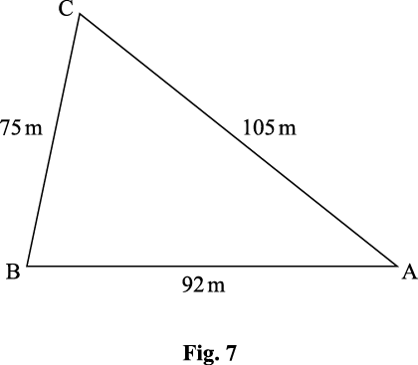

Calculate the area of the village green.

[PT6]

**Extension**

ABCD is a square, side length 8 cm. ABE are points on a circle, CE = DE.

Find the radius of the circle.

[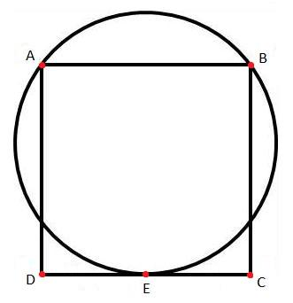](https://twitter.com/OCR_Maths/status/654986469413662720/photo/1)

## Worked solutions

1. Using Area ,  and therefore 

Angle  or 

2. 

3. 

 or 

4. (i) Using Pythagoras 



(ii) 

5. Equation is 

Using , 

Multiplying both sides by , 

Using identity  for the left-hand side,





Hence  giving solutions 

6. Left-hand side 

, using identities  and 



, cancelling 



7. Using Pythagoras 

Given that angle is obtuse 

8. 



Acute angle  , obtuse angle 

9.

A

P

3 km

40°

B

5 km

(i) Using cosine rule, 



Boat is km from the port

(ii) Using sine rule,  giving 

Bearing to sail 

10. Using cosine rule to find angle B



Area =  m2 (3sf)

**Extension**

Let O be the centre of the circle.

CE = 4 cm. Mark point N on BC such that ON parallel to EC. ON = 4 cm.







**OCR Resources**: *the small print*OCR’s resources are provided to support the delivery of OCR qualifications, but in no way constitute an endorsed teaching method that is required by the Board, and the decision to use them lies with the individual teacher. Whilst every effort is made to ensure the accuracy of the content, OCR cannot be held responsible for any errors or omissions within these resources.

© OCR 2019 - This resource may be freely copied and distributed, as long as the OCR logo and this message remain intact and OCR is acknowledged as the originator of this work.

OCR acknowledges the use of the following content: n/a

Please get in touch if you want to discuss the accessibility of resources we offer to support delivery of our qualifications: [resources.feedback@ocr.org.uk](mailto:resources.feedback@ocr.org.uk)

We’d like to know your view on the resources we produce. By clicking on ‘[Like](mailto:resources.feedback@ocr.org.uk?subject=I%20liked%20the%20FSMQ%20Check%20In:%20Pythagoras'%20theorem%20and%20trigonometry)’ or ‘[Dislike](mailto:resources.feedback@ocr.org.uk?subject=I%20disliked%20the%20FSMQ%20Check%20In:%20Pythagoras'%20theorem%20and%20trigonometry)’ you can help us to ensure that our resources work for you. When the email template pops up please add additional comments if you wish and then just click ‘Send’. Thank you.

Whether you already offer OCR qualifications, are new to OCR, or are considering switching from your current provider/awarding organisation, you can request more information by completing the Expression of Interest form which can be found here: [www.ocr.org.uk/expression-of-interest](http://www.ocr.org.uk/expression-of-interest)

Looking for a resource? There is now a quick and easy search tool to help find free resources for your qualification:   
[www.ocr.org.uk/i-want-to/find-resources/](http://www.ocr.org.uk/i-want-to/find-resources/)