|  |  |  |  |
| --- | --- | --- | --- |
| **0** | **1** | **.** | **1** |

Which of the following pairs are greenhouse gases?

Tick (✓) **one** box.

carbon dioxide and carbon particles

nitrogen and methane

methane and carbon dioxide

carbon dioxide and argon (*1 mark*)

|  |  |  |  |
| --- | --- | --- | --- |
| **0** | **1** | **.** | **2** |

What do most scientists base their beliefs about climate change on?

Tick (✓) **one** box.

research by oil companies

peer-reviewed evidence

public opinion

newspaper articles (*1 mark*)

|  |  |  |  |
| --- | --- | --- | --- |
| **0** | **1** | **.** | **3** |

Why is it difficult to be certain about the effect of greenhouse gases?

Tick (✓) **one** box.

modern cars produce less of the greenhouse gases

there is little scientific evidence

the global climate system is very complex

renewable energy is very unreliable (*1 mark*)

|  |  |  |  |
| --- | --- | --- | --- |
| **0** | **2** | **.** | **1** |

The early Earth’s surface and its atmosphere have changed over time (**Figure 1**).

**Figure 1**

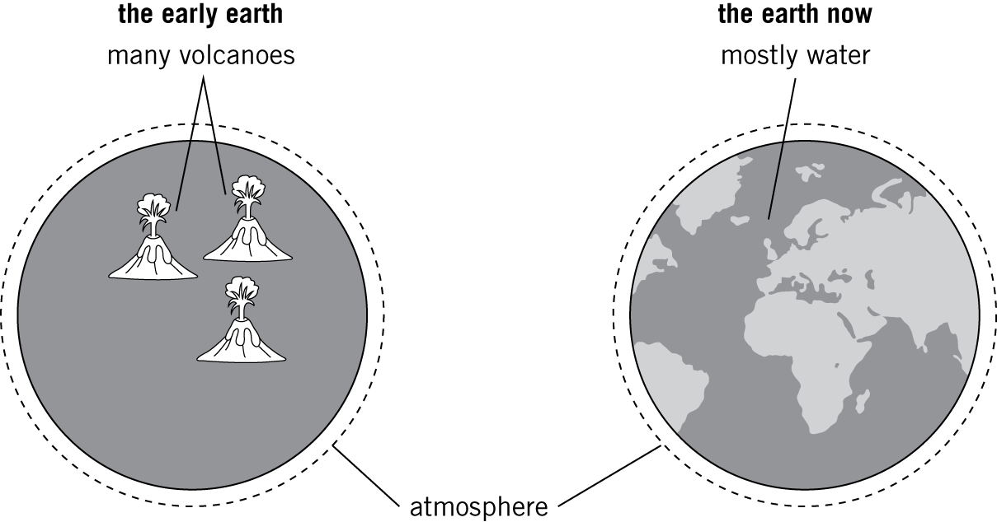

Describe **and** explain how the atmosphere of the early Earth changed into its atmosphere now.

(*6 marks*)

|  |  |  |  |
| --- | --- | --- | --- |
| **0** | **2** | **.** | **2** |

Some gases found in the Earth’s atmosphere are called greenhouse gases. Water vapour is a greenhouse gas.

Name **two** other greenhouse gases.

(*2 marks*)

|  |  |  |  |
| --- | --- | --- | --- |
| **0** | **3** |  |  |

Diesel fuels contain hydrocarbons.

When diesel engines are poorly maintained, the amount of oxygen reaching them to burn the fuel completely may become too low.

|  |  |  |  |
| --- | --- | --- | --- |
| **0** | **3** | **.** | **1** |

Name **two** harmful products of the incomplete combustion of diesel fuel.

Give the harmful effect of each product.

**Product 1:**

**Effect:**

**Product 2:**

**Effect:**  (*4 marks*)

|  |  |  |  |
| --- | --- | --- | --- |
| **0** | **3** | **.** | **2** |

The temperature inside a diesel engine is high enough for two atmospheric gases to react.

Name the pollutant formed.

Give the harmful effect of the pollutant.

(*2 marks*)

|  |  |  |  |
| --- | --- | --- | --- |
| **0** | **4** |  |  |

**Figure 2** shows how the Earth’s mean surface temperature varied between 1880 and 2005.

**Figure 2**

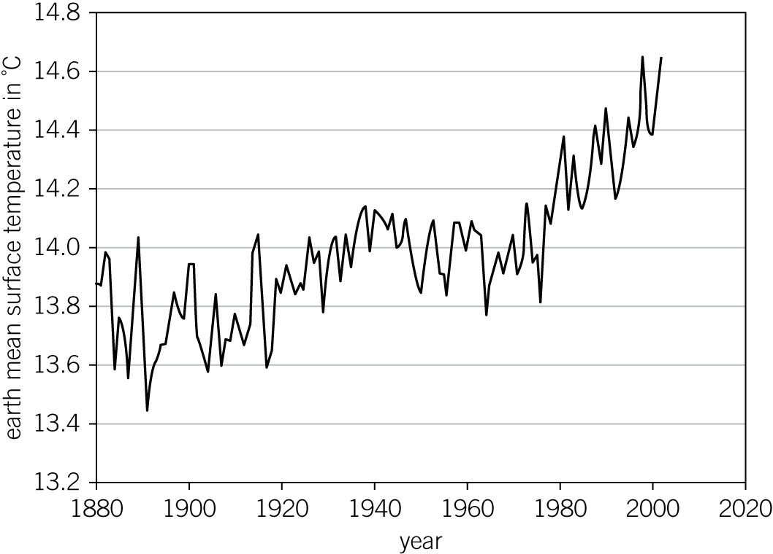

|  |  |  |  |
| --- | --- | --- | --- |
| **0** | **4** | **.** | **1** |

Describe **two** effects on the Earth’s weather systems if the pattern in **Figure 2** continues into the future.

(*2 marks*)

|  |  |  |  |
| --- | --- | --- | --- |
| **0** | **4** | **.** | **2** |

An international conference debates the following methods of reducing the rate of global warming:

* limiting the farming of beef cattle in South America
* increasing taxes on cars that use a lot of petrol or diesel
* increasing the amount of biofuel produced
* increasing grants to help people better insulate their homes.

Explain how **one** of these would help to reduce the rate of global warming.

Suggest what the economic and social impact of this would be on people’s lives.

(*3 marks*)

|  |  |  |  |
| --- | --- | --- | --- |
| **0** | **5** | **.** | **1** |

Acid rain can damage trees and kill animal and plant life.

Name the gas produced when fossil fuels are burnt that can cause acid rain.

(*1 mark*)

|  |  |  |  |
| --- | --- | --- | --- |
| **0** | **5** | **.** | **2** |

Suggest how the amount of acid rain caused by the burning of fossil fuels can be reduced.

(*2 marks*)

|  |  |  |  |
| --- | --- | --- | --- |
| **0** | **5** | **.** | **3** |

Forests can act as ‘carbon dioxide sinks’. They absorb carbon dioxide in the atmosphere and release oxygen through the process of photosynthesis.

The equation for photosynthesis is:

carbon dioxide + water → glucose + oxygen

Suggest how acid rain could further increase the effect of global climate change.

(*2 marks*)

|  |  |  |  |
| --- | --- | --- | --- |
| **0** | **6** | **.** | **1** |

Methane, CH4, is burnt in power stations.

Write the word equation for the complete combustion of methane.

(*2 marks*)

|  |  |  |  |
| --- | --- | --- | --- |
| **0** | **6** | **.** | **2** |

Define what is meant by the term **carbon footprint**.

(*1 mark*)