Paper or plastic?

Specification references

* C10.2.1 Life cycle assessment
* WS 1.3, 4.5

Aims

In this activity you will complete life cycle assessments (LCAs) for paper and plastic bags.

Learning outcomes

After completing this activity, you should be able to:

* state the different stages of an LCA in the correct order
* carry out an LCA for shopping bags made from plastic or paper with support
* explain the importance of LCAs and how they can be misused
* carry out LCAs for different products when data is supplied
* evaluate products in detail using LCAs
* assess advantages and disadvantages of using a certain material to make a product
* realise the importance and usefulness to society of LCAs
* state the limitation of LCAs especially with respect to cost.

Setting the scene

Increasingly, the manufacturing industry is using LCAs to assess the effect that the production, use, and disposal of a material can have on the environment. LCAs can also be used to compare the use of different materials for the same job or to compare the use of the same material for different jobs.

A simple LCA for a manufactured product can be made by listing the inputs in terms of raw materials and energy, and the outputs in terms of environmental impacts and coproducts.

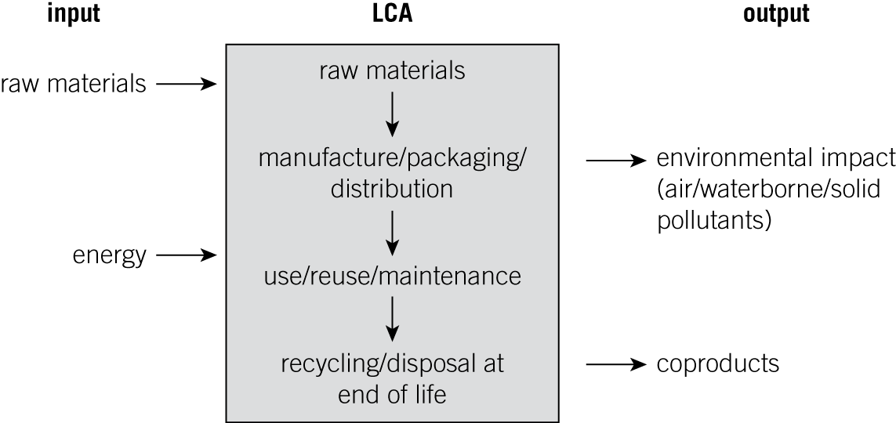

Task

Complete the table for paper and plastic bags by adding your own ratings on a scale of 1 (worst) to 10 (best) for the inputs and outputs. Which bag ‘wins’?

|  |  |  |  |
| --- | --- | --- | --- |
|  |  | Paper bag | Plastic bag |
| INPUT | raw material |  |  |
| energy input |  |  |
| OUTPUT | environmental impact |  |  |
| coproducts |  |  |
|  | total |  |  |

Questions

1 a For each type of bag, name the raw material and classify it as a renewable (sustainable) or non-renewable (finite resource):

i paper bag

ii plastic bag

(*2 marks*)

b Name two possible air pollutants produced if you burn a paper bag.

(*2 marks*)

c Identify a pollution problem with plastic bags.

(*2 marks*)

2 a State two advantages of paper bags over plastic bags.

(*2 marks*)

b State two disadvantages of paper bags compared with plastic bags.

(*2 marks*)

c 1000 paper sacks have a mass of 65 kg and a height when stacked of 110 cm. 1000 plastic sacks have a mass of 6 kg and a height when stacked of 9 cm. What effects do these facts have on the LCAs of paper and plastic?

(*2 marks*)

3 Below are six possible stages in a full LCA, but they are not in the correct order in which they should be carried out. Draw a line to link each stage to its correct step.

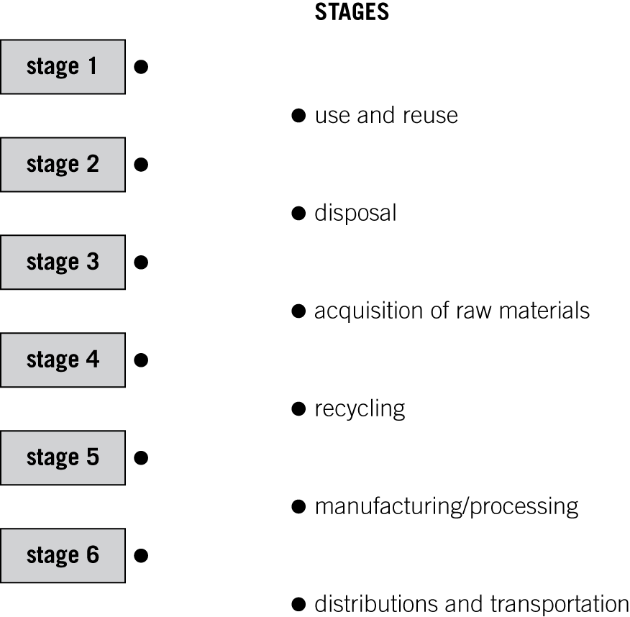 (*5 marks*)

Student follow-up

1 The instruction sheet on a packet of drugs has four key sections:

* what type of drug it is
* how to take the drug
* expected outcomes
* possible side effects of the drug.

State how each of these four sections matches up with a different stage in a LCA.

(*4 marks*)

2 LCAs are devised to evaluate products. However, for businesses cost is a major factor in the choice of a raw material/method of manufacture. Explain how this could affect a business’s evaluation of the inputs and outputs of an LCA.

(*4 marks*)