Paper or plastic?

Specification references

* C10.2.1 Life cycle assessment
* WS 1.3, 4.5

Aims

In this activity students will complete Life Cycle Assessments (LCAs) for paper and plastic bags.

Learning outcomes

After completing this activity, students should be able to:

* state the different stages of an LCA in the correct order
* carry out an LCA for shopping bags made from plastic or paper with support
* explain the importance of LCAs and how they can be misused
* carry out LCAs for different products when data is supplied
* evaluate products in detail using LCAs
* assess advantages and disadvantages of using a certain material to make a product
* realise the importance and usefulness to society of LCAs
* state the limitation of LCAs especially with respect to cost.

Teacher notes

Collect data from the class for the LCA values for plastic and paper bags. Ask students to calculate the mean from these data and work out which bag the class thinks is best.

The more able students could then be asked to choose a pair of products that do the same job but are made from different materials. Then devise LCAs on each product to decide which is best.

A possible extension activity is to look at biodegradable plastics. Students could use the internet to find out about the plastic PVA (polyvinylamine) and how it can be added to wood pulp when making paper bags. Such bags are water-resistant, tough, and easy to dispose of.

Answers

1 a i trees/wood pulp; renewable (sustainable)

ii crude oil/petroleum; non-renewable (finite resource) (*2 marks*)

b any two of: carbon dioxide gas/carbon monoxide gas/particles of carbon (*2 marks*)

c non-biodegradable (1) so builds up at waste sites/landfill (1) (*2 marks*)

2 a any two of: renewable resource/non-see through/easy to dispose of (*2 marks*)

b any two of: not very strong/not waterproof/can’t see inside (*2 marks*)

c Much easier and cheaper to transport plastic sacks as lighter and occupy less space. (*2 marks*)

3 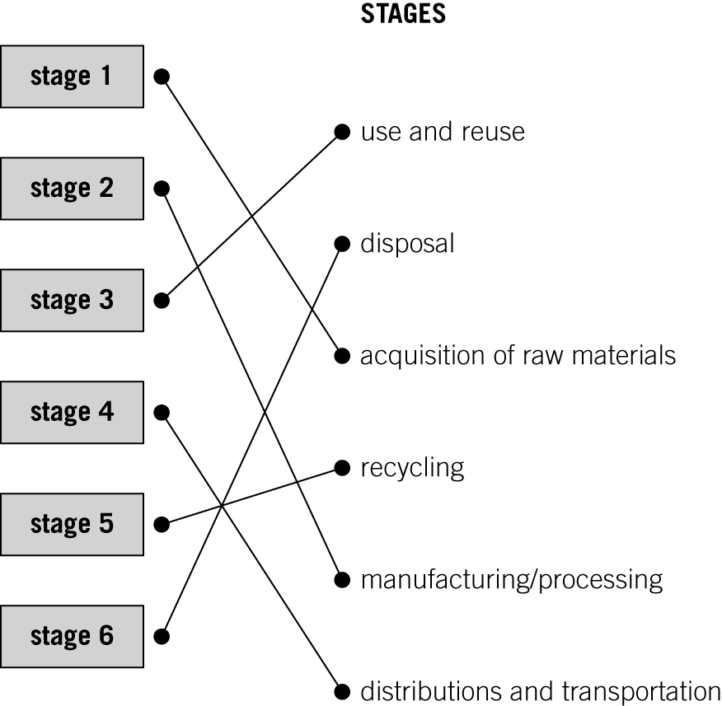 (*5 marks*)

Student follow-up answers

1 • what type of drug it is → relate to the ‘raw materials’ used to make the drug

* how to take the drug → use and reuse
* expected outcomes → relate to a positive output of process
* possible side effects of the drug → unwanted side effects could relate to unwanted pollution effects from a manufacturing process (*4 marks*)

2 For many companies, cost often cancels out environmental factors. The cost of inputs like energy and raw materials are fundamental in deciding methods of manufacture. Companies can only manufacture products if they make profits. The only output that helps to make profit is the product and coproducts. Environmental factors do not help profits unless there are government grants to reduce pollutants. (*4 marks*)