Explaining Physical Changes (Blue level)

1. If 50 cm3 of alcohol is mixed with 50 cm3 of water, which of the following statements is true? [1 mark]

a) The mass of the mixture is less than the sum of the mass of alcohol and the mass of water

b) The mass of the mixture is more than the sum of the mass of alcohol and the mass of water

c) The volume of the mixture is less than 100 cm3

d) The volume of the mixture is more than 100 cm3

2. Puddles dry up in sunshine. What type of change is happening? [1 mark]

a) Decomposition

b) Evaporation

c) Sublimation

d) Condensation

3. Damp clothes dry quicker if they are spread out in a warm breeze. Which of these statements is untrue?   
[1 mark]

a) Increasing the surface area increases the rate of evaporation

b) Water evaporates slower at lower temperatures

c) Moving air is better at drying clothes

d) Increasing the temperature of air decreases the rate of evaporation

4. James is investigating solubility. He adds sugar to water and stirs it. The sugar disappears.   
Which of these is true? [1 mark]

a) If he keeps adding sugar he won’t be able to get it all to dissolve.

b) If the water is cooler, he will be able to dissolve more sugar in it.

c) The sugar hasn’t really disappeared; if he looked carefully he could see the tiny particles in the solution.

d) Stirring affects how much sugar dissolves and how quickly.

5. Look at the picture. [2 marks]

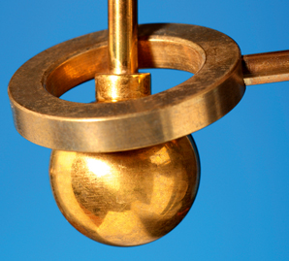

Describe what happens if the metal ball is heated, but the metal ring is not heated.

6. Jemma’s journey to and from school includes crossing a large, steel bridge. In the road surface near one end is a narrow gap, across the road. Her teacher tells her it’s an expansion gap.

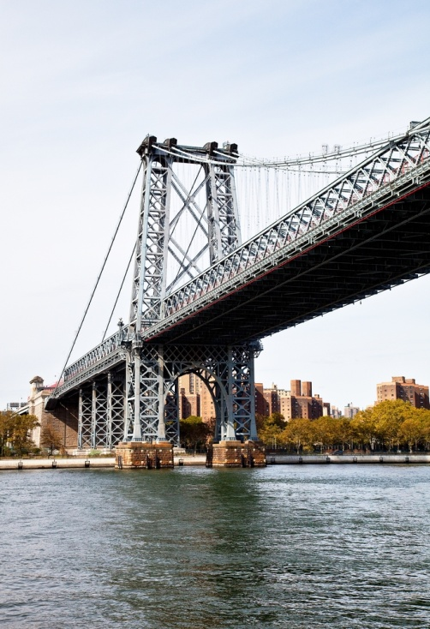

Explain why an expansion gap is needed and how it works. [4 marks]

7. Describe the difference between a physical change and a chemical change in terms of the substances present before and after the change. [2 marks]

8. Somebody walks into the laboratory carrying a beaker with a smelly liquid in it. You are sitting at the opposite end of the laboratory. Explain why you do not immediately smell the liquid. [2 marks]

9. Abi is practising an experiment to show younger pupils. She sets up three candles of different heights in a glass tank. She pours carbon dioxide into the tank (taking care not to pour it straight onto the candles). First the shortest candle goes out, then the middle one and then the tallest one. Explain what this shows about carbon dioxide.   
[2 marks]

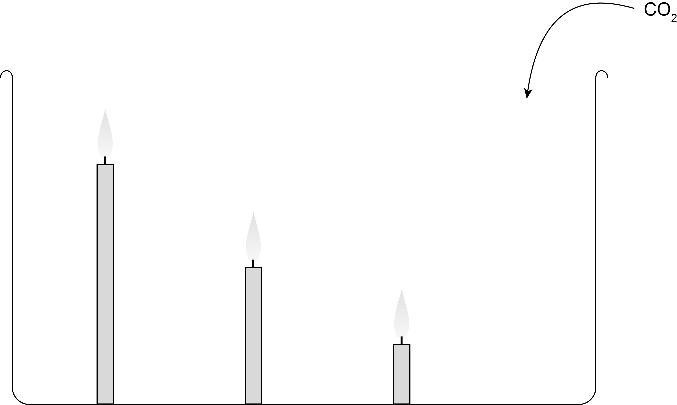

10. Describe how an alcohol thermometer works. [4 marks]

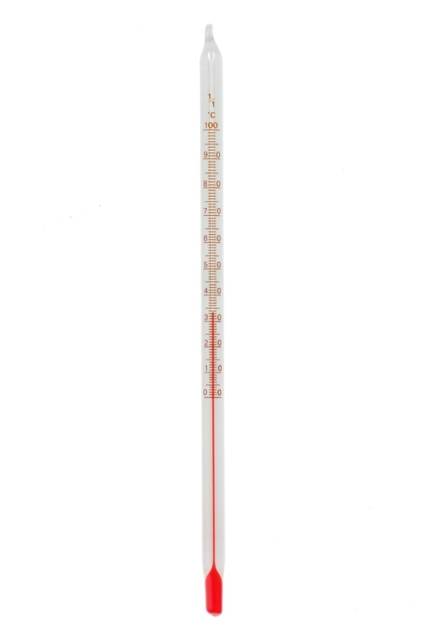

11. Describe and explain the difference between the malleability and ductility of a solid. [4 marks]

12. A metal is represented by the diagram below, in which each coloured circle represents a different element.

S:\Amanda Redstone\16004_P043a_c.jpg

What does this show about the metal? [2 marks]

13. Lucy puts some cooking oil and some water in a boiling tube and shakes it. She then examines it carefully. The oil and water separate out, with the oil floating on top of the water. Shaking it harder produces the same result.

Explain what this experiment shows. [4 marks]

TOTAL\_\_\_\_\_/30