|  |  |  |  |
| --- | --- | --- | --- |
| **0** | **1** |  |  |

Use words or phrases from the box to complete the following sentences about pure and impure substances.

**element colour smell**

**melting point compound atom**

Substances that are chemically pure contain only one or .

A pure substance can be identified by its . (*3 marks*)

|  |  |  |  |
| --- | --- | --- | --- |
| **0** | **2** |  |  |

A solution of sodium hydroxide can be used to identify solutions that contain iron(II) or iron(III) ions.

Draw a line to link each metal ion to the colour of the precipitate it would form with sodium hydroxide solution.

Draw **two** lines.

|  |  |  |
| --- | --- | --- |
|  |  | white |
| iron(II) |  |  |
|  |  | blue |
|  |  |  |
| iron(III) |  | brown |
|  |  |  |
|  |  | green |

(*2 marks*)

|  |  |  |  |
| --- | --- | --- | --- |
| **0** | **3** |  |  |

A student is given a mixture of two compounds, **A** and **B**. He is asked to carry out a flame test to identify the two compounds in the mixture.

|  |  |  |  |
| --- | --- | --- | --- |
| **0** | **3** | **.** | **1** |

Describe what the student should do to carry out a flame test.

(*2 marks*)

|  |  |  |  |
| --- | --- | --- | --- |
| **0** | **3** | **.** | **2** |

Compound **A** contains sodium ions.

Name the colour produced in a flame test by sodium ions.

(*1 mark*)

|  |  |  |  |
| --- | --- | --- | --- |
| **0** | **3** | **.** | **3** |

Compound **B** contains potassium ions.

Name the colour produced in a flame test by potassium ions.

(*1 mark*)

|  |  |  |  |
| --- | --- | --- | --- |
| **0** | **3** | **.** | **4** |

Explain why the student would not be able to tell from the flame that the mixture contains both sodium and potassium ions.

(*2 marks*)

|  |  |  |  |
| --- | --- | --- | --- |
| **0** | **3** | **.** | **5** |

The student added hydrochloric acid to compound **A**.

Carbon dioxide was produced.

Describe the chemical test that the student should carry out to confirm that carbon dioxide was produced.

(*2 marks*)

|  |  |  |  |
| --- | --- | --- | --- |
| **0** | **3** | **.** | **6** |

Name compound **A**.

(*1 mark*)

|  |  |  |  |
| --- | --- | --- | --- |
| **0** | **4** |  |  |

A student wants to identify a sample of an unknown compound. She places a solution of the unknown compound in a test tube. First she adds nitric acid and then silver nitrate solution to the sample. A white precipitate is seen.

She then carries out a flame test with another sample of the unknown compound. A crimson colour is seen.

Name the unknown compound.

(*1 mark*)

|  |  |  |  |
| --- | --- | --- | --- |
| **0** | **5** |  |  |

Link the four gases below with the correct test to determine their presence, and the test result.

Draw **eight** lines.

|  |  |  |  |  |
| --- | --- | --- | --- | --- |
| Gas |  | Test |  | Result |
|  |  |  |  |  |
| chlorine |  | burning splint |  | pop |
|  |  |  |  |  |
| hydrogen |  | glowing splint |  | bleached |
|  |  |  |  |  |
| carbon dioxide |  | limewater |  | relights |
|  |  |  |  |  |
| oxygen |  | damp litmus paper |  | milky |

(*4 marks*)

|  |  |  |  |
| --- | --- | --- | --- |
| **0** | **6** |  |  |

A student uses chromatography to see if artificial food colourings are used in two soft drinks, **X** and **Y**.

The results are shown on the chromatogram (**Figure 1**).

**Figure 1**

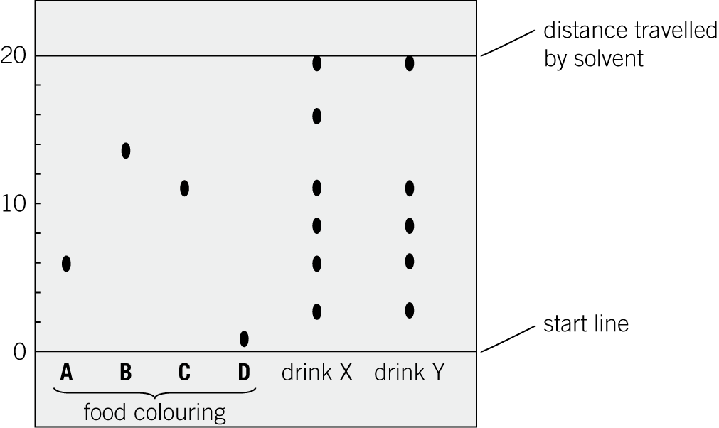

Chromatography experiments must be set up correctly to obtain useful results.

|  |  |  |  |
| --- | --- | --- | --- |
| **0** | **6** | **.** | **1** |

The student draws the start line in pencil.

Explain why.

(*1 mark*)

|  |  |  |  |
| --- | --- | --- | --- |
| **0** | **6** | **.** | **2** |

Use the chromatogram in **Figure 1** to draw conclusions about the colourings in drinks **X** and **Y**.

(*3 marks*)

|  |  |  |  |
| --- | --- | --- | --- |
| **0** | **6** | **.** | **3** |

In chromatography, the *R*f value  

Which artificial food colouring, **A**, **B**, **C**, or **D**, has an *R*f value of 0.3?

(*1 mark*)

|  |  |  |  |
| --- | --- | --- | --- |
| **0** | **7** |  |  |

A group of students had four different colourless solutions in beakers **1**, **2**, **3**, and **4**.

The students knew that the solutions were:

* sodium chloride
* sodium iodide
* sodium carbonate
* potassium carbonate.

They did **not** know which solution was in each beaker.

The teacher asked the students to plan a method that could be used to identify each solution.

The students were given the following reagents to use:

* dilute nitric acid
* silver nitrate solution.

The teacher suggested using a flame test to identify the positive ions.

Outline a method the students could use to identify the four solutions.

You should include the results of the tests you describe.

(*6 marks*)

*AQA, 2014*