|  |  |  |  |
| --- | --- | --- | --- |
| **0** | **1** |  |  |

Use words or phrases from the box to complete the following sentences about sedimentary rocks and fossil fuels.

**limestone fishes coal**

**plankton natural gas sulfur dioxide**

When the skeletons and shells of huge numbers of marine organisms built up on the sea bed over millions of years, carbonate rocks such as were formed.

When trees and ferns were buried in swamps, was formed over millions of years.

Crude oil was formed when the remains of were covered by sediment. (*3 marks*)

|  |  |  |  |
| --- | --- | --- | --- |
| **0** | **2** |  |  |

**Figure 1** shows how the Earth’s mean surface temperature varied between 1880 and 2005.

**Figure 1**

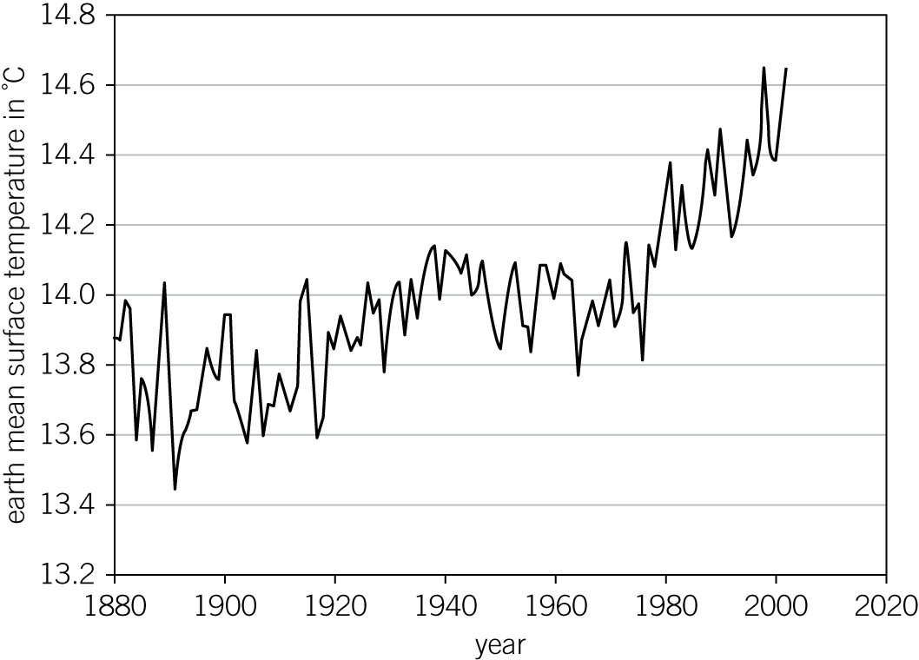

|  |  |  |  |
| --- | --- | --- | --- |
| **0** | **2** | **.** | **1** |

Give **two** consequences for the Earth if the mean surface temperature pattern in **Figure 1** continues into the future.

Tick (✓) **two** boxes.

less sunlight reaching the Earth

damage to limestone buildings

changes in rainfall patterns

more extreme storms

increasing levels of asthma (*2 marks*)

|  |  |  |  |
| --- | --- | --- | --- |
| **0** | **2** | **.** | **2** |

An international conference debates the following methods of reducing the rate of global warming:

* limiting the farming of beef cattle in South America
* increasing the amount of biofuel produced
* increasing grants to help people better insulate their homes.

Suggest how each of these would help to reduce the rate of global warming.

Limiting the farming of beef cattle in South America.

(*1 mark*)

Increasing the amount of biofuel produced.

(*1 mark*)

Increasing grants to help people better insulate their homes.

(*1 mark*)

|  |  |  |  |
| --- | --- | --- | --- |
| **0** | **3** |  |  |

Diesel fuels contain hydrocarbons.

When diesel engines are poorly maintained, the amount of oxygen reaching them may become too low to burn the fuel completely.

The temperature inside a diesel engine is high enough for two atmospheric gases to react.

Draw **three** lines to link each polluting exhaust emission from diesel engines with its effect.

|  |  |  |
| --- | --- | --- |
| Emission |  | Effect |
|  |  |  |
|  |  | damage to limestone buildings |
| carbon monoxide |  |  |
|  |  | less oxygen carried by red blood cells |
| carbon particles |  |  |
|  |  | increase in fossil fuel use |
| nitrogen oxides |  |  |
|  |  | sunlight reflected back into space |

(*3 marks*)

|  |  |  |  |
| --- | --- | --- | --- |
| **0** | **4** | **.** | **1** |

Which of the following pairs are greenhouse gases?

Tick (✓) **one** box.

carbon dioxide and carbon particles

nitrogen and methane

methane and carbon dioxide

carbon dioxide and argon (*1 mark*)

|  |  |  |  |
| --- | --- | --- | --- |
| **0** | **4** | **.** | **2** |

What do most scientists base their beliefs about climate change on?

Tick (✓) **one** box.

research by oil companies

peer-reviewed evidence

public opinion

newspaper articles (*1 mark*)

|  |  |  |  |
| --- | --- | --- | --- |
| **0** | **4** | **.** | **3** |

Why is it difficult to be certain about the effects of greenhouse gases?

Tick (✓) **one** box.

modern cars produce less of the greenhouse gases

there is little scientific evidence

the global climate system is very complex

renewable energy is very unreliable (*1 mark*)

|  |  |  |  |
| --- | --- | --- | --- |
| **0** | **5** |  |  |

The early Earth’s surface and its atmosphere have changed through time (**Figure 2**).

**Figure 2**

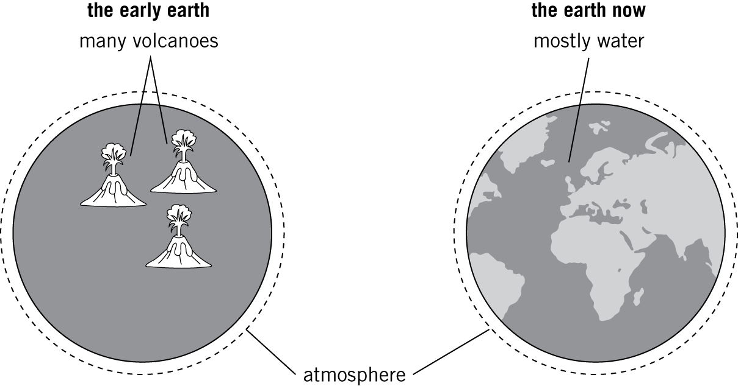

|  |  |  |  |
| --- | --- | --- | --- |
| **0** | **5** | **.** | **1** |

Describe **and** explain how the atmosphere of the early Earth changed into its atmosphere now.

(*6 marks*)

|  |  |  |  |
| --- | --- | --- | --- |
| **0** | **5** | **.** | **2** |

**Table 1** shows the percentage composition of gases in the atmosphere today.

Give the names of the missing gases to complete **Table 1**. (*3 marks*)

**Table 1**

|  |  |
| --- | --- |
| Gas | Percentage composition of air today |
| argon | 0.90 |
|  | 0.04 |
|  | 78.00 |
|  | 21.00 |
| other gases | trace amounts |

|  |  |  |  |
| --- | --- | --- | --- |
| **0** | **5** | **.** | **3** |

Acid rain can damage trees and kill animal and plant life.

Name the gas produced when fossil fuels are burnt that can cause acid rain.

(*1 mark*)

|  |  |  |  |
| --- | --- | --- | --- |
| **0** | **5** | **.** | **4** |

Suggest how the amount of acid rain caused when fossil fuels are burnt can be reduced.

(*2 marks*)

|  |  |  |  |
| --- | --- | --- | --- |
| **0** | **5** | **.** | **5** |

Forests can act as ‘carbon dioxide sinks’. They absorb carbon dioxide in the atmosphere and release oxygen during the process of photosynthesis.

The equation for photosynthesis is:

carbon dioxide + water → glucose + oxygen

Suggest how acid rain could further increase the effect of global climate change.

(*2 marks*)

|  |  |  |  |
| --- | --- | --- | --- |
| **0** | **5** | **.** | **6** |

Methane, CH4, is burnt in power stations. If methane is burnt in a limited supply of oxygen incomplete combustion can occur.

Name **two** pollutants that can be released by the incomplete combustion of methane.

(*2 marks*)