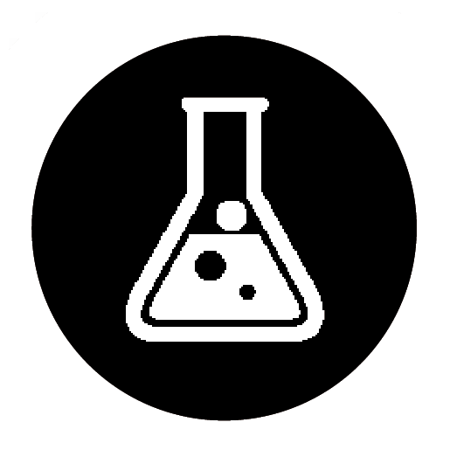 Analysis and purification of water samples

Specification references:

* **Required practical 13**: Analysis and purification of water samples from different sources, including pH, dissolved solids, and distillation.
* C10.1.2 Potable water
* AT 2–4
* WS 2.3–2.7

Aims

In this required practical students will plan and carry out an experiment that uses distillation to collect pure water from a solution. Students will then test the water to show that it is pure.

Learning outcomes

After completing this practical, students should be able to:

**Aiming for 4**

* safely distil salty water
* outline a method for distillation, recalling the names of the apparatus used
* use a thermometer to measure boiling points.

**Aiming for 6**

* safely distil salty water
* describe and explain in detail how to safely distil salty water
* recognise the risks associated with distillation and work safely
* accurately measure temperature to ±1 °C
* comment on the purity of the distillate.

**Aiming for 8**

* safely distil salty water
* describe and explain in detail how to safely distil salty water
* write a detailed method, including how boiling point can be measured and used to determine the identity and purity of the distillate
* recognise and give justifications for how risks can be minimised in a distillation experiment
* evaluate the purity of the product
* justify the use of distillation to make portable water.

Teacher notes

This practical uses simple apparatus rather than a condenser, as students will find such a setup easier to use. The teacher could use a condenser to carry out a class demonstration of distillation.

Reduce the risk for Aiming for grade 4 students by using water coloured with food colouring as the solution to separate. Students could also use an IR thermometer gun to measure the temperature, so there is no need to read a scale.

Wrapping a cold damp cloth around the delivery tube, held in place with elastic bands, will help to condense the distillate.

Some students may have suitable dexterity to use quick fit apparatus for the distillation. You may wish to allow students to complete a fractional distillation of an ink, ethanol, and water mixture. Use the boiling point of the first distillate to identify the ethanol and that of the second distillate to identify the water.

Ensure that all plans are checked for safety before the student attempts the experiment. Key points to be aware of are that glassware will become hot when heated, the vapours can cause scalds, and the distillation equipment must have a vent to prevent pressurisation and risk of explosion. Make sure that a water bath is used to heat the ethanol and that no naked flames are used.

Three versions of the student sheet are supplied: Aiming for grade 4, Aiming for grade 6, and Aiming for grade 8. These give varying levels of support.

* At the start of the lesson students can be reminded of the meaning of pure by comparing the purity of distilled water, tap water, and mineral water. Only distilled water is pure as it contains only water molecules.
* The main aim of the experiment can be introduced, stressing that students need to separate the solution and that this could be extended to test the purity of the distillate.
* After giving out the student sheets, a class discussion will be helpful to ensure that students understand the main stages of distillation and how the distillate can be identified by the temperature of the vapour. Students should be encouraged to look back at previous work on mixtures to help them.

Answers

**Aiming for grade 4**

1 a orange (*1 mark*)

b This is the hottest flame and could injure a person or cause a fire. (*1 mark*)

c Any sensible suggestion, for example, use a flame proof mat, always leave on the orange flame, ignite on the orange flame, set up in the centre of the bench, tie long hair back. (*1 mark*)

2 A pure substance has a sharp boiling point and it is unique (1). By measuring the boiling point, it can be compared to trusted data, for example, a data book, and the substance can be identified (1). (*2 marks*)

3 If the substance is pure, one clear boiling point would be measured (1).

If there is a range, then the substance is a mixture (1).

The wider the range, the greater the amount of impurities (1). (*3 marks*)

**Aiming for grade 6**

1 The bulb of the thermometer is where the temperature is taken (1).

It needs to be in line with the opening of the delivery tube so the vapour temperature, which is the boiling point of the liquid, is taken (1). (*2 marks*)

2 To prevent parallax error. (*1 mark*)

3 So that the mixture doesn’t bubble too much (1) and some travels through the delivery tube (1) reducing the purity of the distillate (1). (*3 marks*)

4 Anhydrous copper sulfate indicates that water is present but not the purity (1). At sea level pure water will boil at exactly 100 °C (1) and this is the only chemical that will boil at exactly this temperature under normal atmospheric conditions (1). (*3 marks*)

**Aiming for grade 8**

1 Simple distillation is a separation technique that is used to separate solutions where the solvent is the desired product (1). Fractional distillation is a separation technique used to separate a liquid mixture of different miscible chemicals (1), each with a different boiling point (1). (*3 marks*)

2 Any three of: Ethanol is flammable; the naked flame of the Bunsen burner could cause the distillate to catch fire; the heating is more easily controlled; less likely to burn yourself. (*3 marks*)

3 Students should calculate the percentage difference (1). For stating the expression (1); for correctly calculating their percentage difference (1); for using this to evaluate their distillation, i.e. the smaller this value, the more accurate their result is (1). (*4 marks*)

4 Yield would increase (1) as no vapours are lost to the atmosphere (1) so more distillate would condense (1). (*3 marks*)

Technician notes

Safety

* no naked flames if using flammable solvents
* remember that the blue flame of the Bunsen burner is for heating and can cause burns
* the glassware will get hot, make sure it cools before students touch it
* steam from the boiling mixture can cause scalds
* wear eye protection.

Equipment

|  |  |
| --- | --- |
| * solution to separate * flame proof mat * two-hole bung * gauze * ‘n’ shape delivery tube * large beaker * anti-bumping granules or broken pottery * water bath | * Bunsen burner * conical flask * tripod * spirit thermometer –10–110 °C * boiling tube * crushed ice * pH meter |