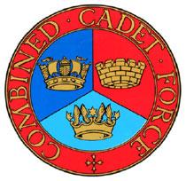

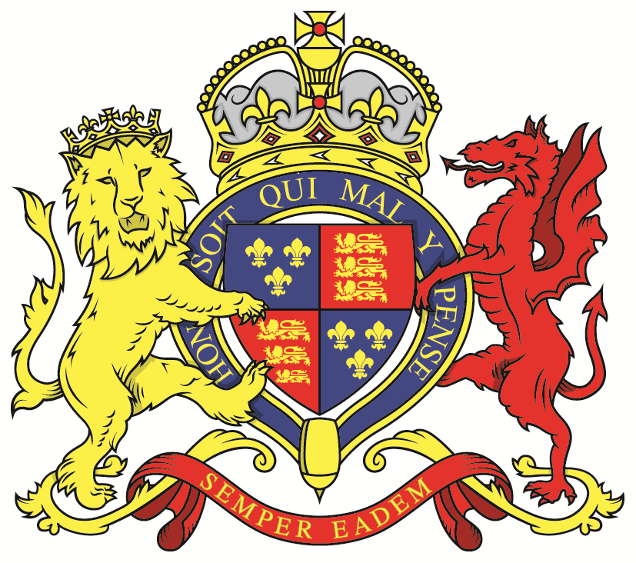

**How to Wear your Uniform Correctly**

* Bush hat/beret must be worn travelling to/from school, outside around school in the day and when on parade. Neck strap does not have to be worn.
* Hair must be neat and not too long.

College regulations apply – clear of ears, eyes and collar.

* Collar must be ironed flat.
* Sleeves are to be folded (not just rolled) neatly with a 3 finger width.
* Jacket (looks like a shirt) must be tucked in with the creases gathered at the side.
* Smock (looks like a jacket) can be worn in the case of bad weather.
* Rank slide must be worn the correct way up (Cadet at top) on the outermost layer – change it when you change your jacket/smock.
* Belt must be tight and slides pushed in to the centre as far as possible. Male part on the right, female on the left.
* Trousers should be pressed but should not have creases down the middle. Pockets should be pressed flat and fastened closed.
* Trouser ties must be drawn so the bottom of the trousers look neat. Any laces (boot or trouser ties) must be hidden out of sight.
* Laces must be tight.

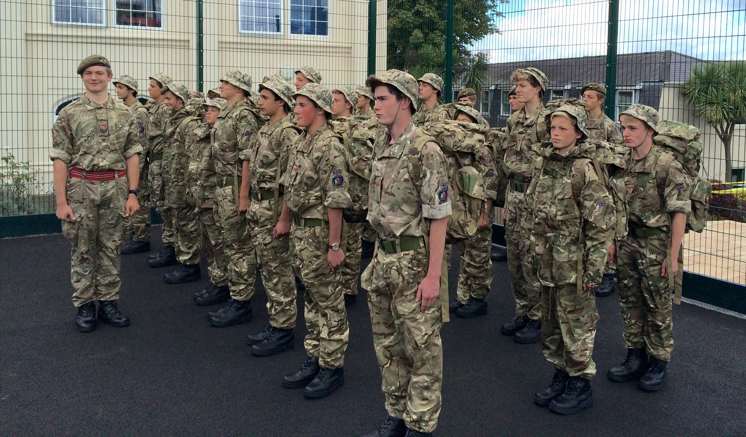

* BOOTS MUST BE POLISHED.   
  No scuffs from playing football etc.
* It is worth checking over each other’s   
  uniform before going onto the parade square.