Working with data

You have probably never heard of *Yersinia pestis*. It is the bacterium which was responsible for the great outbreaks of plague which swept through Europe in the Middle Ages. The Black Death was the worst of these and killed almost a quarter of the entire population of Europe, while the Great Plague of 1665 had a terrible effect on London and other British cities (Figure 1).

**Figure 1** Burying the dead during the Great Plague in 1665. Detailed records made at the time have allowed us to follow the course of the disease in detail as it swept through London

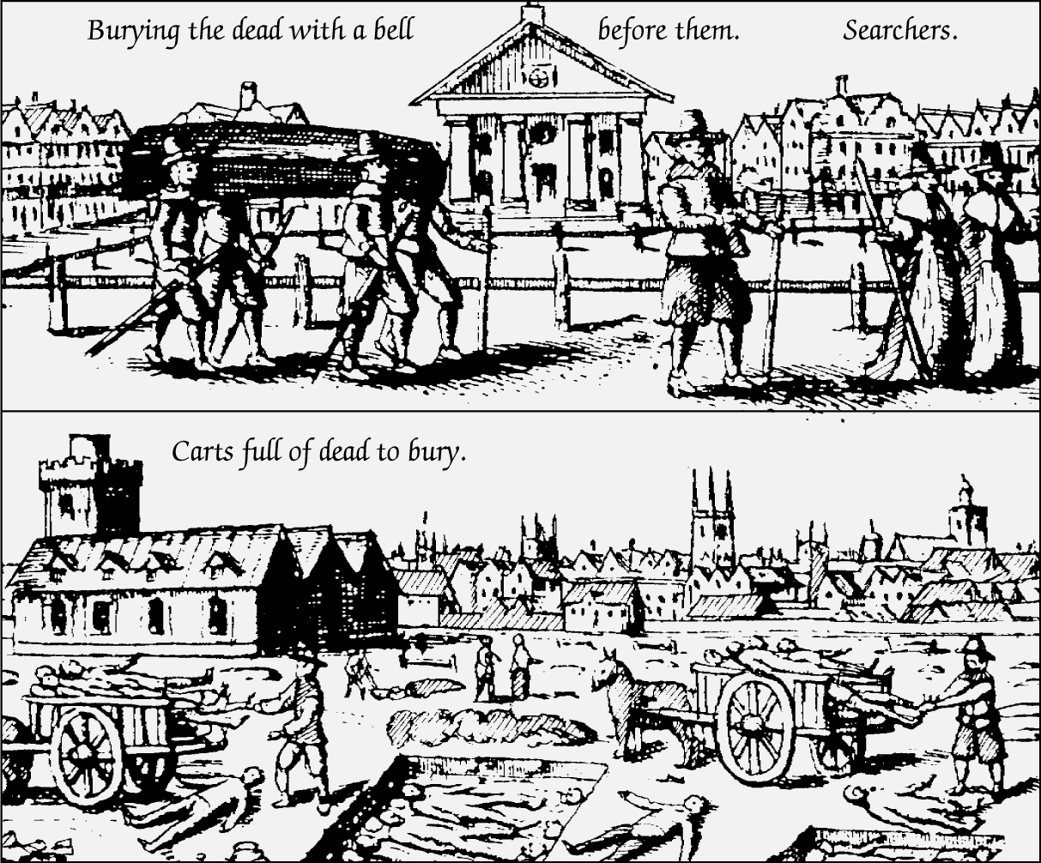

The data given below come from *‘A Journal of the Plague Year’*, a book written by the novelist Daniel Defoe and published in 1722. He took the facts and figures about the number of people dying and built a novel round them. Although the book is fiction, the figures that it contains are accurate.

PTO

|  |  |  |
| --- | --- | --- |
|  | **Dead from all diseases** | **Dead from diseases other than plague** |
| **From 15 to 21 August** |  | 1331 |
| **From 22 to 28 August** | 7496 | 1394 |
| **From 29 August to 4 September** | 8252 | 1264 |
| **From 5 to 11 September** | 7690 | 1056 |
| **From 12 to 18 September** | 8297 | 1132 |
| **From 19 to 25 September** | 6460 | 927 |

The numbers of some particular articles of distempers:

|  |  |  |  |  |  |  |  |
| --- | --- | --- | --- | --- | --- | --- | --- |
|  | **Aug 8-14** | **Aug 15-21** | **Aug 22-28** | **Aug 29-Sept 4** | **Sept 5-11** | **Sept 12-18** | **Sept 19-25** |
| **Fever** | 353 | 348 | 383 | 364 | 332 | 309 | 268 |
| **Spotted fever** | 190 | 166 | 165 | 157 | 97 | 101 | 65 |
| **Surfeit** | 87 | 74 | 99 | 68 | 45 | 49 | 36 |
| **Teeth** | 113 | 111 | 133 | 138 | 128 | 121 | 112 |
| **Total** | 743 | 699 | 780 | 727 | 602 | 580 | 481 |

1 Use these figures to construct a single table showing the causes of death in London in August and September 1665. Before you start you will need to look carefully at the figures and make sure that you understand the information they show. In particular you will need to think about the following:

* The weeks for which the data are complete.
* What information you need to work out before you complete your table.
* How to combine this material into a single table. (*5 marks*)

2 (a) Calculate the percentage of deaths due to plague for each week from Defoe’s data.

Include this data in your table. Show your working for one example. (3 *marks*)

(b) Explain why knowing the percentage of deaths due to plague allows us to make a better comparison of the effects of different outbreaks of the disease. (*2 marks*)

3 The figures about the causes of death shown here are not as reliable as figures about causes of death collected today. Suggest **two** reasons for this. (*2 marks*)