**Graphing and Maths Skills in Chemistry – Practice Questions**

**Name: ……………………………. Mark: ………/31 Grade: ………**

**Q1.**

Lithium carbonate reacts with dilute hydrochloric acid.

A group of students investigated the volume of gas produced.

This is the method used.

1.       Place a known mass of lithium carbonate in a conical flask.

2.       Measure 10 cm3 of dilute hydrochloric acid using a measuring cylinder.

3.       Pour the acid into the conical flask.

4.       Place a bung in the flask and collect the gas as shown in **Figure 1**.

**Figure 1**

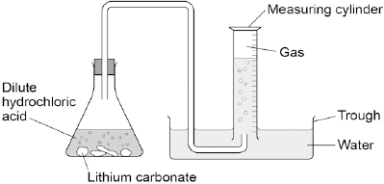

(a)     **Figure 2** shows the measuring cylinder.

**Figure 2**

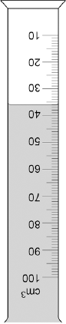

What volume of gas has been collected? Volume = __________________ cm3

**(1)**

(b)     The table below shows the students’ results.

|  |  |
| --- | --- |
| **Mass of lithium carbonate in g** | **Volume of gas in cm3** |
| 0.0 | 0 |
| 0.1 | 22 |
| 0.2 | 44 |
| 0.3 | 50 |
| 0.4 | 88 |
| 0.5 | 96 |
| 0.6 | 96 |
| 0.7 | 96 |

On **Figure 3**:

•        Plot these results on the grid.

•        Complete the graph by drawing **two** straight lines of best fit.

**Figure 3**

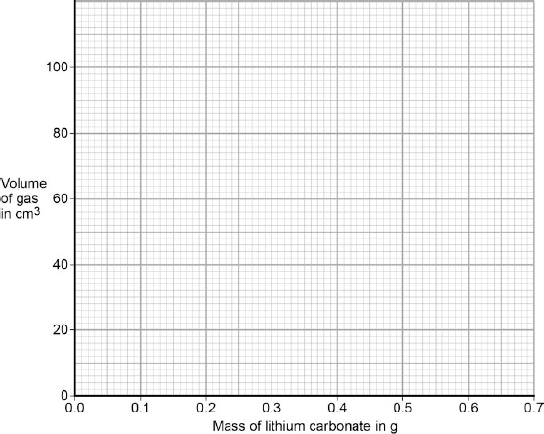

**(4)**

(c)     What are **two** possible reasons for the anomalous result?

|  |  |
| --- | --- |
| Tick **two** boxes. |  |
| Too much lithium carbonate was added. |  |
| The bung was not pushed in firmly enough. |  |
| There was too much water in the trough. |  |
| The measuring cylinder was not completely over the delivery |  |
| The conical flask was too small. |  |

**(2)**

(d)     Describe the pattern the graph shows up to 0.4 g of lithium carbonate added.

___________________________________________________________________

___________________________________________________________________

___________________________________________________________________

___________________________________________________________________

**(2)**

**(Total 9 marks)**

**Q2.**

Lead bromide is a solid. Some students were measuring how soluble lead bromide is at different temperatures.

This is the method they used.

**A**    Pour 100 cm3 of water into a beaker.

**B**    Heat or cool the water to the required temperature.

**C**    Add lead bromide to the water.

**D**    Stir until no more lead bromide dissolves.

**E**    Transfer 50 cm3 of the lead bromide solution into an evaporating basin of known mass.

**F**    Heat the evaporating basin until all of the water has evaporated.

**G**    Measure the mass of the evaporating basin containing the dry lead bromide.

(a)     (i)      How could the lead bromide solution be separated from the undissolved solid lead bromide after step **D**?

Draw a ring around the correct answer.

**electrolysis**       **filtration**       **neutralisation**

**(1)**

(ii)     Draw a ring around the correct answer to complete the sentence.

A suitable item of apparatus for measuring 50 cm3 of the lead bromide solution

|  |  |
| --- | --- |
| in step **E** is a measuring | cylinder.  funnel.  tube. |

**(1)**

(iii)    One student’s results are shown in **Table 1**.

**Table 1**

|  |  |
| --- | --- |
| Volume of lead bromide solution | 50 cm3 |
| Mass of empty evaporating basin | 35.4 g |
| Mass of the evaporating basin containing dry lead bromide | 36.0 g |

Calculate the mass of lead bromide dissolved in 50 cm3 of lead bromide solution.

______________________________________________________________

______________________________________________________________

Mass of lead bromide dissolved = __________ g

**(2)**

(b)     A different student got the results shown in **Table 2**.

|  |  |
| --- | --- |
| **Temperature of lead bromide solution in °C** | **Mass of lead bromide dissolved in 50 cm3 of solution in g** |
| 0 | 0.20 |
| 20 | 0.40 |
| 40 | 0.70 |
| 60 | 1.70 |
| 80 | 1.55 |
| 100 | 2.30 |

(i)     Plot these results on the grid in **Graph 1**.

Draw a smooth curve of best fit.

**Graph 1**

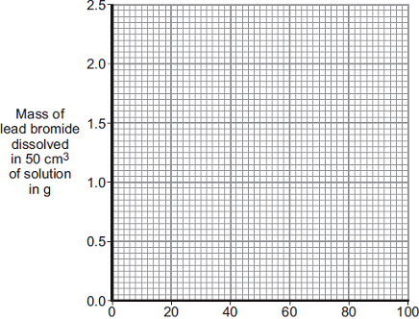

      Temperature in °C

**(3)**

(ii)     One of the points is anomalous.

Draw a ring around the anomalous point on the graph.

Suggest **one** possible error in the experiment, and give a reason why this error would cause the anomalous point.

______________________________________________________________

______________________________________________________________

______________________________________________________________

______________________________________________________________

**(3)**

(c)     The solubility of lead bromide is so low that it can be made using a precipitation reaction.

A student investigated how much lead bromide was precipitated when different volumes of potassium bromide and lead nitrate solutions were mixed together.

This is the method the student used.

•        Place 10 cm3 of lead nitrate solution in a boiling tube.

•        Using a burette, add 2 cm3 of potassium bromide solution to the boiling tube containing the lead nitrate solution.

•        Leave the mixture to stand.

•        Measure the depth of the lead bromide precipitate using a ruler.

•        Repeat using different volumes of potassium bromide solution.

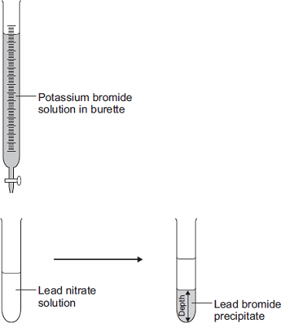

(i)      A teacher suggested that the student should do the reaction in a measuring cylinder.

Explain why it is a good idea to do the reaction in a measuring cylinder.

______________________________________________________________

______________________________________________________________

______________________________________________________________

**(2)**

(ii)     The student’s results are plotted on **Graph 2**.

**Graph 2**

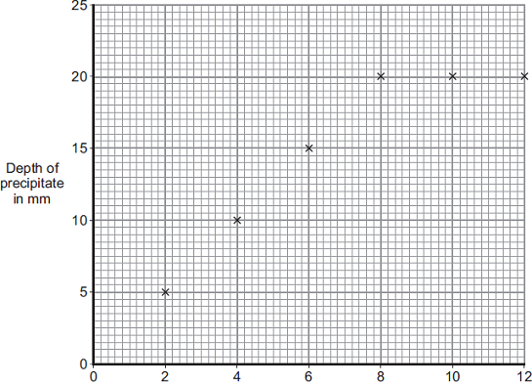

      Volume of potassium bromide solution in cm3

There are no anomalous points.

Complete the graph by drawing two straight lines through the points.

**(2)**

(iii)    What depth of precipitate would you expect to get if 14 cm3 of potassium bromide was used?

Give a reason for your answer.

Depth of precipitate ________________________ mm

Reason _________________________________________________

______________________________________________________________

**(2)**

(iv)    How would the results be different if the experiment was repeated using solutions at a higher temperature? Give a reason for your answer.

______________________________________________________________

______________________________________________________________

______________________________________________________________

______________________________________________________________

**(2)**

**(Total 18 marks)**

**Q3.** Some theories suggest that the Earth’s early atmosphere was the same as Mars’ atmosphere today. The table below shows the percentage of four gases in the atmosphere of Mars today and the atmosphere of Earth today.

|  |  |  |
| --- | --- | --- |
| **Gases** | **The atmosphere of** | |
| **Mars today** | **Earth today** |
| Carbon dioxide | 95.00% | 0.04% |
| Nitrogen | 3.50% | 78.00% |
| Argon | 1.00% | 0.96% |
| Oxygen | 0.50% | 21.00% |

(a)     Which **one** of the gases in the table is a noble gas?

___________________________________________________________________

**(1)**

(b)     The percentage of carbon dioxide in the Earth’s early atmosphere was 95.00%.  
It is 0.04% in the Earth’s atmosphere today.

(i)      Calculate the decrease in the percentage of carbon dioxide in the Earth’s atmosphere.

______________________________________________________________

______________________________________________________________

Decrease in percentage = _______________%

**(1)**

(ii)     Give **two** reasons for this decrease.

______________________________________________________________

______________________________________________________________

______________________________________________________________

______________________________________________________________

**(2)**

**(Total 4 marks)**