Interpreting reactions of biological molecules

Task introduction

Different biological molecules can be tested for using different tests. You must be able to describe these tests and also interpret their results. You should also be able to explain the results of the reactions of these biological molecules.

Part 1

**1** A student was given four solutions labelled A to D. The solutions contained:

* sucrose
* glucose
* starch
* an enzyme which breaks down starch into glucose.

Before she began the experiments the student wanted to be sure none of the samples had become contaminated with samples of lipids that had also been used in the lab.

**a)** Explain a test she could carry out. [4]

Having determined that the samples had not been contaminated she then carried out the following tests.

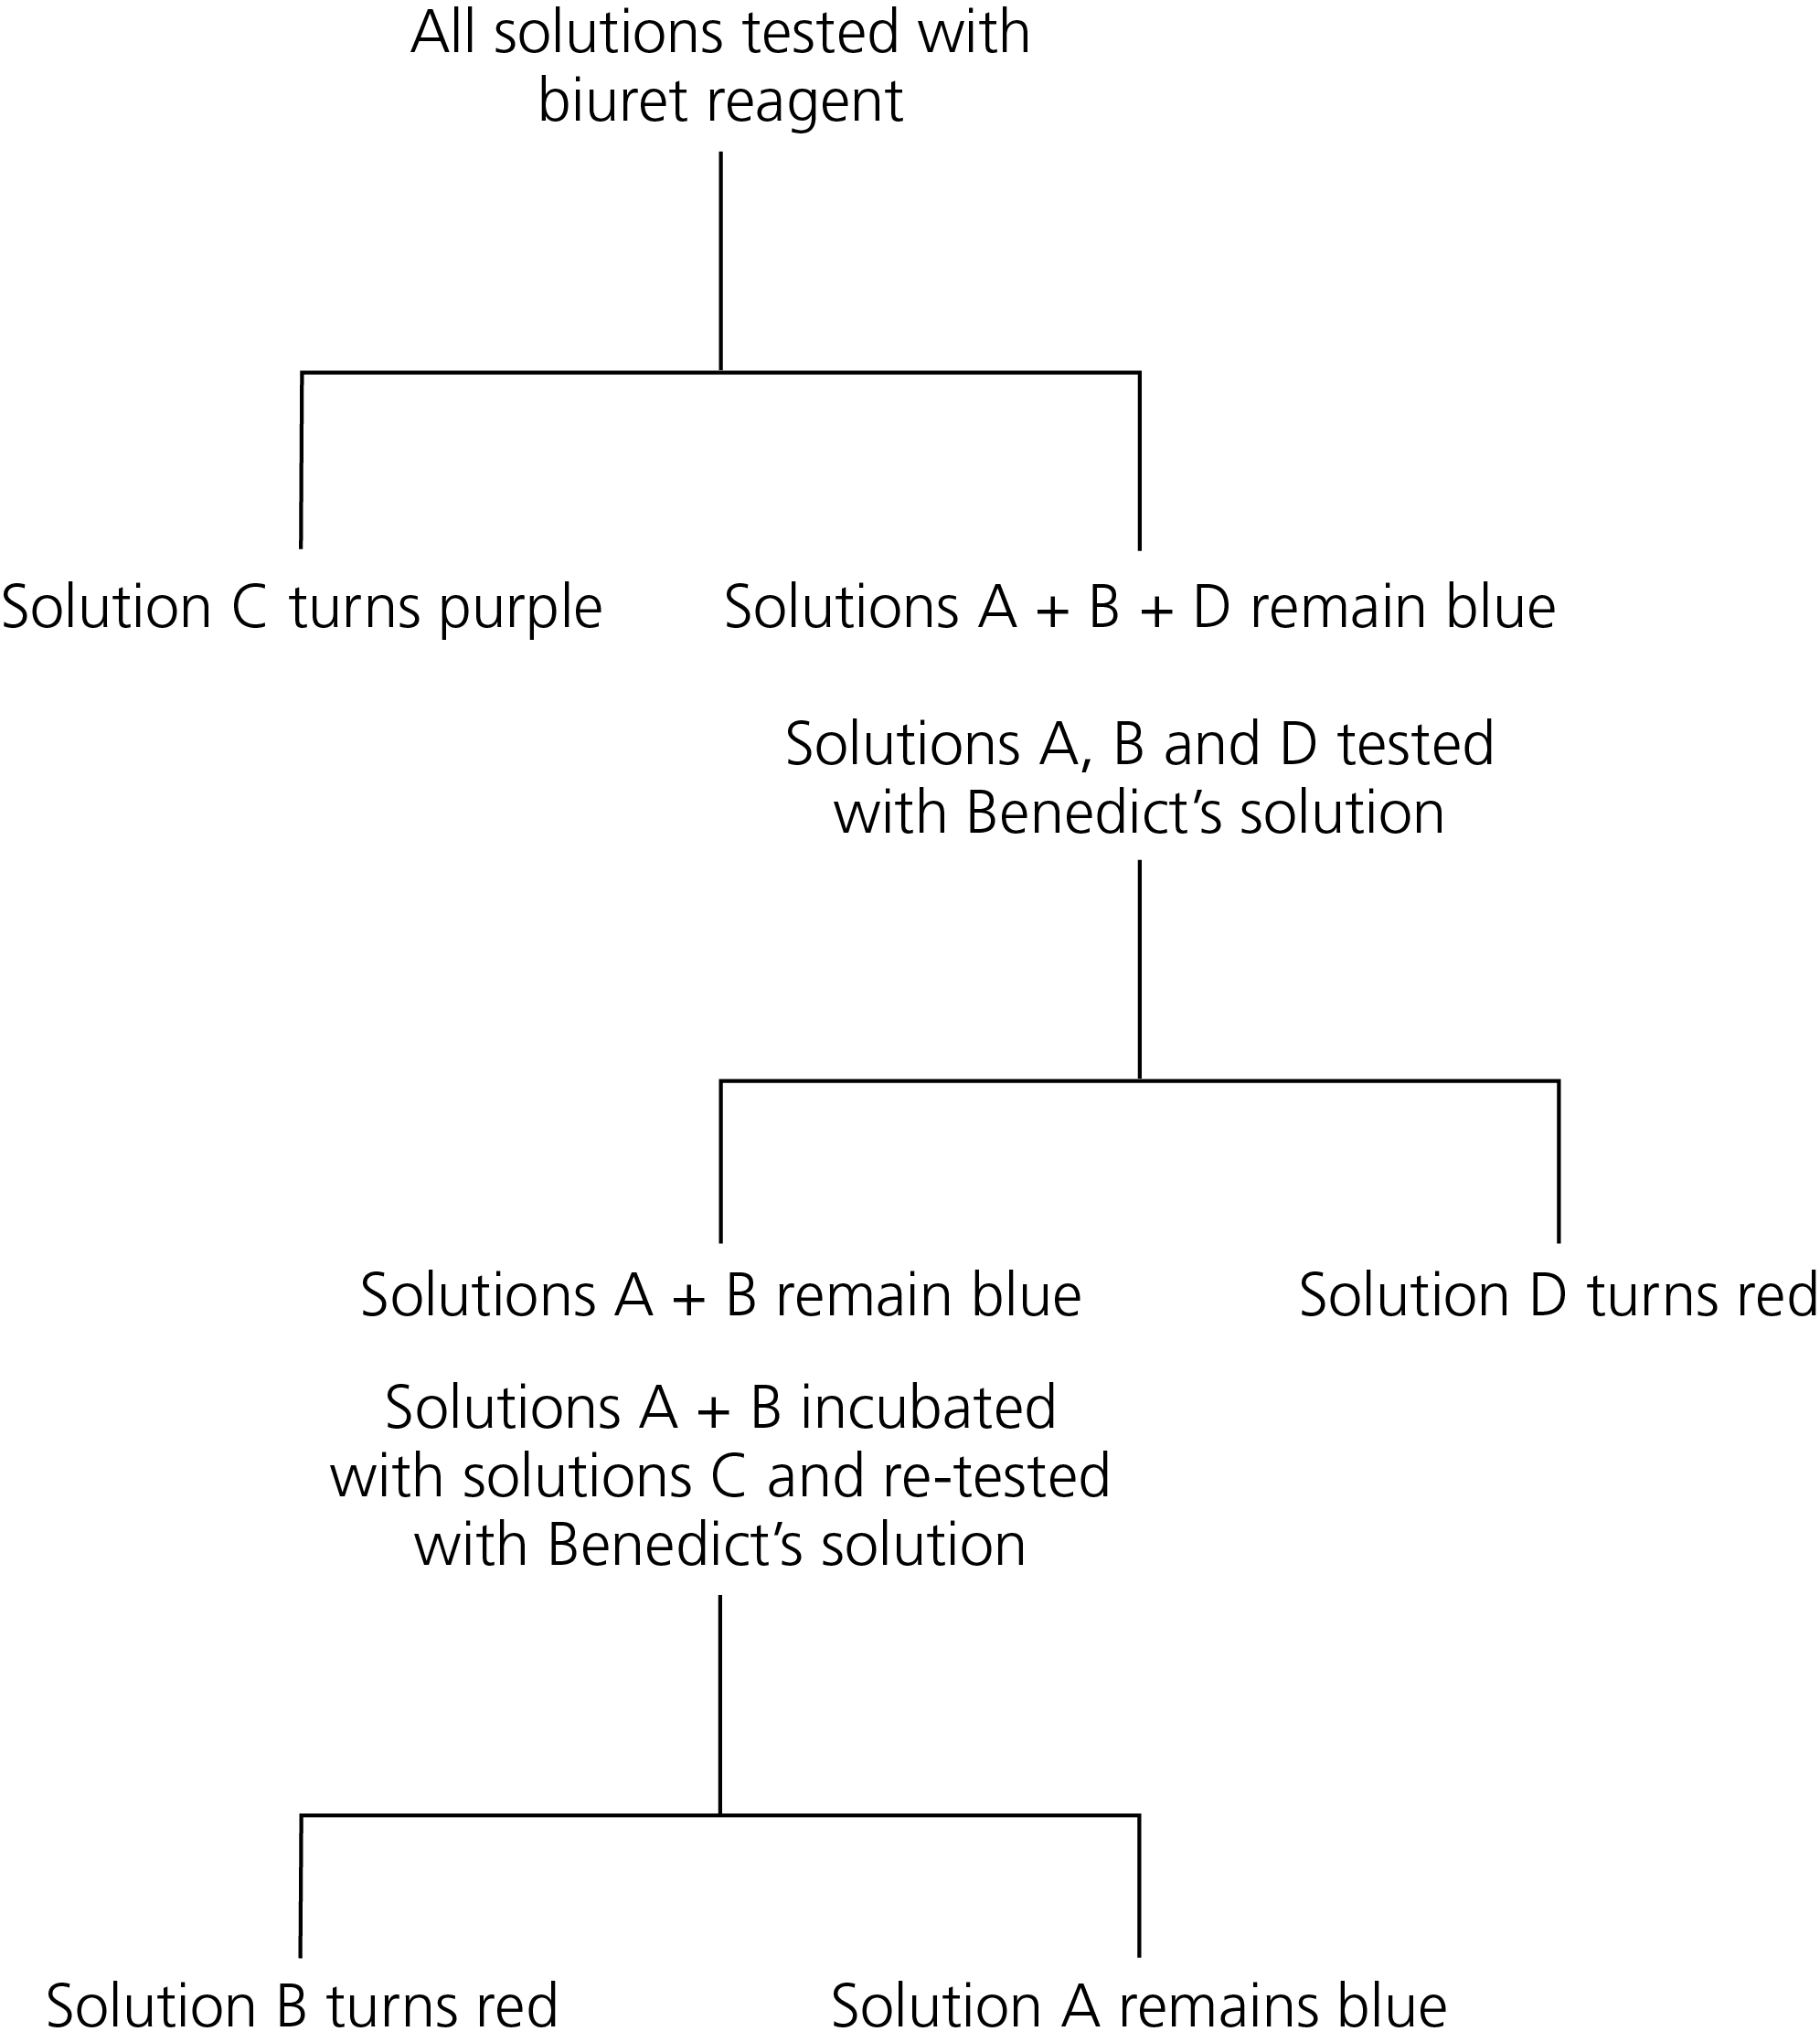

**b)** Identify the solutions A to D. [4]

**c)** Explain why solutions A and B gave different results when heated with Benedict’s after they had been incubated with solution C. [3]

Part 2

**2** A student was carrying out an investigation into joining amino acids together.

He joined a molecule of alanine to a molecule of glycine. [1]

**a)** What type of molecule had he produced? [1]

**b)** What bond joins the two amino acids together? [1]

**c)** What name is given to this reaction? [1]

**d)** Using the diagram below, draw the molecule produced by this reaction. [4]

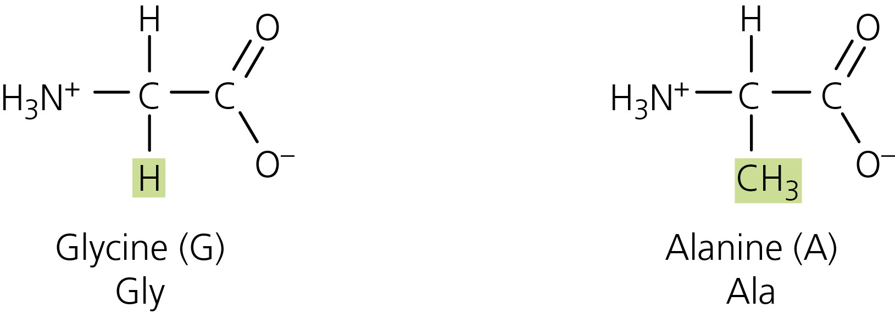

The student continued his investigation by joining many amino acids together.

**e)** In this reaction what was the:

**i)** monomer [1]

**ii)** polymer? [1]

**f)** The student wanted to determine he was producing proteins. What test could be use? [1]

**g)** This test produced a positive result on his later molecules. However, he recorded a negative result when investigating his initial samples of amino acids. Explain why. [2]

On using this test the student was surprised to discover that different samples were giving different shades of the positive results (purple). Some were very light while others were much darker. After doing some reading he realised this was linked to the number of amino acids in the protein. The more amino acids present, the darker the test result.

**h)** Why would more amino acids results in a darker positive test result? [2]

**i)** How could this be used to turn the biuret test into a quantitative test to compare the number of amino acids in different proteins? [3]

The student wanted to determine which amino acids made up the proteins in a sample. He first heated the proteins with strong acid.

**j)** Explain the effect of this on the proteins. [4]

The student then used chromatography to separate the amino acids in the solution. His results are shown below.



**k)** Using the Rf values listed below, determine which amino acids were in the sample. [4]

|  |  |
| --- | --- |
| Arginine | 0.20 |
| Asparagine | 0.5 |
| Cysteine | 0.4 |
| Glutamine | 0.13 |
| Glutamic acid | 0.30 |
| Histidine | 1.11 |
| Leucine | 0.73 |

**l)** One of the amino acids’ Rf values listed above is incorrect. Identify the incorrect amino acid and explain your answer.

**i)** Incorrect amino acid. [1]

**ii)** Explanation. [2]