|  |  |  |  |
| --- | --- | --- | --- |
| **0** | **1** |  |  |

Water must be treated to make it fit to drink.

|  |  |  |  |
| --- | --- | --- | --- |
| **0** | **1** | **.** | **1** |

Link each water treatment to its effect.

Draw **three** lines.

|  |  |  |
| --- | --- | --- |
| Treatment |  | Effect |
|  |  |  |
|  |  | removes dissolved salt |
| ozone |  |  |
|  |  | destroys microorganisms |
| desalination |  |  |
|  |  | removes solid particles |
| filtering |  |  |
|  |  | clumps fine particles together |
|  |  |  |
|  |  | dries out sludge |

(*3 marks*)

|  |  |  |  |
| --- | --- | --- | --- |
| **0** | **1** | **.** | **2** |

Explain why seawater is not treated in the UK to provide drinking water.

(*1 mark*)

|  |  |  |  |
| --- | --- | --- | --- |
| **0** | **2** |  |  |

Clothing is made from natural resources and from finite resources from the Earth.

|  |  |  |  |
| --- | --- | --- | --- |
| **0** | **2** | **.** | **1** |

Name one natural resource and one finite resource used to make clothing.

**Natural resource:**

**Finite resource:**  (*2 marks*)

|  |  |  |  |
| --- | --- | --- | --- |
| **0** | **2** | **.** | **2** |

Link the **two** words used to describe resources with its correct meaning.

|  |  |  |
| --- | --- | --- |
|  |  | replaced as quickly as they are used |
| renewable |  |  |
|  |  | recycled to make new products |
| sustainable |  |  |
|  |  | available for future generations |

(*2 marks*)

|  |  |  |  |
| --- | --- | --- | --- |
| **0** | **3** |  |  |

Touch-screen phones are made of many different materials.

**Figure 1** shows the percentage by mass of the main materials in a touch-screen phone.

**Figure 1**

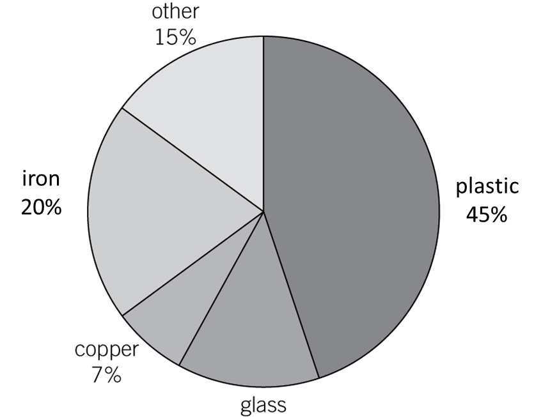

|  |  |  |  |
| --- | --- | --- | --- |
| **0** | **3** | **.** | **1** |

Calculate the percentage by mass of glass in a touch-screen phone.

Percentage  % (*1 mark*)

|  |  |  |  |
| --- | --- | --- | --- |
| **0** | **3** | **.** | **2** |

The materials in a computer system should be recycled at the end of its useful life.

Why is recycling the materials important?

Tick (✓) **two** boxes.

recycling uses no energy

extracting new iron causes serious pollution

there is little copper in the computer system

reserves of copper ore will be conserved

iron is an inexpensive metal (*2 marks*)

|  |  |  |  |
| --- | --- | --- | --- |
| **0** | **3** | **.** | **3** |

Why are more computers recycled now than 20 years ago?

Tick (✓) **one** box.

computers last a shorter time than they used to

the price of copper has risen greatly

new iron ore reserves have been discovered

the cost of energy has fallen (*1 mark*)

|  |  |  |  |
| --- | --- | --- | --- |
| **0** | **4** |  |  |

Distillation can be used to obtain potable water from water that is not fit to drink because it contains salts (**Figure 2**).

**Figure 2**

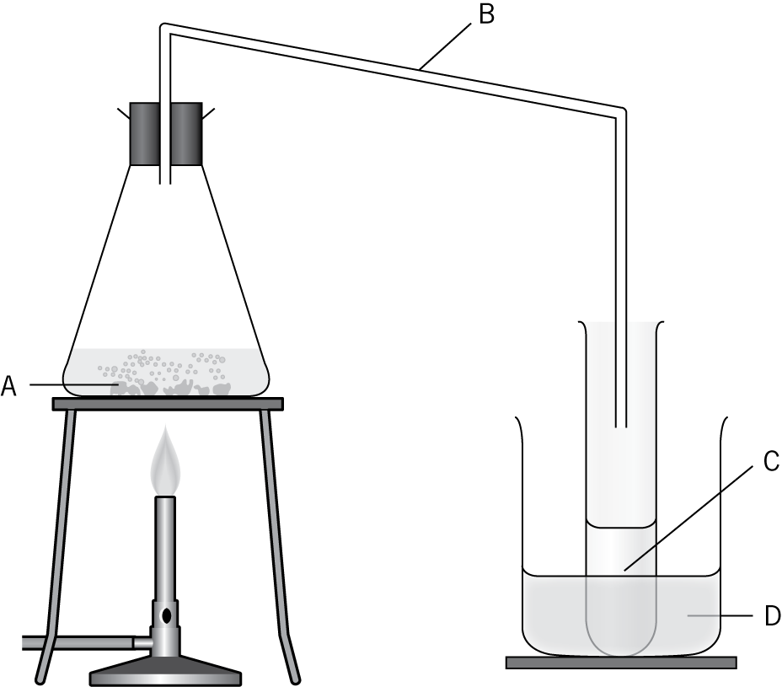

Link each part of the apparatus labelled in **Figure 2** with the substance found there.

Draw **four** lines.

|  |  |  |
| --- | --- | --- |
|  |  | steam |
|  |  |  |
| **A** |  | rain water |
|  |  |  |
| **B** |  | iced water |
|  |  |  |
| **C** |  | distilled water |
|  |  |  |
| **D** |  | salty water |
|  |  |  |
|  |  | salt |

(*4 marks*)

|  |  |  |  |
| --- | --- | --- | --- |
| **0** | **5** |  |  |

Most car fuels are obtained from crude oil. Crude oil is a resource from the Earth’s crust.

The data in **Figure 3** show how the discovery of new oil reserves has changed in each decade since 1900.

**Figure 3**

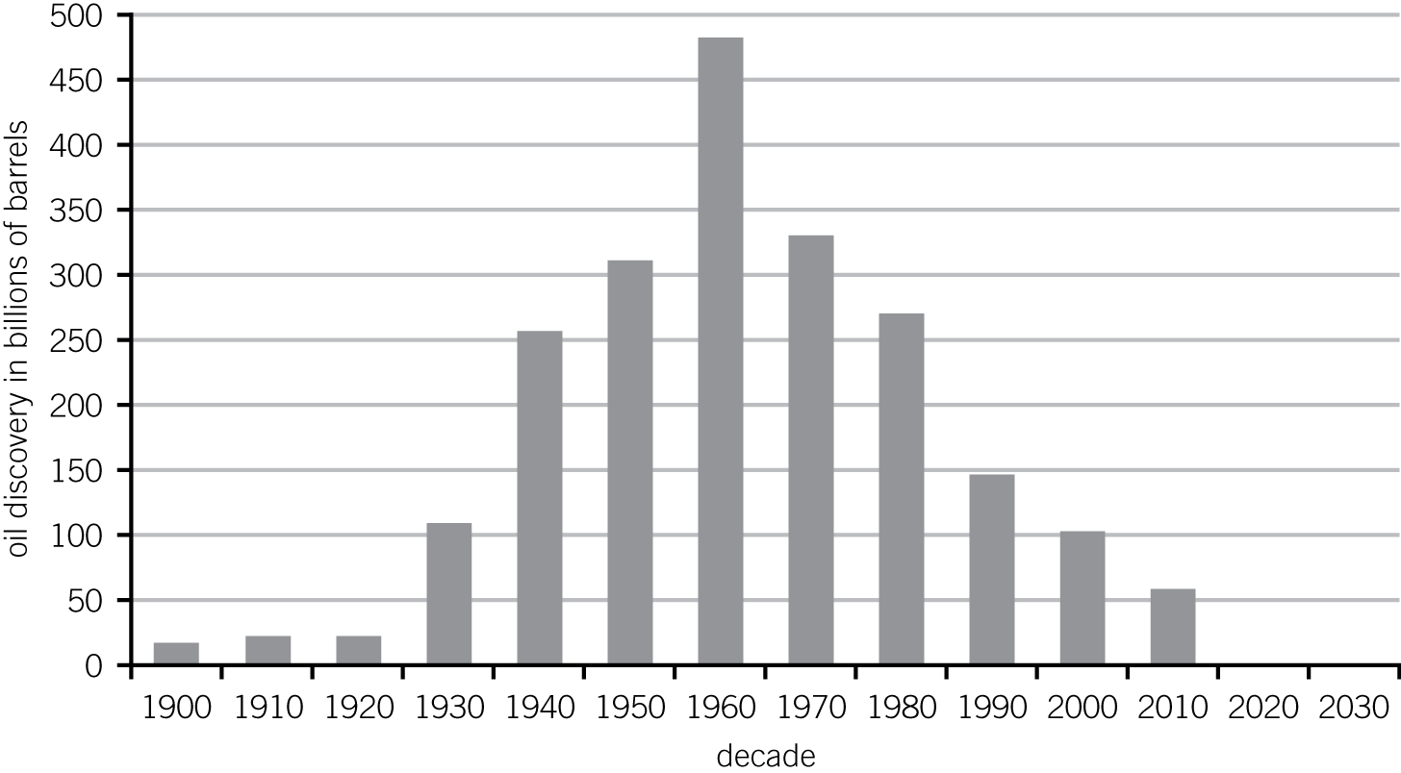

|  |  |  |  |
| --- | --- | --- | --- |
| **0** | **5** | **.** | **1** |

Use the data to calculate the oil discovery in 1960 as a percentage of that in 1900.

Percentage  % (*1 mark*)

|  |  |  |  |
| --- | --- | --- | --- |
| **0** | **5** | **.** | **2** |

Estimate the amount of oil that will be discovered in the decade beginning 2020.

Amount of oil   billion barrels (*1 mark*)

|  |  |  |  |
| --- | --- | --- | --- |
| **0** | **5** | **.** | **3** |

Suggest why the discovery of oil increased between 1900 and 1960.

(*1 mark*)

|  |  |  |  |
| --- | --- | --- | --- |
| **0** | **5** | **.** | **4** |

Suggest why the discovery of oil fell after 1960.

(*1 mark*)

|  |  |  |  |
| --- | --- | --- | --- |
| **0** | **5** | **.** | **5** |

Give **two** reasons why the data in **Figure 3** cannot tell us accurately when oil reserves will run out.

1

2 (*2 marks*)

|  |  |  |  |
| --- | --- | --- | --- |
| **0** | **6** |  |  |

Shopping bags can be made from poly(ethene) or paper.

A Life Cycle Assessment (LCA) can help decide which type of bag a supermarket should provide for its customers.

The first and last stages involved in an LCA are:

* extracting and processing raw materials
* disposal at the end of useful life.

|  |  |  |  |
| --- | --- | --- | --- |
| **0** | **6** | **.** | **1** |

Describe briefly the other **two** stages in an LCA.

1

2 (*2 marks*)

|  |  |  |  |
| --- | --- | --- | --- |
| **0** | **6** | **.** | **2** |

Compare the use of poly(ethene) and paper bags by considering:

* the extraction and processing of the raw materials needed to produce each bag
* the disposal of each type of bag at the end of its life.

(*6 marks*)