Question | Answers | Extra information | Mark | AO /  Spec ref.
01 | propene ─ turns bromine water colourless  ethanoic acid ─ turns universal indicator orange  methanol ─ has the formula CH3OH |  | 1  1  1 | 2 × AO1  1 × AO2  C7.2.2  C7.2.3  C7.2.4  WS1.2, 4.1
02.1 | C4H8 | allow H8C4 | 1 | AO2  C7.2.1
02.2 | bar to 117 °C | ± 1 °C | 1 | AO3  C7.2.1  MS2c
02.3 | Independent variable is discrete/ names/non-continuous/not numerical. |  | 1 | AO3  C7.2.1
02.4 | propene |  | 1 | AO2  C7.2.1
02.5 | The higher the melting point, the higher the boiling point. |  | 1 | AO2  C7.2.1
03.1 | Ethene is an unsaturated compound;  ethene’s series has the general formula CnH2n. |  | 1  1 | AO1  C7.2.1
03.2 | addition |  | 1 | AO1  C7.2.2
03.3 | C2H4 + Cl2 → C2H4Cl2 |  | 1 | AO2  C7.2.2
04.1 | = 16.05  = 16.1 (°C) | Accept 16.1 for 2 marks.  Accept 16.5 for 1 mark. | 1  1 | AO2  C7.2.3  MS2b
04.2 | Accept any number in range  17.5–18.2 |  | 1 | AO3  C7.2.3
04.3 | Add a lid/add insulation/move flame closer to beaker. | Allow add draft shields or less water in the beaker. | 1 | AO3  C7.2.3  AT1, 5
04.4 | carbon dioxide |  | 1 | AO1  C7.2.3
05 | Level 3: There is a reasonably detailed description of both methods giving reactants, products and conditions showing how ethanol is produced from sugar and by hydration with steam. This could be achieved by including chemical equations. |  | 5–6 | AO1×4  AO2×2  C7.2.2  C7.2.3  WS1.2
 | Level 2: There is a basic description of both methods. There is an attempt to give reactants and some conditions showing ethanol production from sugar and by hydration with steam. |  | 3–4
 | Level 1: There is a brief description of one method, including reactants. Little or no mention of conditions of the two methods of producing ethanol. |  | 1–2
 | Level 0: No relevant content. |  | 0
Indicative content:
Hydration:
- ethene named
- water/steam named
- high temperature/300 °C
- high pressure/60–70 atmospheres
- catalyst
- word equation
- only ethanol produced.
Sugar:
- sugar or glucose named
- aqueous solution/water
- yeast
- warm/25–50 °C
- anaerobic/fermentation
- word equation
- carbon dioxide also produced.
This indicative content is not exhaustive, other creditworthy responses should be awarded marks as appropriate.
06.1 | butanoic acid |  | 1 | AO1  C7.2.4
06.2 | 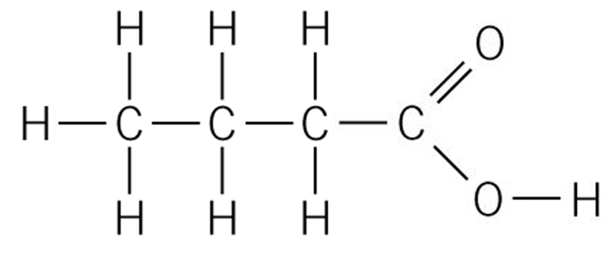 |  | 1 | AO1  C7.2.4
06.3 | covalent bonds | Accept shared pair of electrons. | 1 | AO2  C2.1.4
06.4 | sodium carbonate |  | 1 | AO2  C7.2.4
06.5 | H₂O + CO₂ | Either order;  both required for 1 mark. | 1 | AO2  C7.2.4
06.6 | Bubbles of gas/carbon dioxide are given off. |  | 1 | AO2  C1.1.1
06.7 | ester |  | 1 | AO3  C7.2.4

