**SPEAKING TEST GENERAL INFORMATION**

**Foundation tier assessment time and marks**

* The total assessment for the three tasks is 7 to 9 minutes plus 12 minutes’ preparation time.
* The assessment is worth 70 marks.
* The assessment consists of the following three tasks which must be conducted in the following order:

**Task 1** – one role play recommended to last between one to one-and-a-half minutes for 10 marks

**Task 2** – one picture-based task recommended to last between two-and-a-half to three minutes for 24 marks

**Task 3** – a conversation recommended to last between three-and-a-half to four-and-a-half minutes for 36 marks.

**Higher tier assessment time and marks**

* The total assessment for the three tasks is 10 to 12 minutes plus 12 minutes’ preparation time.
* The assessment is worth 70 marks.
* The assessment consists of the following three tasks which must be conducted in the
* following order:

**Task 1** – one role play recommended to last between two to two-and-a-half minutes for 10 marks

**Task 2** – one picture-based task recommended to last between three to three-and-a half minutes for 24 marks

**Task 3** – a conversation recommended to last between five to six minutes for 36 marks.

* The conversation is in two parts, each covering a separate theme.
* For Part 1, the candidate will select one topic from one theme in advance.
* For Part 2, a separate theme will be allocated by Pearson using the sequencing grid.

Throughout the conversation in order to facilitate a genuine and spontaneous interaction, the nature of questions should enable candidates to:

• answer questions freely, in turn allowing them to produce extended sequences of speech

• develop conversations and discussions

• give and justify own thoughts and opinions

• refer to past, present and future events.

**Assessment criteria for the Foundation tier**

**Part 1 Role play – Foundation tier (10 marks)**

There is a maximum of 2 marks for each of the five prompts on the role play cards.

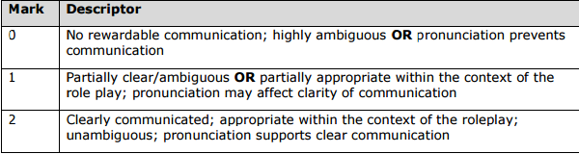

**Part 2 Picture-based task – Foundation tier (24 marks)**

There are two mark grids to be applied to this task which are:

* communication and content
* linguistic knowledge and accuracy.

**Picture-based task: communication and content - Foundation tier**

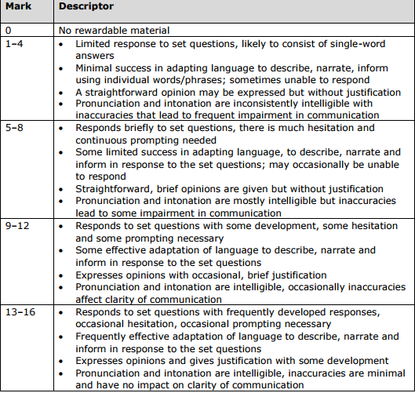

**Picture-based task: linguistic knowledge and accuracy - Foundation tier**

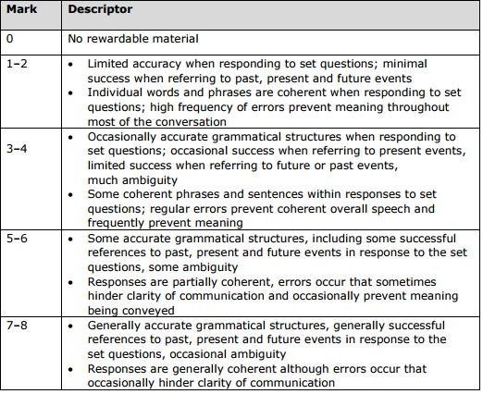

**Part 3 Conversation - Foundation tier (36 marks)**

There are three mark grids to be applied to this task, they are:

* communication and content
* interaction and spontaneity
* linguistic knowledge and accuracy.

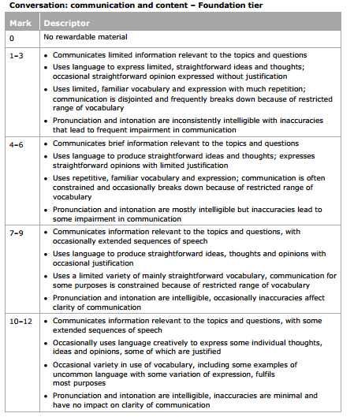

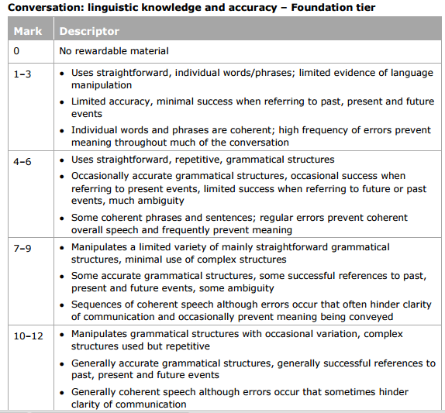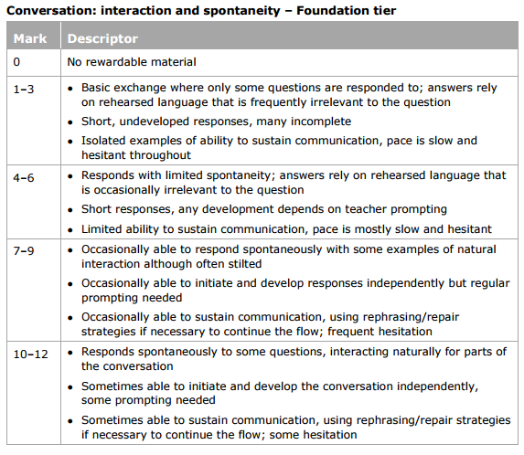

**Assessment criteria for the Higher tier**

**Part 1 Role play – Higher tier (10 marks)**

For this task, students’ work is marked by Pearson using the following assessment criteria. The mark grid is applied once to each individual response to the prompts. There is a maximum of 2 marks for each of the five prompts on the role play cards.

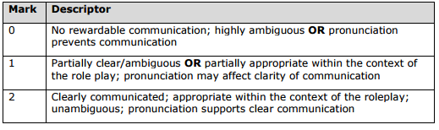

**Part 2 Picture-based task – Higher tier (24 marks)**

There are two mark grids to be applied to this task, which are:

* communication and content
* linguistic knowledge and accuracy.

**Picture-based task: communication and content - Higher tier**

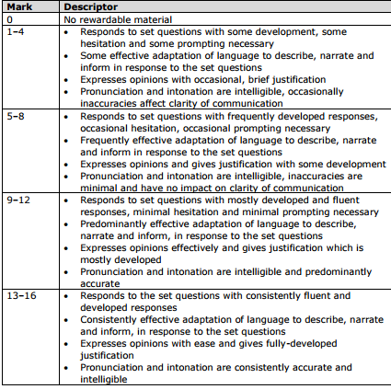

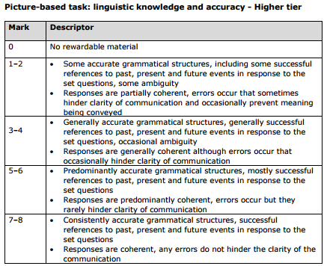

**Part 3 Conversation - Higher tier (36 marks)**

There are three mark grids to be applied to this task, they are:

* communication and content
* interaction and spontaneity
* linguistic knowledge and accuracy.

**Conversation: communication and content - Higher tier**

