**Making life cycle assessments**

**A life cycle assessment, or LCA, can be used to assess the environmental impact of the manufacture and use of different materials and products.**

**Making a life cycle assessment**

The articles that we use have three main life stages: manufacture, use and disposal. A life cycle assessment, or LCA, is a study of the stages in the life of a manufactured product.

**Key features**

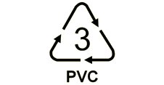

Polymers have recycling symbols like this one for PVC to show what they are

The key features of a life cycle assessment include the following factors:

* the main requirements for energy input
* the environmental impact and sustainability of making the materials from natural resources
* the environmental impact of making the product from the material
* the environmental impact of using the product
* the environmental impact of disposing of the product by incineration, landfill or recycling.

It is possible to make a life cycle assessment of a material. The outcome of this life cycle assessment will depend on:

* a consideration of the factors involved in the production of the material
* a consideration of the factors that involve each of the products that are made from this material.