**What is a simple test for the presence of amino acids?**

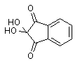Ninhydrin (1,2,3-Indantrione monohydrate, or triketohydrindene hydrate) is often used to detect alpha-amino acids and also free amino and carboxylic acid groups on proteins and peptides. When about 0.5 mL of a 0.1% solution of ninhydrin is boiled for one or two minutes with a few mL of dilute amino acid or protein solution, a blue colour develops. A ninhydrin solution in ethanol or other volatile solvents is often used as a developer for amino acids in paper chromatography or thin layer chromatography. Ninhydrin spray is also used on crime scenes to visualize fingerprints, which contain trace amounts of amino acids.

Ninhydrin degrades amino acids into aldehydes, ammonia, and CO2 through a series of reactions; the net result is ninhydrin in a partially reduced form **hydrindantin**: 

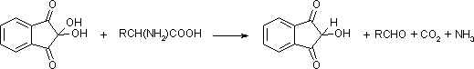

Ninhydrin then condenses with ammonia and hydrindantin to produce an intensely blue or purple pigment, sometimes called Ruhemann's purple:

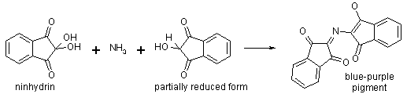

The colour varies slightly from acid to acid, probably because unreacted acids complex with the pigment. Proline and hydroxyproline give a yellow colour. Since all that is required for colour development is ammonia and partially reduced ninhydrin, the ammonium salts of weak and strong acids, as well as certain amines, can give a false positive result to the ninhydrin test.

The striking colour change is due to the large change in electron confinement on formation of the anion. Note the delocalization of negative charge (how many resonance structures can you draw?). Changes in electron confinement are also associated with [acid-base indicator colour changes](http://antoine.frostburg.edu/chem/senese/101/features/water2wine.shtml).

Author: [Fred Senese](http://antoine.frostburg.edu/chem/senese/index.shtml)[senese@antoine.frostburg.edu](mailto:%20senese@antoine.frostburg.edu) Copyright © 1997-2010 by [Fred Senese](http://antoine.frostburg.edu/chem/senese/index.shtml)  
Comments & questions to [fsenese@frostburg.edu](mailto:fsenese@frostburg.edu)  
Last Revised 08/17/15.URL: <http://antoine.frostburg.edu/chem/senese/101/organic/faq/amino-acid-test.shtml>

[General Chemistry Online!](http://antoine.frostburg.edu/chem/senese/101/index.shtml) What is a simple test for the presence of amino acids?