**Interpreting Data – Lungs and Breathing**

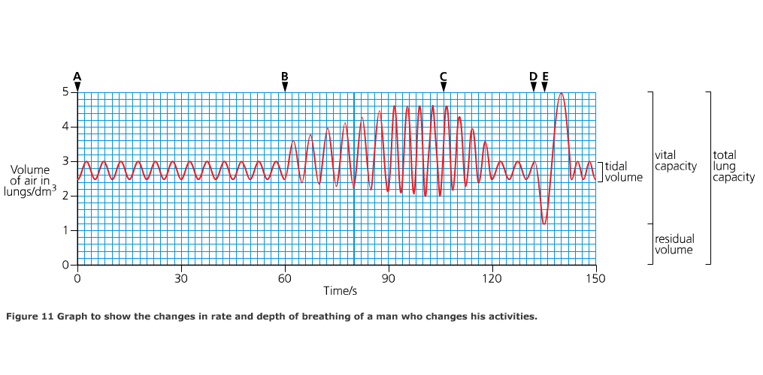

* From A-B the person is at rest (shallow steady breathing – tidal volume)
* At B exercise starts (deeper breaths)
* At C exercise stops (breathing returns to normal)
* At D maximum breath out (any air left in lungs is the residual volume)
* At E maximum breath in (maximum in and out is vital capacity)
* pulmonary ventilation rate (dm3min-1) = tidal volume (dm3) x breathing rate (min-1)

Calculate the pulmonary ventilation rate of a person who takes 17 breaths in a minute with a mean tidal volume of 600cm3. Show your working.

Answer: ……………………….



